CHAPTER 3 Ecosystems: What Are They & How Do They Work?

Core Case Study: Tropical Rainforests Are Disappearing
Rainforests only cover 2% of the Earth, but contain up to half of the world’s terrestrial plant and animal species.
What is the tropical rainforest land being used for when it is cut down? cropland, grazing, building settlements

What are the 3 harmful effects of disrupting these ecosystems?
- Reduce the Earth’s vital biodiversity by destroying habitats causing premature extinction
- Accelerates climate change by reducing the trees’ uptake of CO₂
- Changes regional weather patterns

3-1: What Is Ecology?
Ecology is the study of how organisms interact with their environment (living and nonliving)

Ecology Levels of Organization from simplest to broadest
LEVEL | DESCRIPTION | PICTURE
- Organism | -an individual living being
- Population | -group of individuals of the same species living in a particular place
- Community | -populations of different species living in a particular place and potentially interacting
- Ecosystem | -community of different species interacting with one another and with their nonliving environment
- Biome | -a particular area of similar climate, precipitation, etc
- Biosphere | -the Earth

Science Focus: Have You Thanked the Insects Today?
Give examples of why insects are an important part of the earth’s natural capital.
Pollination, controls other pest populations, loosen and renew the soil

3-2: What Keeps Us and Other Organisms Alive?
Earth’s life support system components:
- Atmosphere | Thin envelope of gasses surrounding Earth  Troposphere- layer of the atmosphere that contains the air we breathe and where our weather occurs, extends about 4 miles above the surface  Greenhouse gases- CO₂, water vapor, CH₄ (methane)  Stratosphere- contains O3 has to filter out most of the sun’s harmful ultraviolet radiation; “global sunscreen” that helps prevent skin cancer and cataracts
- Hydrosphere | Consists of all of the water (liquid, ice, and water vapor) on or near the Earth’s surface
- Geosphere | Consists of the Earth’s hot core, thick mantle (mostly rock), and thin outer crust

Terrestrial biomes have distinct climate and certain species adapted to them.
Examples of biomes found across 39th parallel in US: Chaparral, Coniferous Forest,
Desert, Grassland, Deciduous Forest
Aquatic life zones include freshwater and marine life zones.

Three factors that sustain life on Earth:
- the one way flow of high quality energy from the sun through living organisms in their feeding interactions and into the environment as low quality energy
- the cycling of matter or nutrients
- gravity

Explain what happens to solar energy as it reaches the Earth.
The energy reaches the Earth in the form of electromagnetic waves, mostly as light, UV radiation, and heat.
Ozone gas in the lower stratosphere absorbs most of the sun’s harmful UV radiation.
The UV, visible, and infrared energy that reaches the atmosphere warms the air, generates winds, and powers photosynthesis.
As the infrared radiation travels back up through the atmosphere it encounters greenhouse gases which trap the heat to warm the Earth.

What is the natural greenhouse effect? Why is the greenhouse effect good to a certain point?
The earth naturally has greenhouse gases that trap the heat from the sun. Without this natural greenhouse effect, the earth would be too cold for survival. Greenhouse gases are a good thing until there is too much- this leads to climate change (global warming).

3-3: What Are The Major Components of an Ecosystem?
How do abiotic factors affect biotic factors?
Species thrive under certain conditions such as level of sunlight, precipitation, temperature, etc.
Biotic Factors vs. Abiotic Factors
-living -nonliving

Explain the term “range of tolerance” in relation to trout using the figure in the Prezi.
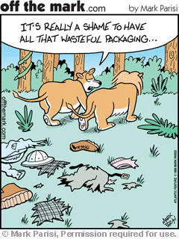
Variations in chemical and physical components of the environment
in which the species can thrive (like pH, temperature, sunlight)

How do limiting factors regulate population growth? Give an example.
Too much or too little of any abiotic factor can limit or prevent
growth of a population, even if all other facts are within the
optimal range of tolerance

Draw a food chain. Make sure your arrow show energy flow.

Trophic levels- feeding level

Producer | aka autotroph; make their own nutrients from photosynthesis (energy from the sun) or chemosynthesis (energy from chemicals like hydrogen sulfide)  EX: plants, algae, phytoplankton
Primary Consumer | aka herbivores; plant eaters  EX:rabbits, grasshoppers, deer, zooplankton
Secondary Consumer | aka carnivores; meat eaters that eat primary consumers  EX: hyenas, spiders, frogs
Tertiary Consumer | meat eaters that eat secondary consumers  EX: tigers, wolves, hawks, orcas
Omnivore | eat both plants and animals  EX: pigs, foxes, humans
Decomposer | consumers that release nutrients from the dead bodies of plants and animals and return them to the soil, water, or air for reuse  EX: bacteria, fungi
Detritivore | feeds on waste of dead bodies of other organisms called detritus  EX: mites, earthworms, catfish, large scavengers like vultures

Aerobic Respiration vs. Anaerobic Respiration
Uses oxygen to convert glucose to Does NOT use oxygen to convert glucose
Energy, CO₂, and water to CH4, ethyl alcohol, acetic acid
Hydrogen sulfide, and energy

*KEY IDEA: Ecosystems are sustained through a combination of one way energy flow from
the sun through these systems and nutrient cycling of key materials

Science Focus: Many of the World’s Most Important Species Are Invisible To Us
What are micro-organisms and why are they so important? Microorganisms refer to thousands of species of bacteria, protozoa, fungi, and phytoplankton that often get a bad reputation as germs that cause infection. However, these microbes also help with digestion, purify water by breaking down waste, helps produce food like cheese and yogurt, decompose waste into nutrients in the soil, etc.

3-4: What Happens to Energy in an Ecosystem?
Food Chain vs. Food Web
Sequence of organisms that serves as Shows the complex web of feeding
a food source for the next interactions since organisms usually feed on
more than one thing

What is biomass and what happens to biomass as you move up a food chain?
Biomass- the dry weight of all organic matter contained in its organisms; the biomass decreases as you move up the food chain

What is ecological efficiency and what happens to it as you move up a food chain?
The percentage of usable chemical energy transferred as biomass from one trophic level to another; typically 10% of the energy is passed on while the other 90% is lost as a lower quality energy like heat

Energy flow pyramids explain why there are usually only 4 to 5 tropic levels in a food chain because the amount of high quality energy is so low as you move higher in the food chain. It also explains why the Earth can support more people if we eat at a lower trophic level by consuming more grains, fruits, and vegetables.

**This is difficult- make sure you really understand the next two terms:
Gross Primary Productivity vs. Net Primary Productivity
Rate at which a producer converts solar The total energy plants get through
energy into chemical energy through photosynetheis minus the energy needed
photosynthesis for respiration

EQUATION NPP= GPP-R

Which terrestrial ecosystem has the highest NPP?
Swamps and Marshes, Tropical Rainforests

Which aquatic ecosystem has the highest NPP?
Estuaries

3-5: What Happens to Matter in an Ecosystem?
What is the importance of biogeochemical cycles? These cycles are responsible for
continually moving nutrients through air, water, soil, rock, and living organisms

What is a sink or reservoir? Areas where nutrients accumulate in one portion of the cycle and can remain there for various lengths of time; storage

Summarize/Draw each cycle below (These are really important concepts and will show up again and again!)
- Water Cycle
- Carbon Cycle
- Nitrogen Cycle
- Phosphorus Cycle
- Sulfur Cycle

CHAPTER 4 Biodiversity and Evolution

Core Case Study: Why Should We Care about the American Alligator?
What has happened to the American Alligator population since 1930? Why should we care?
-Populations declined drastically due to hunting for their exotic meat and skin used for shoes belts, and purses.
-American Alligators are keystone species and plays a huge role in sustaining their environment. These alligators dig holes in the mud which hold water during dry spells that provide refuge for aquatic life and a food source for others like fish, turtles, snakes, etc. ---The alligator’s nesting mounds also provide nesting and feeding sites for herons and turtles. Their role as a top predator also keeps other populations in check.
American Alligators became classified as a threatened species in 1977 and they have made
a comeback since then.

4-1: What Is Biodiversity and Why Is It Important?
Biodiversity- variety of Earth’s species, genes, ecosystems, and processes
Species Diversity- different types of species in an ecosystem

Ecosystem Diversity- variety of deserts, grasslands, forests, mountains, oceans, lakes,
rivers, wetlands

Functional Diversity- variety of processes like matter cycling, energy flow, etc

Genetic Diversity- variety of genes within a species that allows for adaptation

4-2: Where Do Species Come From?
Why do we have so much biodiversity? Use the term natural selection in your answer.
Life changes over time through changes in genes of populations. Natural selection is when
the strongest are able to survive in certain environments, therefore reproducing and passing on desirable traits.

How does the fossil record prove organisms have changed over time? Most of what we know
about Earth’s history comes from fossils. The fossil record, although incomplete, gives clues as to past species and how they may have evolved over time. The fossil record probably only represents about 1% of the species that have ever lived!

How does the genetic makeup of a population change over time? Populations change, not
the individual! Genetic variability occurs through mutations. If those mutations allow for
better survival, then those mutations may be passed on to the next generation.

Explain how individuals that have a beneficial trait are able to survive to reproduce.
An adaptation is a heritable trait that enables an individual to survive through natural selection and to reproduce more than others. The trait must lead to differential reproduction which enables individuals to leave more offspring than other members of the population.

Give 3 reasons why humans are such a powerful species.
- Strong opposable thumb
- Walks upright
- Complex brain
4-3: How Do Geological Processes and Climate Change Affect Evolution?
Tectonic plates have drifted apart over time, which has 2 major effects on evolution:
- The location of continents and oceanic basins greatly influences the earth’s climate and thus determine where plants and animals live.

- The movement has allowed species to move, adapt, and form new species through natural selection.

How have earthquakes and volcanoes affected evolution?
Earthquakes cause fissures in the crust that can separate and isolate populations. Over time
this can lead to formation of new species.
Volcanoes destroy habitats and can reduce or wipe out entire populations of species.

How has climate change affected natural selection? Periods of warming and cooling can affect ice sheets, sea level, temperature, precipitation etc. The change in climate determines where different types of plants and animals can survive. Some species go extinct, therefore opening up niches for other species.

4-4: How Do Speciation, Extinction, and Human Activities Affect Biodiversity?
Speciation- formation of new species
Common Mechanisms for Speciation:
- Geographic Isolation- different groups of the same population of a species become physically separated from one another for a long period of time. This can be due to migration, physical barriers (mountains, roads, rivers), and natural disasters (earthquakes and volcanoes)

- Reproductive Isolation- When members of a population become so different that they can no longer reproduce to create fertile offspring.

Endemic Species- species that are found in only 1 area are vulnerable to extinction

Extinction- when an entire species ceases to exist

Background Extinction- low rate of extinction that may take place naturally

Mass Extinction- significant rise in extinction rates above background level due to a catastrophic, widespread, event in which large groups of species are wiped out.
Earth has experienced 5 mass extinctions in the last 500 millions years.

4-5: What Is Species Diversity and Why Is It Important?
Species Diversity (aka species richness)- the number of different species
Species Evenness- relative abundance of individuals within each species

Science Focus: Species Richness on Islands: Theory of Island Biogeography
Why do large islands tend to have more species than small islands? The species
richness on an island is determined by the island’s size (smaller islands tend to have fewer species), and the island’s distance from the mainland (the closer the island, the easier to immigrate).

Why are species-rich ecosystems sustainable? If there is a large variety of producers, then that will support a greater variety of consumers. Also, if there are more species, then they’re more likely to withstand environmental disturbances (like drought, disease, pests, climate change, etc)

4-6: What Roles Do Species Play in an Ecosystem?
Niche- a species role in the ecosystem (interactions, biotic and abiotic needs)
Habitat- where species live

What happens if two species try to occupy the same niche?
Competition will occur in which there is a winner and a loser.

Generalist Species vs. Specialist Species
-broad niches, live in many places, -narrow niches, live in 1 habitat, eats
eat a variety of foods, and has a wide a small variety of food, and has a narrow
range of tolerance range of tolerance; prone to extinction

EX: mice, rates, deer, raccoons EX: tiger salamanders, China’s Giant Panda

Cockroaches are generalist. How has this helped them to survive forever? They can eat almost anything, live and breed almost anywhere, high reproductive rates, and can go for up to a month without food.

Native Species vs. Invasive Species
The species that normally live and aka- non-native species that are intentionally
thrive in a particular ecosystem or accidentally introduced to an ecosystem

What are indicator species and why are they important? Give an example.
Species that provide early warnings of damage to a community or ecosystem
EX: Trout indicate if the water is polluted or low on oxygen because they need
clean water and high dissolved oxygen to survive.

Describe 3 reasons why amphibians are vanishing:
- Habitat loss and fragmentation of wetlands, deforestation and urban development
- Prolonged drought that can dry breeding pools
- Pollution, especially exposure to pesticides

What are keystone species and why are they important? Give an example.
Keystone species play a large role in sustaining their ecosystem’s balance. For
example, these species may be pollinators, top predators, creators of breeding
grounds or other habitat space
Ex: American Alligator, Bees, Sea Lion, Sea Stars, Lions
What are foundation species and why are they important? Give an example.
Species that play a large role in shaping communities by creating or enhancing
habitats that benefit other species
Ex: elephants, beavers
CHAPTER 7 (partial) Climate and Terrestrial Biodiversity

7-2: How Does Climate Affect the Nature and Location of Biomes?
What are biomes and what makes biomes different from one another?
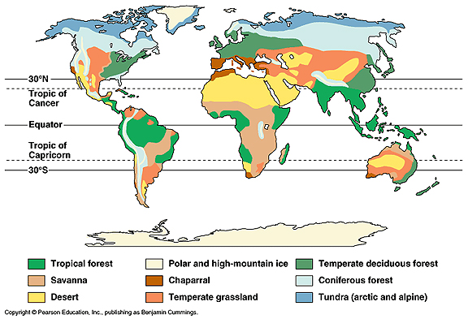
Looking at figure 7-9, how does elevation affect vegetation?
Tropical Forests to Deciduous Forests to Coniferous Forests to Herbs, Lichen, and Mosses
Biome- large terrestrial region with similar climate, soil, plants, and animals

Desert- low precipitation, soil with little vegetation
3 Major Types of Desert: | Description: | Location example:
- Tropical Desert | Hot and dry most of the year; few plants; rocks and sand; sand is disturbed often by off-road vehicles | Sahara Desert, Namib of Africa
- Temperate Desert | High daytime temps in summer, low temps in winter, more precipitation than tropical deserts, sparse vegetation, drought resistant shrubs, cacti, and succulents | Mojave Desert
- Cold Desert | Winters are cold, summers are warm, and precipitation is low, plants and animals have adaptations that help them stay cool and to get enough water to survive | Gobi Desert

**Why are desert ecosystems fragile? The soils take decades to hundreds of years to recover from disturbances (such as off-road vehicles). This is because of their slow plant growth, low species diversity, slow nutrient cycling (due to low bacteria), and lack of water.

Grassland- mostly in the interior of continents; areas too moist for deserts, but too dry for forests
3 Major Types of Grassland: | Description: | Location example:
- Tropical Grassland (Savanna) | Scattered clumps of trees, warm temps year round; alternating wet and dry seasons; herds of grazing and browsing animals; plants are adapted to survive drought and extreme heat | East Africa
- Temperate Grassland (Tall and Short Grass Prairies) | Winters are bitterly cold; summers are hot and dry; uneven precipitation throughout the year; many grasses die and decompose therefore there is a high level of organic matter that accumulates leading to fertile soil; drought tolerant grasses; plants can survive fires because the roots below are not harmed | Montana
- Cold Grassland (Tundra) | Bitterly cold, treeless plains; low growing grasses, lichen, moss; permafrost; animals have adaptations of thick fur; seasonal wetlands are home to mosquitoes and flies; migratory birds and caribou, | South of the Arctic Polar Ice Caps

Why is the tundra a fragile biome and how is global warming affecting it? Global warming has a large effect on this biome due to the melting of permafrost which releases CH₄ and CO₂ from the soil. This biome is fragile due to very slow soil formation and human activities due to drilling and pipelines.

Shrubland- many coastal regions that border deserts | Description: | Location example:
aka: Chaparral | Closeness to the sea provides a longer winter rainy seasons; dense growths of low lying shrubs and occasional small trees; the soil is thin and not very fertile; warm and dry summers that cause plants to become dry and flammable; this ecosystem is often maintained by fires; adaptations in which plants store food reserves in fire resistant roots or seeds that only sprout under hot fire; many people live here due to mild winters and warm, dry summers | Southern California, central Chile, Southern Australia

Forest Systems- dominated by trees
3 Major Types of Forests: | Description: | Location example:
- Tropical Rain Forest | Hot, moisture filled air; high precipitation; lush forests; uniformly warm temperatures; high humidity; wide variety of plant and animal species; high NPP; broadleaf evergreen plants; tops of trees form a dense canopy, therefore little vegetation on forest floor; specialized niches in distinct layers of the forest that enables coexistence of a great variety of species  **The soil is very poor here due to rapid decomposition and recycling of scarce soil nutrients. Heavy rainfall also leaches nutrients from the soil | Found near equator, Congo Basin
- Temperate Forest | 4 distinct seasons in which temps change significantly; long, warm summers; cold winters; abundant precipitation; dominated by deciduous trees that lose their leaves during the winter; slow rate of decomposition; therefore has a thick layer of leaf litter; this biome has been disturbed the most by humans, once home to large predators (bears, wolves, pumas, etc), but have since been displaced | Georgia
- Cold Forest(Coniferous, aka: Boreal, aka: Taiga) | Long, dry, cold winters; short, cool summers; dominated by coniferous (cone-bearing) evergreen trees; needle-shaped, waxy leaves are able to withstand intense cold and drought; low plant diversity; slow decomposition; nutrient poor, acidic soil; wide variety of wildlife | Northern regions of North America, Asia, and Europe
Looking at Figure 7-17, explain how specialized niches reduce competition in the rainforest.
Plants and animals have specific niches that they fill in different layers of the
rainforest. This minimizes competition for resources and allows for coexistence of a
variety of species.

Describe the importance of mountains in their ecosystems.
-contain the majority of the world’s forests that provide habitat for much of the
plant’s terrestrial biodiversity
-sanctuary for many migrating species
-regulate Earth’s climate because of mountaintops that are covered with ice/snow
that reflect solar radiation back into space that helps cool the Earth; if the ice
melts, the darker mountain top actually absorbs heat which leads to a warmer
climate
-affects sea levels by storing water in glacial ice

7-3: How Have We Affected the World’s Terrestrial Ecosystems?
Humans have degraded or are using unsustainably 62% of the Earth’s major terrestrial ecosystems.
How have humans impacted the following terrestrial ecosystems?
Give 2 examples for each ecosystem:
Deserts | Grasslands | Forests | Mountains
1. soil destruction by off-road vehicles | 1. conversion to cropland | 1. clearing for agriculture | 1. timber extraction
2. depletion of groundwater | 2. release of CO₂ from burning grasslands | 2. conversion to tree plantations | 2. mineral extraction

CHAPTER 8 Aquatic Biodiversity
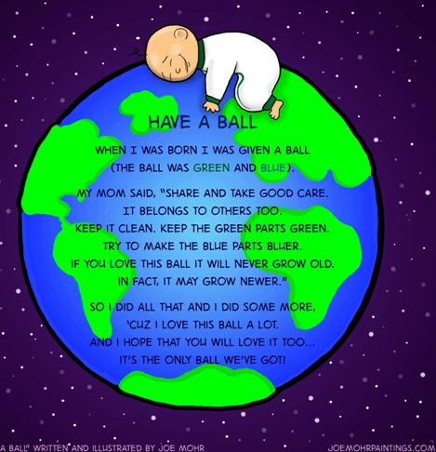
Core Case Study: Why Should We Care about Coral Reefs?
Where are coral reefs found? Clear, warm coastal waters of
tropics and subtropics
How are coral reefs formed? Colonies of polyps secrete
limestone around themselves that hardens to form a
crust

Explain how coral reefs represent mutualism. Single celled
algae called zooxanthellae live in the tissues of the
polyp. The algae provides polyps with food and oxygen
and helps produce calcium carbonate (coral skeleton).
Polyps provide algae a well-protected home and nutrients.

Describe ecological & economic services provided by coral reefs.
Ecological
-help moderate temperate by removing CO₂ from the atmosphere
-act as natural barriers to protect coastlines form erosion by waves and storms
-provides habitat for ¼ of all marine organisms
Economic
-produce about 1/10 of global fish catch in developing countries
-provide jobs and building materials
-supports fishing and tourism industries

Coral reefs are being destroyed by coastal development, pollution, overfishing, warmer
ocean temperatures, and increasing ocean acidity.

What is coral bleaching? (Very important!)
This occurs when corals die and turn white. They are dying due to increased ocean
temperature and increased ocean acidity. Ocean acidification occurs when the ocean
absorbs too much atmospheric CO2 from the burning of fossil fuels. That CO2 in the water then forms a weak acid (carbonic acid) that dissolves calcium carbonate.

8-1: What is the General Nature of Aquatic Systems?
Saltwater covers 71% of the Earth’s surface and freshwater covers 2.2%.
The distribution of aquatic organisms is based on the water’s salinity.
Aquatic life zones are classified into 2 major groups:
- Marine (saltwater)- oceans, estuaries, wetlands, shorelines, coral reefs, mangrove forests
- Freshwater- lakes, rivers, streams, inland wetlands

*Estuaries are a mix of saltwater and freshwater.
Saltwater and freshwater contain major types of organisms:
- Plankton- free-floating organisms
- Phytoplankton- drifting plants, including algae
- Zooplankton- drifting animals, including single celled protozoa and jellyfish
- Ultraplankton- photosynthetic bacteria, responsible for most of primary productivity near the ocean’s surface

- Nekton- strongly swimming consumers such as fish, turtles, and whales

- Benthos- bottom dwellers such as oysters, clams, worms, lobsters, and crab

- Decomposers- breaks down organic compounds in the dead bodies and waste of aquatic organisms into nutrients that are used by producers

Key factors determining the types and numbers of organisms in each layer of aquatic zones:
1. Temperature
2. Dissolved oxygen
3. Availability of food
4. Availability of light and nutrients

Why does photosynthesis take place in the euphotic zone? This is the zone in which sunlight
can penetrate through the water.

Light penetration can be reduced by cloudiness in the water aka: Turbidity which can occur due to excessive algal blooms.
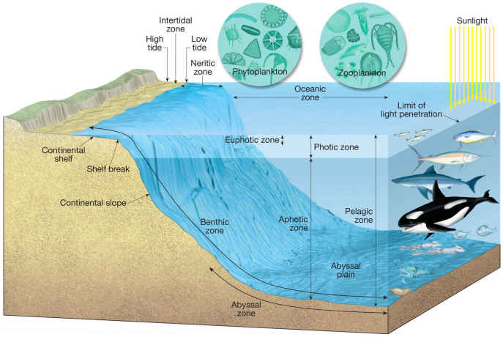
8-2: Why Are Marine Aquatic Systems Important?
Marine Ecosystems-
Ecological Services | Economic Services
-climate moderation  -CO₂ absorption  -nutrient cycling  -reduces storm impact  -habitat space and nursery areas | -food  -pharmaceuticals  -harbors and transportation  -recreation  -employment  -building materials

Marine life is found in 3 major life zones:
- Coastal Zone
- Open Ocean
- Ocean Bottom

Coastal Zone
Description: | *warm, nutrient-rich, shallow water that extends from the high-tide mark on land to the gently, sloping shallow edge of the continental shelf.  *makes up 10% of the ocean, but contains 90% of all marine species.  *many areas have a high NPP because ample sunlight and plant nutrients that flow into this area from land.
Estuaries: | *where fresh water mixes with salt water.
Coastal Wetlands: | *coastal land covered with water all or part of the year includes river mouths, inlets, bays, sounds, seagrass beds and salt marshes in temperate zones and mangrove forests in tropical zones  *Earth’s most productive ecosystems because of high nutrient input, rapid circulation of nutrients, and ample sunlight.  *Seagrass beds are highly productive, help stabilize shorelines and reduce wave impact.  *Why is life hard in these coastal ecosystems?  -must adapt to daily and seasonal changes in tidal and river flow,  water temperature, salinity, and sediment and pollution runoff.
Mangrove Forests: | *Found in sub-tropical regions like Southeast Asia and South America  *69 different tree species can grow in salt water where their roots can be seen above water where they can obtain oxygen.  *Describe 3 ecological or economic services provided by this aquatic system:  -maintain water quality by filtering pollutants  -provide food, habitat, and nursery sites  -reduce storm impact and coastal erosion  -supplies timber and fuelwood  *Loss of mangrove forests can lead to:  -polluted drinking water caused by salt water intrusion
Intertidal Zone: | *area of shoreline between high tide and low tide.  *What must organisms deal with that live in this zone?  -must be able to avoid being swept  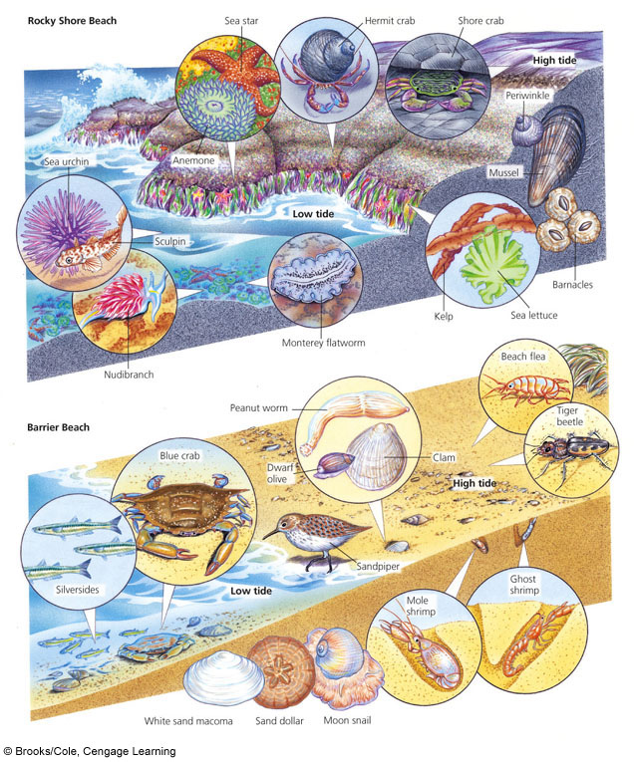  away by waves  -must be able to survive changes in  salinity  *Rocky Shores- lives in pools and  other crevices  *Barrier Beaches or Sandy Shores-  burrow between the tides  What is the importance of sand dunes?  -they are the first line of defense  Against the waves; help protect against  Flooding  *both areas have lots of birds that feed  on these creatures that are exposed in  between tides

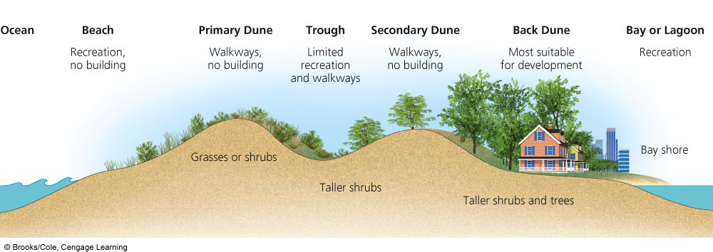

Open Ocean and Ocean Floor
Description: | *sharp increase in water depth at the edge of the continental shelf  *zones are based on the penetration of sunlight  *Divided into 3 vertical zones:  1. Euphotic Zone-  -brightly lit upper zone with drifting phytoplankton  -nutrient levels are low  -DO (dissolved oxygen) levels are high  2. Bathyal Zone-  -dimly lit middle zone that gets little sunlight  -does not contain photosynthetic organisms  -zooplankton & smaller fish migrate to the surface to feed at night  3. Abyssal Zone-  -dark and very cold, no sunlight, no photosynthesizing producers  -has little DO (dissolved oxygen)  -has a decent level of plant nutrients from decomposition  *Marine Snow- showers of dead and decaying organisms  *Deposit Feeders- take mud into their gut to extract nutrients  *Filter Feeders- pass water through or over their bodies to remove  nutrients  *NPP is low in the open sea, but upwellings bring nutrients from ocean bottom.

8-3: How Have Human Activities Affected Marine Ecosystems?
Major Threats to Marine Systems:
- Coastal Development- destroys and pollutes coastal habitats

- Overfishing- depletes populations of commercial fish species

- Runoff of Nonpoint Pollution- such as fertilizers, pesticides, and livestock waste

- Point Source Pollution- sewage from passenger cruise ships and spills from oil tankers

- Habitat Destruction- from coastal development and trawler fishing boats that drag weighted nets across the ocean bottom

- Invasive Species- introduced by humans; can deplete populations of native species and cause economic damage

- Climate Change- enhanced by human activities that could cause a rise in sea levels, which could destroy coral reefs and flood coastal marshes and coastal cities

- Climate Change- from burning fossil fuels, which warms and acidifies oceans

Name 3 Major Human Impacts on Coral Reefs:
1. Coral Bleaching
2. Ocean Warming
3. Soil Erosion

Case Study: The Chesapeake Bay- an Estuary in Trouble
How has population growth affected the Chesapeake Bay?
The estuary receives a massive amount of waste from the huge population.

Nitrates and phosphate levels have risen sharply which causes
algal blooms and eventually dissolved oxygen is depleted.

Point source pollution affecting Chesapeake Bay- primarily sewage treatment plants and industrial plants account for much of the phosphate pollution

Nonpoint source pollution affecting Chesapeake Bay- mostly runoff of fertilizer and animal waste

The native oyster population is nearly gone. What is the importance of oysters in the Chesapeake Bay?
Oysters filter and clean the water by removing excess nutrients that may lead to algal blooms. Because of this, oysters help keep the DO levels in the water stable.

Officials are thinking about introducing nonnative Asian oysters.
Give one PRO and one CON to this idea.
Pro- the invasive oysters are resistant to deadly parasites and grow bigger and faster than native oysters, therefore they will better clean the water
Con- unpredictable and irreversible; could have negative effect on other organisms

8-4: Why Are Freshwater Ecosystems Important?
Freshwater life zones include standing (lentic) bodies of water such as lakes, ponds, and wetlands, and flowing (lotic) bodies of water such as rivers and streams.

Lakes are formed when precipitation, runoff, and groundwater seepage fills depressions in the earth’s surface

What can cause these depressions in the land? Glaciation, crustal displacement, and volcanic activity

Deep lakes consist of 4 distinct zones:
- Littoral Zone- near the shore and consist of the shallow sunlit waters; high biodiversity because of ample sunlight and runoff of nutrients; rooted plants, frogs, turtles, crayfish, bass

- Limnetic Zone- open, sunlit surface layer away from the shore; many photosynthetic organisms; high levels of DO; zooplankton, phytoplankton, larger fish

- Profundal Zone- deep, open water where it is too dark for photosynthesis; low DO; fish that are adapted to cooler, darker waters live here

- Benthic Zone- inhabited mostly by decomposers, detritus feeders, and some fish; nourished mainly by dead matter that falls from the littoral and limnetic zones

Label the 4 zones of a lake:
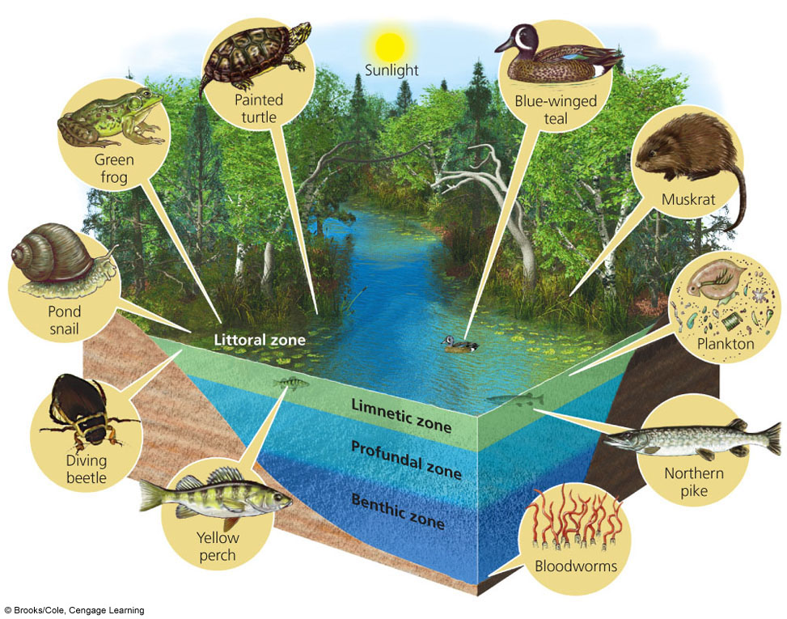

Two main types of lakes based on nutrient content and primary productivity:
- Oligotrophic Lakes- low NPP
very little plant nutrients, usually clear water, and surrounded by steep banks

- Eutrophic Lakes- high NPP
large supply of plant nutrients; usually shallow, murky water; high turbidity

*Cultural Eutrophication- acceleration of eutrophication of lakes caused by humans which puts excessive plant nutrients from fertilizers into lakes.

Many lakes fall somewhere between the two extremes of Oligotrophic and
Hypereutrophic and are called Mesoeutrophic.

Precipitation that doesn’t sink into the ground or evaporates becomes surface water and that becomes runoff
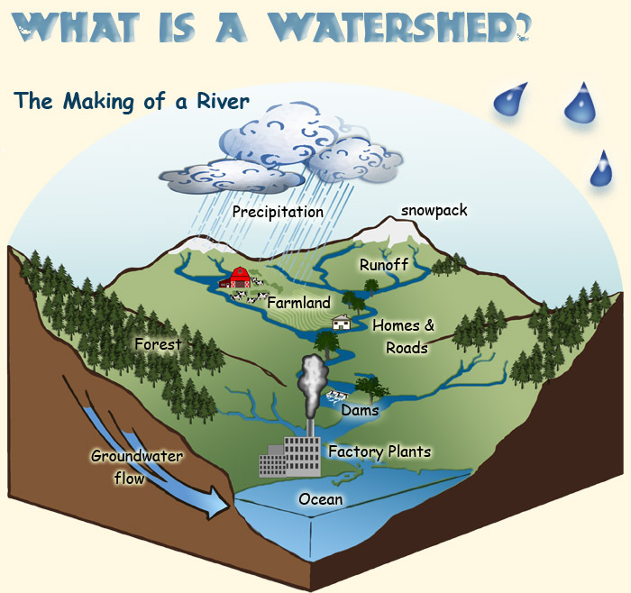

What is a watershed (drainage basin)?
Land area that delivers runoff,
sediments, and dissolved substances
to a stream

Streams often begin in mountainous or hilly areas and flows
through 3 aquatic life zones to the sea:
- Source Zone | * The waters here are usually shallow, cold, clear, and swiftly moving.  * As it flows it dissolves large amounts of oxygen from the air.  * Nutrients come mostly from organic matter (leaves, branches) that fall into the water.  * Populated by cold water fish (like trout) that need lots of  dissolved oxygen.  * Name 1 animal adaptation for this area:  Compact and flattened bodies to live under stones, muscular  bodies to swim in the fast currents  * Name 1 plant adaptation for this area:  Able to attach to rocks or survive under the surface of the water
- Transition Zone | * Headwaters merge to form wider, deeper, and warmer streams that flow down gentle slopes with fewer obstacles.  * More turbid, slower flowing, and has less dissolved oxygen.  * Supports more producers and fish that have less O2 demand.
- Floodplain Zone | * Streams join into wider and deeper rivers that flow across  broad, flat valleys.  * Water in this zone has a higher temperatures and less  dissolved oxygen.  * Supports a large population of producers and aquatic plants.  * Water in this zone is usually muddy and contains a high concentration  of silt because erosion.  * At its mouth, the river may divide into many channels as  it flows through deltas built up as sediments are deposited.
Sketch the path water takes as it moves through each zone. Use figure 8-17 as a guide

Case Study: Dams, Deltas, Wetlands, Hurricanes, and New Orleans
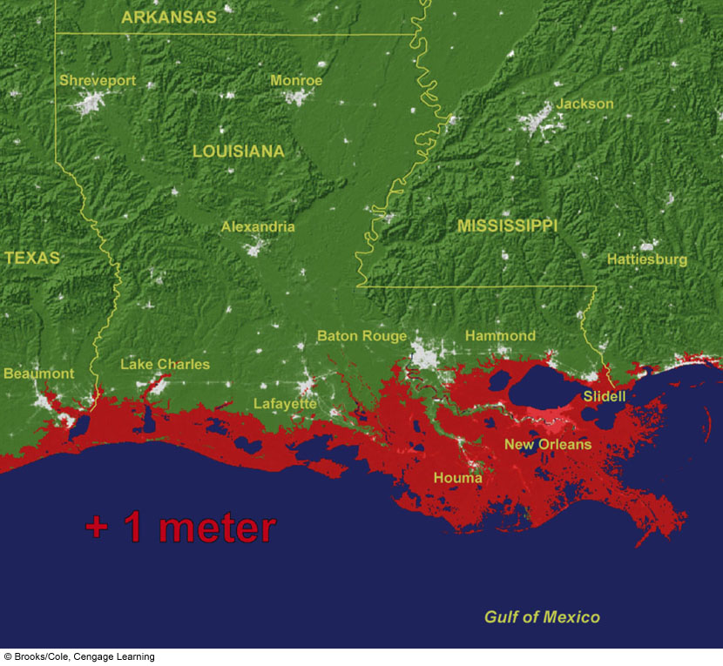
Coastal deltas, mangrove forests, and coastal
wetlands provide natural protection against
flood damage from storms, hurricanes, and
typhoons.

Louisiana has lost more than 1/5 of its
wetlands since 1950 due to:
oil and gas wells and coastal development

What has been built in this area to reduce
flooding along rivers and trap sediments?
Dams and levees

This has caused the river deltas to sink and no longer provide protection.
What has caused New Orleans to now be 3 meters below sea level?
land subsidence (sinking) due to lack of sediments being deposited and groundwater extraction; also sea levels have risen

Why would building taller levees not really work for New Orleans?
Increasingly stronger hurricanes and rising sea levels will take over

What are inland wetlands?
Land covered with freshwater all or part of the time & located away from the coast

Name 3 types of inland wetlands:
1. marshes
2. swamps
3. floodplains

Describe 3 ecological or economic services provided by inland wetlands.
- Filtering and degrading toxic waste and pollutants
- Reducing flooding and erosion by acting as a storm barrier
- Helping to recharge groundwater

8-5: How Have Human Activities Affected Freshwater?
Humans are affecting freshwater ecosystems in 4 major ways:
- Dams and canals fragment about 40% of the world’s 237 large rivers which alter and destroy wildlife habitats

- Flood control levees and dikes built along rivers disconnect the rivers from their floodplains, destroying aquatic wildlife habitats

- Cities and farms add pollutants and excess plant nutrients to nearby streams, rivers, and lakes causing cultural eutrophication.

- Many inland wetlands have been drained or filled to grow crops or have been covered with concrete, asphalt, and buildings.

