CHAPTER 5 Biodiversity, Species Interactions, & Population Control

Core Case Study: Southern Sea Otters: Are they back from the brink of extinction?
Why did the sea otters become nearly extinct by the early 1900s?
They were hunted for their fur and their food source (shellfish) was also used heavily by humans.
How has their population been able to recover since the 1930s?
The US Fish and Wildlife Services declared the Southern Sea Otters an endangered species and was therefore protected by the Endangered Species Act.

Why should we care about sea otters?
- They generate millions of dollars in tourism.

- Some believe it is unethical to allow a species to prematurely go extinct.

- They are a keystone species that play an important ecological role in the ecosystem because of their interactions with other species. They also control populations of sea urchins and other kelp eating species.

5-1: How Do Species Interact?
Species Interact in 5 Major Ways:
Interaction | Definition | Example
- Interspecific Competition  Intraspecific  Competition | -competition for resources between DIFFERENT species  -competition for resources between members of the SAME species
- Predation | -when members of one species (the predator) feeds directly on another species (the prey)
- Parasitism | -when one organism (the parasite) feeds on the body of, or the energy used by, another species (the host), usually by living on or in the host  -one benefits, the other is harmed
- Mutualism | -an interaction that benefits both species by providing each with food, shelter, or some other resource
- Commensalism | -an interaction that benefits one species but has little, if any, effect on the other

The most common interaction between species is competition for limited resources.

Explain the Competitive Exclusion Principle.
No two species can occupy the same niche. Otherwise competition will occur and there will be a “winner and a loser.”

Predators may capture prey by:
- Walking-
- Swimming
- Flying
- Pursuit and Ambush
- Camouflage
- Chemical Warfare- use venom to paralyze prey
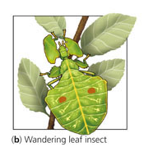
Prey may avoid capture by:
- Camouflage
- Chemical Warfare- discourage predators with chemicals that are
Poisonous, irritating, foul smelling, or bad tasting.
- Warning Coloration- “Eating me may be risky!”
- Mimicry- evolve to look like a poisonous species
The nonpoisonous viceroy looks and acts like the poisonous
monarch
- Deceptive Looks- body markings that make the prey look bigger
or scarier than they actually are
- Deceptive Behavior- scare off predators by puffing up, spreading wings, or living
in large groups

Why are predators so important?
Predators control population sizes of prey and play a role in the evolution of that
species.

Describe an example of coevolution.
Bats and Moths: Bats hunt at night using echolocation. As a countermeasure, certain moths have evolved ears that are sensitive to this frequency, thus allowing them to try to escape.

5-2: How Can Natural Selection Reduce Competition between Species?
Explain how the different types of warblers represent resource partitioning.
Each species of warbler must live in different parts of the tree in order to overlap niches.
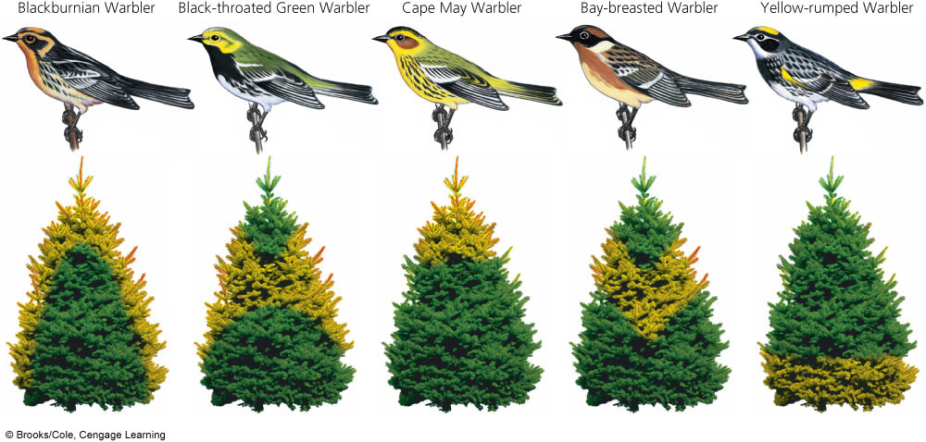

Why is it important that species 1 and 2 evolved, as shown in the graph below?
They evolve in a way that their niches no longer overlap, thus reducing competition.
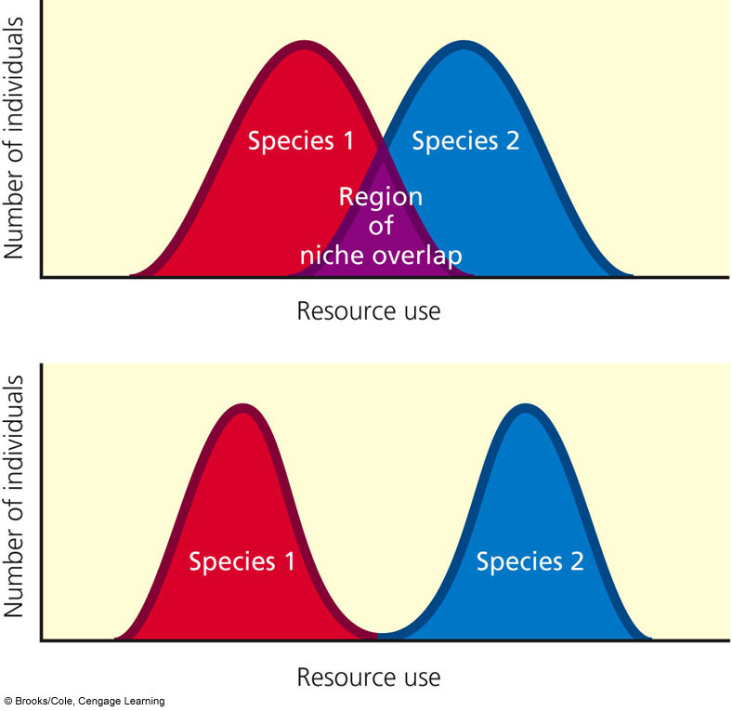

5-3: What Limits the Growth of Populations?
Population dynamics is the study of how the distribution, numbers, age structures, and
density change in a population in response to changes in environmental conditions.

Populations are distributed usually in 3 general patterns:
- Clumped
Why would populations want to clump together?
Species cluster around resources, clumped populations have a better chance at finding scattered resources, living in groups protects some from predators, hunting in packs give some a better chance of catching prey, and some species form groups for mating and caring for the young.

- Uniform

- Random

Four variables that govern changes in population size
1. Births
2. Deaths
3. Immigration
4. Emigration

Population change= (Births+Immigration) - (Deaths+ Emigration)

Age Structure- proportion of individuals at various age groups
- Pre-reproductive stage- | Not mature enough to reproduce
- Reproductive stage- | Capable of reproduction
- Post-reproductive stage- | Too old to reproduce

The size of a population will increase if is made of individuals that are mostly in their reproductive stage or soon to be in the reproductive stage.

Growth pattern terms to know:
- Biotic Potential- | Capacity for population growth under ideal conditions
- Intrinsic Rate of Increase (r)- | Rate at which a population would grow if it had unlimited resources  -populations with a high intrinsic rate of growth typically reproduce early in life, have short generation times, can reproduce many times, and have many offspring
- Environmental Resistance- | Combination of all factors that limit the growth of a population
- Carrying Capacity (K)- | The maximum population size based on the habitat and number of resources
- Logistic Growth- | Involves rapid exponential growth followed by a steady decrease until the population levels off  S-curve

r-selected species vs. K-selected species
-many, usually small offspring -reproduce later in life
-little to no parental care -have a small number of offspring
-population overcomes -longer life spans
environmental changes quickly -provides parental care
-opportunists- reproduce and -population typically follows a logistic curve
disperse rapidly
-can exhibit “boom and bust”
growth cycles

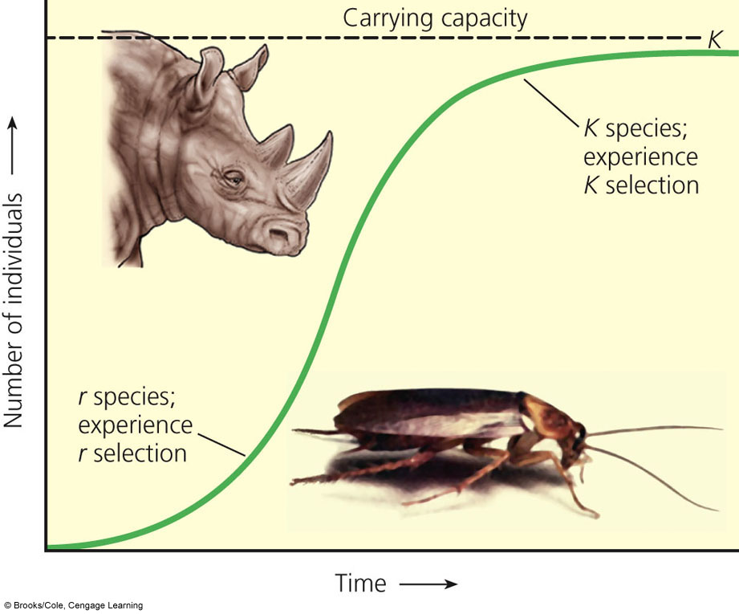
Label the following on the graph:
- Carrying Capacity
- K-selected species
- R-selected species

Explain why the cockroach is r selected.

Explain why the rhino is K selected.

Factors that play a role in the loss of genetic diversity and the survival of small, isolated populations:
- Founder Effect- when a few individuals colonize in a new habitat that is geographically isolated; genetic variability may threaten the survival

- Demographic Bottleneck- occurs when only a few individuals survive a disaster
Lack of genetic diversity limits the population size

- Genetic Drift- involves random changes in the gene frequencies that can lead to unequal reproductive success

- Inbreeding- occurs when individuals of a small population mate with one another

Population Density- number of individuals in a population found in a particular area
Density-dependent population controls: | Factors that limit population growth that are based on a population’s size  Ex: parasitism, infectious disease, competition
Density-independent population controls: | Factors that limit population growth that are not based on population size  Ex: natural disasters, fire, habitat destruction

Four Patterns of Variation in Population Size:
- Stable- | Population size fluctuates slightly above and below carrying capacity
- Irruptive- | Populations explode to a high peak then crash to a more stable lower level
- Cyclic (Boom and Bust Cycles)- | Cyclic fluctuations in population size
- Irregular- | Changes in population size with no recurring pattern

Explain the population cycles for the snowshoe hare and Canada lynx using the graph below.
Top-down population control
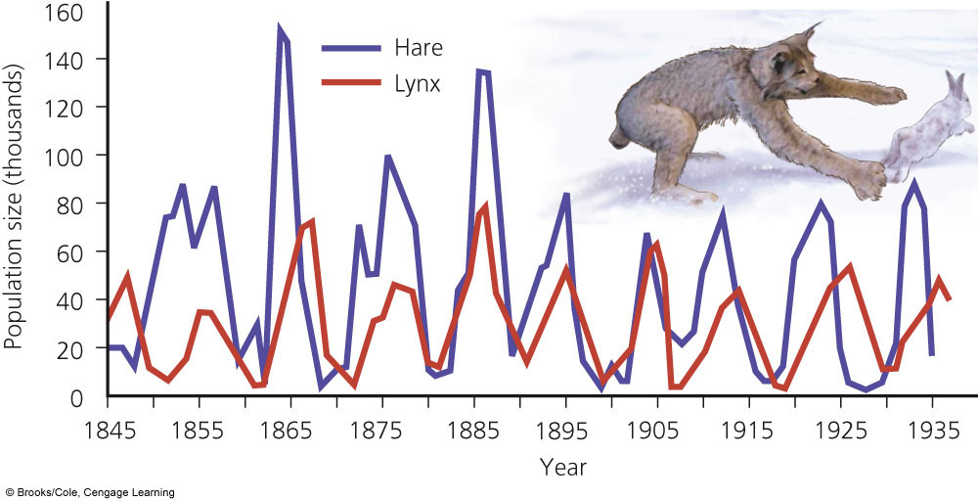
Changes in food availability
Predatory/Prey interactions

Describe 2 examples from history that have controlled human populations.
1. Bubonic Plague

2. AIDS

5-4: How Do Communities and Ecosystems Respond to Changing Environmental Conditions?
Ecological Succession-

Gradual change in species composition
Primary Succession-

Establishment of a community in a lifeless terrain and no soil

Pioneer Species(lichen, mosses) come in first to help make soil
Secondary Succession-

Communities develop in areas with soil

Can occur after a fire,
flood, deforestation

Label the following diagrams of succession as primary or secondary AND explain why.
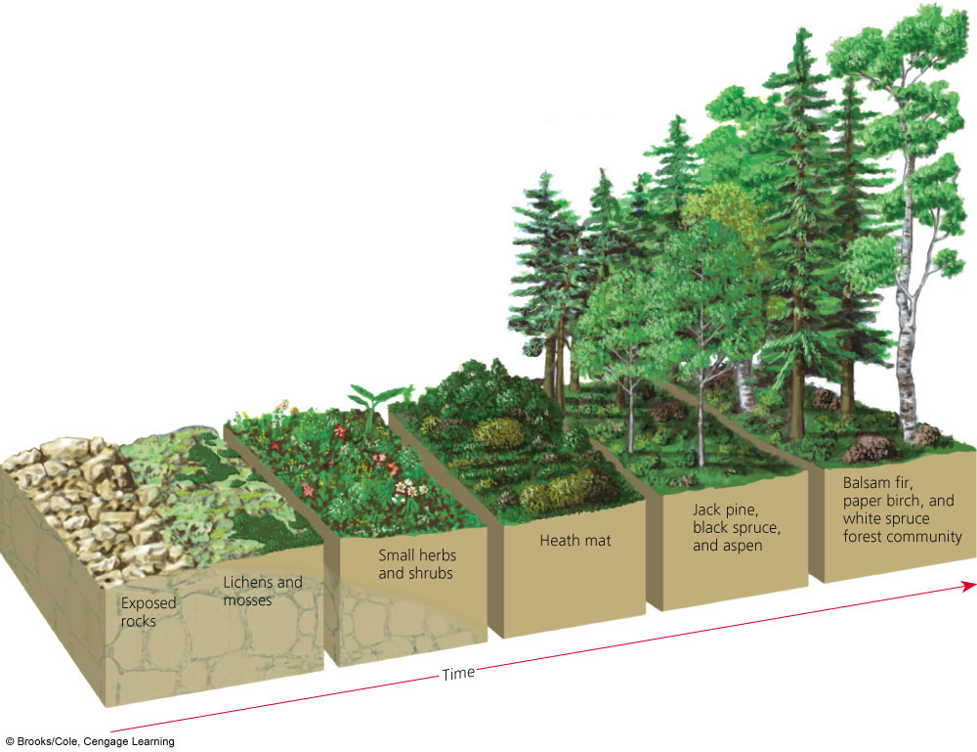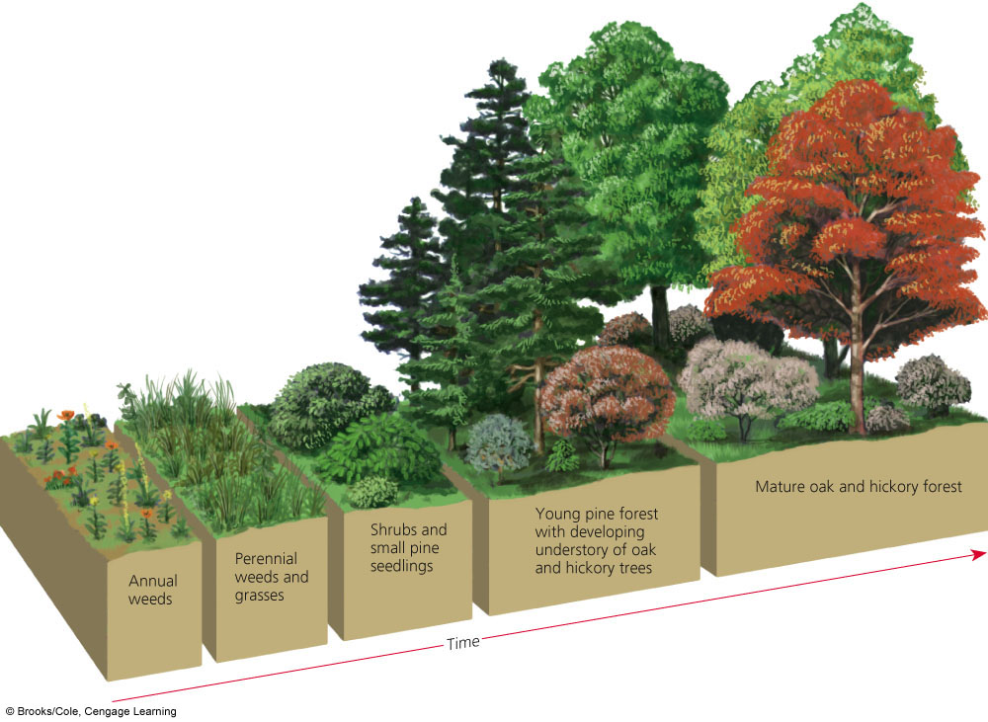

What is a climax community?
Dominated by a few long-lived plant species and is in balance with its environment

CHAPTER 6 Human Population & Its Impact

Core Case Study: Are There Too Many of Us?
The world population is currently around 7 billion people!
The world population in 2050 is projected to be 9.3 billion.
Describe the 2 views on the question “Can the Earth support that many people?”
- “The planet already has too many people that are collectively degrading the Earth’s natural capital. There are too many people in developing countries and the per capita resource consumption in developed countries is too high.”

- “Technological advances will allow us to overcome the environmental resistance and will increase the Earth’s carrying capacity.

Two serious consequences if birth rates aren’t lowered:
- Death rates may increase because of declining health and environmental conditions.

- Resource use and environmental degradation may intensify as more consumers increase their already large ecological footprints. This could increase environmental stresses such as disease, biodiversity loss, water shortages, traffic congestion, pollution of the oceans, and climate change.

6-1: How Many People Can the Earth Support?
In the last 200 years, the human population has experienced exponential growth.
Three factors that account for this increase:
- Humans developed the ability to expand in to diverse new habitats and different climate zones.

- The emergence of early and modern agriculture allowed more people to be fed for each unit of land area farmed.

- The development of sanitation systems, antibiotics, and vaccines helped control infectious disease agents.

What are the effects of altering nature to meet our needs?
-reduction in biodiversity
-increasing use of the Earth’s NPP
-increasing genetic resistance of pest species and disease causing bacteria
-elimination of many natural predators
-introduction of invasive species
-interfering with earth’s chemical cycling and energy flow process

Why is it a problem that most of the world’s population growth is taking place in developing countries?
Most of the world’s growth is taking place in already overcrowded developing countries that are least equipped to deal with the pressures of rapid growth.

What is cultural carrying capacity?
the optimum level that would allow most people to live in reasonable comfort and freedom without impairing the ability of the planet to sustain future generations.

6-2: What Factors Influence the Size of the Human Population?
What three factors lead to population growth/change?
1. births
2. deaths (mortality)
3. migration
What is the equation for population change (growth rate)?
POPULATION CHANGE = (births+immigration) - (deaths+emigration)
Crude birth rate: # of births per 1,000
Crude death rate: # of deaths per 1,000

List the world’s 10 most populous countries (give 2008 population for top 5)

1. China (1.3 billion)
2. India (1.1 billion)
3. US (300 million)
4. Indonesia (240 million)
5. Pakistan (173 million)
6. Brazil
7. Nigeria
8. Bangladesh
9. Russia
10. Japan

Replacement Level Fertility- average # of children a couple must have to replace themselves
Total Fertility Rate- average # of children born to a woman in a population during her reproductive years

List the ten factors that affect TFR and how they change it:
FACTOR | WHAT HAPPENS TO TFR?
- Importance of children as part of the labor force | TFR increases if children are an important part of the work force.
- Cost of raising and educating children | TFR decreases in developed countries where it is more expensive to raise a child.
- Availability of private and public pension systems (retirement) | TFR increases when retirement systems are not in place because children will be needed to care for the elderly.
- Urbanization | TFR decreases in urban areas (better jobs, birth control, etc)
- Education and employment opportunities available for women | TFR decreases when women have access to education and jobs outside the home.
- Average age of marriage | TFR decreases when a woman has her first child after the age of 25.
- Availability of legal abortions | TFR decreases when abortions are legally available.
- Availability of reliable birth control | TFR decreases when women can better choose when they want to have children.
- Religious beliefs, traditions, and cultural norms | TFR increases when religion or culture demands large families.
- Infant Mortality Rate (IMR)- # of kids per 1,000 that die before their 1st birthday | TFR decreases when IMR is low. A high IMR usually indicates poor nutrition and high incidence of infectious diseases.

Two useful indicators of overall health of a country or region:
- Life Expectancy- average # of years a newborn can expect to live
- Infant Mortality Rate- # of kids per 1,000 that die before their 1st birthday

Why are people living longer?
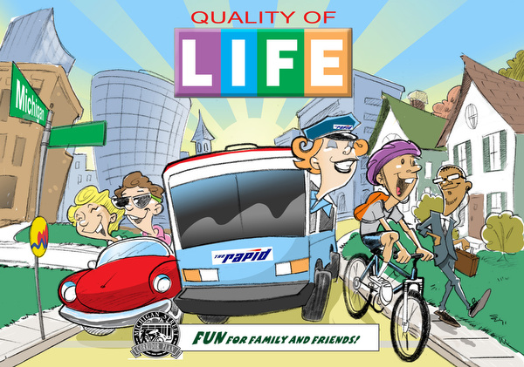

- Increased food supply and distribution
- Better nutrition
- Medical advances like vaccines and antibiotics
- Safer water supplies
- Better sanitation

Why is IMR in the US still so high?
- Inadequate health care for poor women before and after birth
- Drug addictions among pregnant women
- High birth rate among teenagers

Why Do People Migrate?
- Seek jobs and economic improvement
- Religious persecution, ethnic conflicts, political oppression
- Environmental degradation

6-3: How Does the Population’s Age Structure Affect Its Growth or Decline?
Age Structure Categories:
Pre-reproductive | Age 0-14
Reproductive | Age 15-44
Post-reproductive | Age 45 and older

How can age-structure information be used to make population and economic projections?
Examples:
A large pre-reproductive group will signify a future increase in population size.
A large post reproductive group will signify a larger need for retirement resources.
Ex: baby boomers

Label each of the pyramids as: expanding slowly, stable, expanding rapidly, and declining
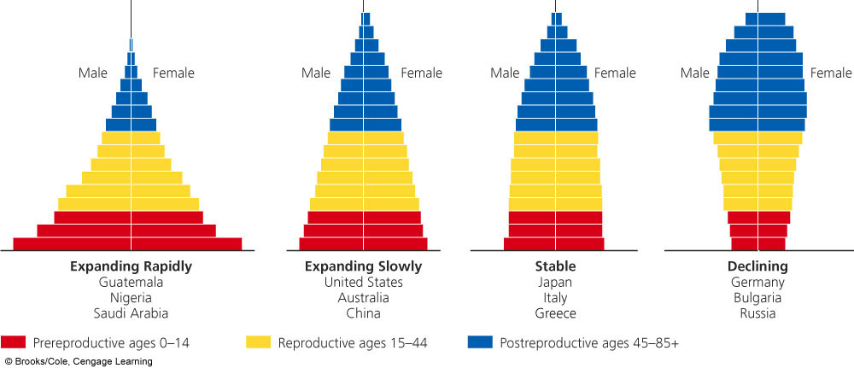
Expanding Rapidly
Expanding Slowly
Stable
Declining

Name 3 problems that can occur when populations rapidly decline.
1. Can threaten economic growth
2. Labor shortages
3. Can reduce government revenues with fewer workers

6-4: How Can We Slow Human Population Growth?
Demographic Transition: shows the stages of population growth; as countries become more industrialized, first their death rates and then their birth rates decline

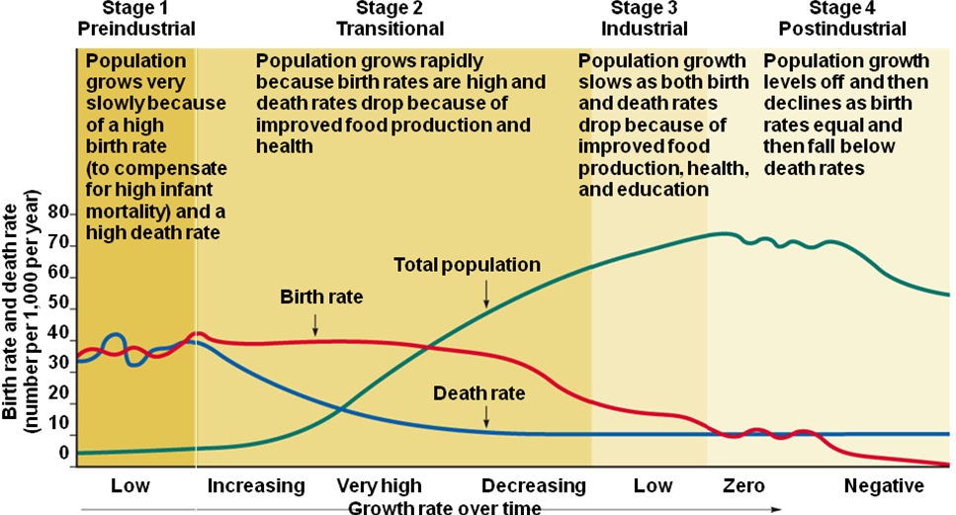

What does family planning involve and how can it reduce population growth?
Family Planning- education and clinical services to help a couple choose how many children to have and when to have them
-major factor in reducing the # of births throughout the world
-has reduced the # of legal and illegal abortions
-responsible for a 55% drop in TFR in developing countries

How does empowering women reduce population growth?
Women tend to have fewer children if they are educated, hold a paying job outside the home, and live in societies where their human rights are not oppressed.

Case Study: What is China’s One Child Policy?
Goal- bring population growth under control and encourage economic growth
*Discourages premarital sex and urges people to delay having kids.
*Married couples who pledge to have only 1 child receive more food, larger pensions, better housing, free school tuition, and preferential employment.
Results-
TFR has decreased from 5.7 to 1.6
350 million+ people have moved from extreme poverty to middle class
Negative Effects-
Since there is a strong preference for a male child, there have been many abandoned or murdered baby girls. Some of the girls are sold.
There have also been reports of forced abortions and other coercive actions.

