CHAPTER 14 Geology and Nonrenewable Resources

Core Case Study: Environmental Effects of Gold Mining
- 6 tons of mineral waste is created to make 2 gold wedding rings!
- What is cyanide heap leaching and why is it so harmful?
This is a mining technology in which mountains are leveled in order to extract gold. To extract the gold, miners spray a solution of highly toxic cyanide salt onto open air piles of rock. The solution drains into the storage ponds and the gold is removed.

In 2000, snow and heavy rains washed out a dam at one of the cyanide leach ponds at a gold mine in Romania. This released large amounts of cyanide laced water which contaminated food supplies and killed thousands of fish and aquatic plants.

14-1: What Are the Earth’s Major Geological Processes and Hazards?
Define: Geology- study of the earth’s surface and interior
Crust- contains oceanic and continental crust, Oxygen is the most abundant element here
Label and define the 3 major concentric zones
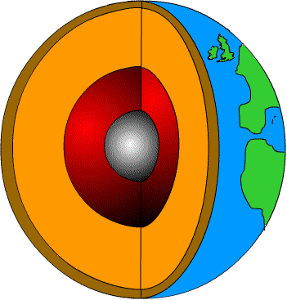
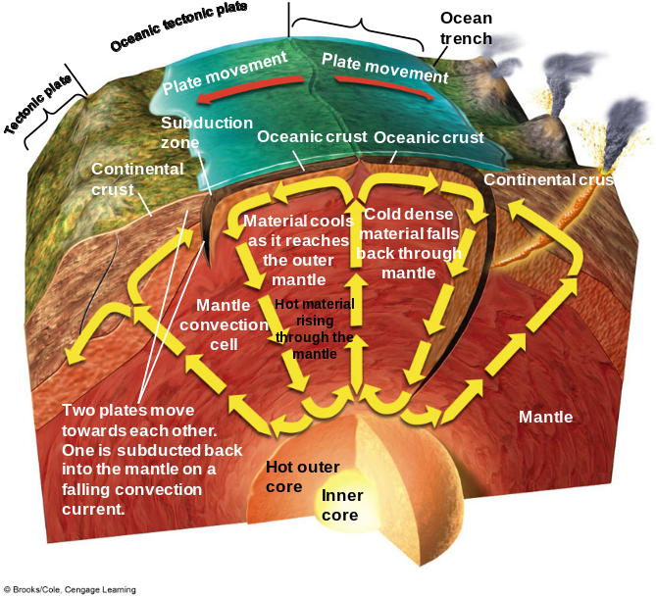
Mantle- mostly solid rock; includes the asthenosphere- partially melted rock
Core- extremely hot, has a solid inner core, and a liquid outer core

Convection Cells moves large volumes of rock and heat in loops within the mantle.
-Magma cools as it reaches the outer mantle
and then falls toward the core.
-Magma heats back up near the core and
rises toward outer mantle again.

Tectonic plates move very slowly atop the denser mantle on hot soft rock. The plates are composed of continental crust, oceanic crust, and the outermost part of the mantle= lithosphere

What happens when…

oceanic plates move apart from one another: | an oceanic plate collides with a continental plate: | two continental plates collide: | continental plates slide past one another
DIVERGENT PLATE- magma flows up through the resulting cracks  Results in oceanic ridges | CONVERGENT PLATE-  When an oceanic plate collides with a continental plate, the continental plate rides up over the denser oceanic plate; oceanic plate melts= SUBDUCTION  Results in a trench | CONVERGENT PLATE- two continental plates collide  Results in the formation of mountain ranges | TRANSFORM FAULT- plates grind against one another  Results in earthquakes

Internal Geological Processes- generated by heat from the earth’s interior and typically build up the earth’s surface in the form of continental and oceanic crust.
Ex: mountains and volcanoes

External Geological Processes-driven by energy from the sun (flowing water and wind) and influenced by gravity tend to wear down the earth’s surface.
Ex: Weathering- breaks rocks into smaller pieces to build soil
Erosion- material is loosened or worn away and deposited elsewhere
*Glaciers also cause erosion when they moved down a mountainside

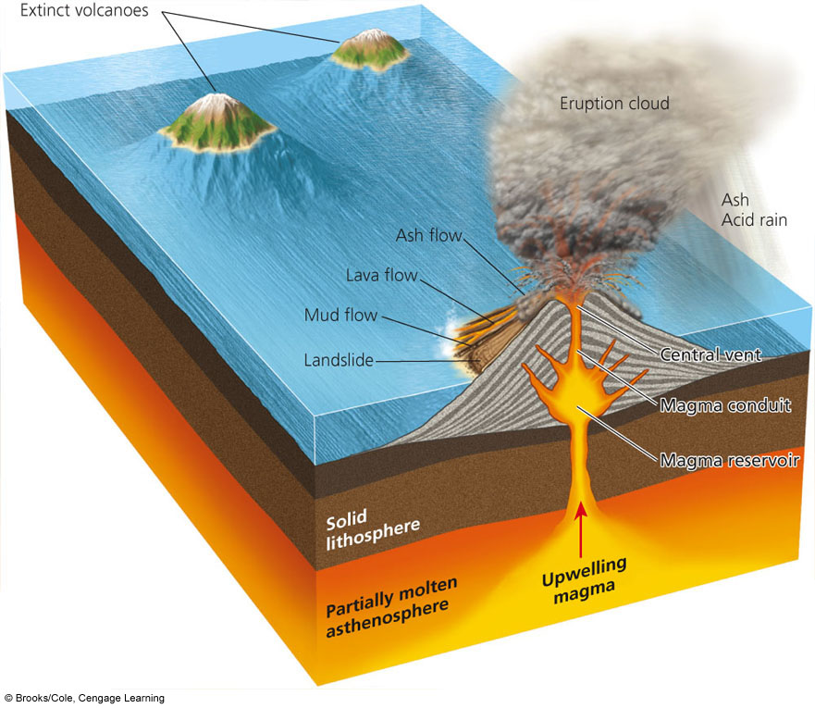
VOLCANOES
- form from tectonic plate movement (convergent and subduction) and usually found along boundaries of tectonic plates
- occurs when magma reaches earth’s
surface through a central vent, or fissure
- lava= magma that reaches the earth’s surface
- eruption releases large chunks of lava, liquid
lava, ash, gases like CO₂ and SO₂
- benefit: highly fertile soil from the weathering of lava

- 1991- Mount Pinatubo- reduced solar energy and cooled atmosphere for 15 months
- 1980- Mount St. Helen’s- worst in history

**What is the RING OF FIRE and why does it exist?
Ring of volcanoes around the Pacific Ocean

EARTHQUAKES
- Cause: forces inside the earth’s mantle and along its surface push, deform, and stress rocks; at some point the stress causes the rocks to suddenly shift or break to produce transform faults; energy that has accumulated over time is released

Define: Seismic Waves- vibrations when
energy is released

Focus- where the earthquake begins
below the surface

Epicenter- on the earth’s surface
above the focus

Magnitude- the severity of earthquakes

Amplitude- size of the seismic waves

Seismograph- instrument used to measure
amplitude

Richter Scale- scale to measure magnitude of
earthquake; each unit is 10x greater
than the previous unit

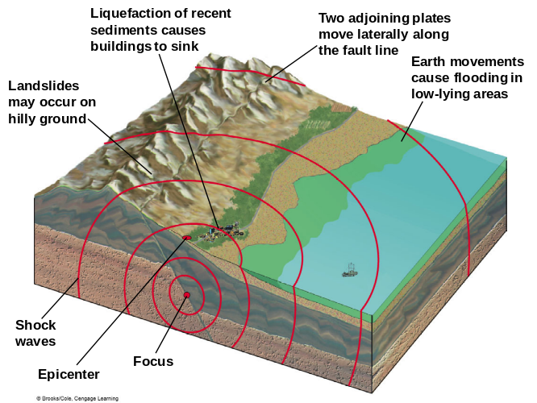

Effects of earthquakes:
shaking, displacement of the
ground and infrastructure

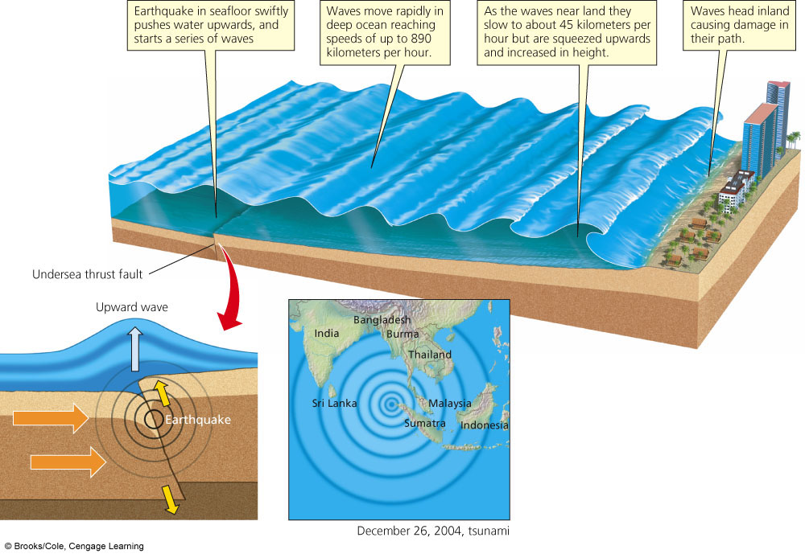
TSUNAMIS
- series of large waves generated when the ocean
floor suddenly rises or falls or underwater earthquake
- detected by ocean buoys
- Dec 2004- tsunami in Indian Ocean, earthquake had a magnitude of 9.15 and waves 100 ft high
  - Mangrove Forests- reduced death toll by protecting buildings and people from force of the waves

14-2: How Are the Earth’s Rocks Recycled?
Mineral- element or inorganic compound that occurs naturally as a solid
EX: gold, silver, diamonds, sodium chloride

Rock-solid combination of one or more minerals
EX: limestone, quartz
3 Major Types of Rocks:
Sedimentary Rock | Igneous Rock | Metamorphic Rock
Made of sediments- dead plant and animal remains and existing rocks that are weathered  Sediments are transported and accumulate in layers  EX: shale, sandstone, limestone, bituminous coal | Forms below or on the earth’s surface when magma wells up from the upper mantle or deep crust and then cools or hardens  Makes up the bulk of the earth’s surface  EX: granite, lava rock | Forms when preexisting rock is subjected to high temperatures and high pressure  EX: anthracite coal, slate, marble
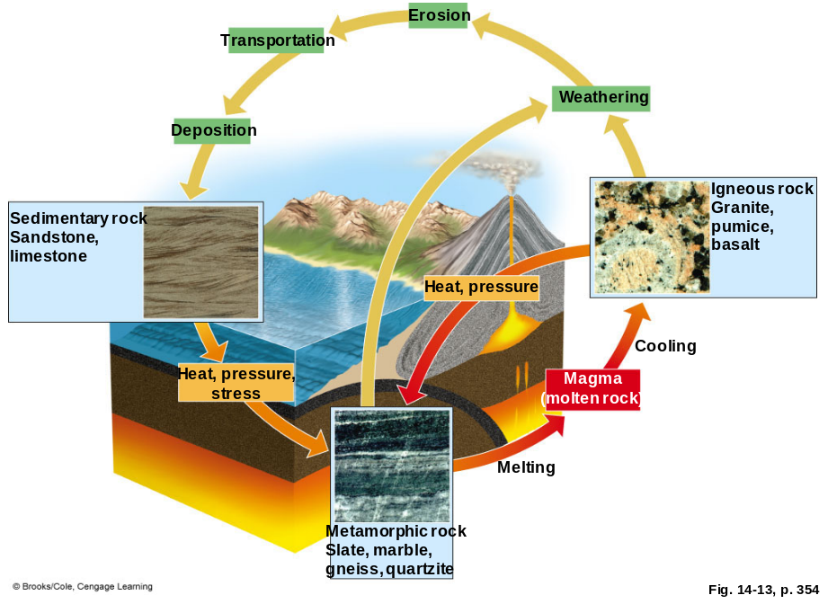

ROCK CYCLE
- chemical and physical processes

that change rocks from one type to
another
- recycles the Earth’s 3 types of
rocks over millions of years
- slowest of all earth’s cyclical
processes

14-3: What Are Mineral Resources & What Are the Environmental Effects of Using Them?

Mineral Resources- concentration of naturally occurring material that can be extracted and processed into useful products or raw materials at an affordable cost
EX: fossil fuels, metallic minerals (aluminum, iron, and copper), non-metallic minerals (sand, gravel, limestone)

High Grade Ore:  Contains large amounts of the desired resource | Ore- rock that contains large enough concentration of a particular mineral (usually metal) to make a profit | Low Grade Ore:  Contains a small amount of the desired resource

Describe how each is a part of our lives:

Aluminum | Packaging, cans, aircrafts
Manganese, Cobalt, and Chromium | Steel alloys in lightbulbs, computers, cars
Copper | Conductor of electricity
Platinum | Electrical equipment, car pollution control converter
Gold | Electrical equipment, jewelry, medical implants
Sand | Glass, bricks, concrete
Limestone | Roads, concrete, cement
Phosphate salts | Inorganic fertilizers and some detergents

Mineral Resource Reserve- estimate of a mineral resource’s supply based on ability still be profitable at current prices.

Fill in the typical life cycle of a metal resource:
Surface Metal Ore Separate Smelting Melting Conversion Discard
Mining Ore Metal to product product

Advantages: | Mineral Use | Disadvantages:
-significant income  -generates taxes  -employment  -useful products | Mineral Use | -uses a large amount of energy  -disturbs land  -erodes soil  -produces solid waste  -creates air and water pollution

Types of Mining

- Surface Mining | - Gigantic equipment strips away the overburden- the soil and rock overlying a mineral deposit  *Deposited as a waste material called gangue, tailings, or  spoils  - Used to extract 90% of nonfuel minerals and 60% of coal in the US
- Open Pit Mining | - Type of surface mining where machines dig holes and remove ore, sand, gravel, and stone
- Strip Mining | - Extract deposits that lie close to the surface in horizontal beds  *Area Strip Mining- terrain is flat and equipment  removes overburden, removes mineral deposit, and then  fill resulting trench back up with overburden.  *Contour Strip Mining- used to mine coal on  hilly or sloped terrain
- Mountain Top Removal | - The top of the mountain is removed to expose seams of coal  - Seen heavily in Appalachian Mountains
- Subsurface Mining | - Removes coal and metal ore that are deep underground  - Miners dig vertical shafts and blast open tunnels

Describe 4 ways mining is harmful to the environment:
- Scarring and disruption of the land surface- spoils and tailings are left behind that are susceptible to weathering and erosion; regrowth of vegetation is very slow because there is no topsoil; mountains have disappeared;

- Subsidence- the collapse of land above some underground mines

- Produces large amounts of solid waste- ¾ of all solid waste in the US comes from mining operations

- Water and air pollution- wind and water erosion cause toxin laced mining wastes to be deposited in areas other than mining sites; water often contains mercury, arsenic and sulfuric acid; toxic chemicals are also released into the air

  - Acid Mine Drainage-occurs when rainwater seeps through a mine or mining waste pile and carries sulfuric acid (produced when aerobic bacteria act on iron sulfide minerals) to nearby streams

Removing Metal From Ores:
Ore has two components:
- Ore Mineral- the desired metal
- Gangue- waste material which produces tailings
*Particles of toxic metals blow by the wind or leached from tailings by rainfall
can contaminate surface water and groundwater
After removal of the gangue, smelting is used to release metals from the ore.
* Smelting releases many air pollutants like SO₂ and particulates that acidify soil
and damage vegetation

Summitville Gold Mine:
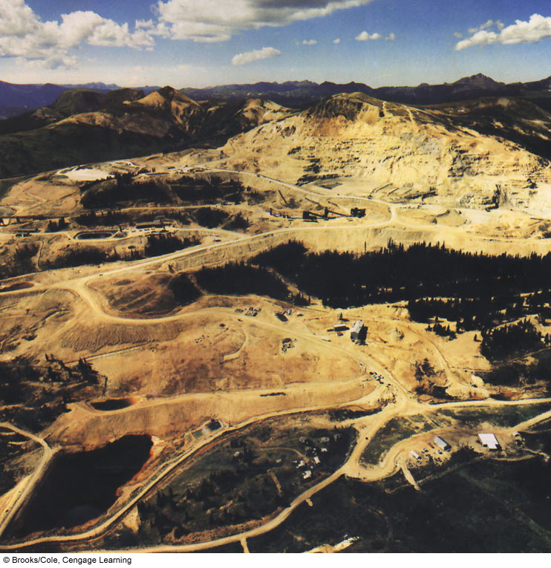
*A Canadian company used the 1872
mining law to buy the land very cheap.
*They spent $1 million to develop the site.
*They mined $98 million worth of gold…
*During the mining process, they used
highly toxic cyanide salts to
extract gold from ore.
*Then they declared bankruptcy and
walked away without cleaning anything up!

14-4: How Long Will Supplies of Nonrenewable Mineral Resources Last?
Which 5 nations supply the most nonrenewable mineral resources?
US, Canada, Russia, South Africa, and Australia

The US imports some resources (even though they can be found in US) because we
use them faster than they can be produced.
The future supply of a nonrenewable mineral depends on:
1. the actual or potential supply
2. the rate at which we use it

A mineral becomes economically depleted when it costs more than it is worth
to find, extract, transport, etc.
At this point we can do one of five things:
- recycle or reuse existing supplies 2. waste less 3. use less
4. find a substitute 5. do without (I know… crazy!)
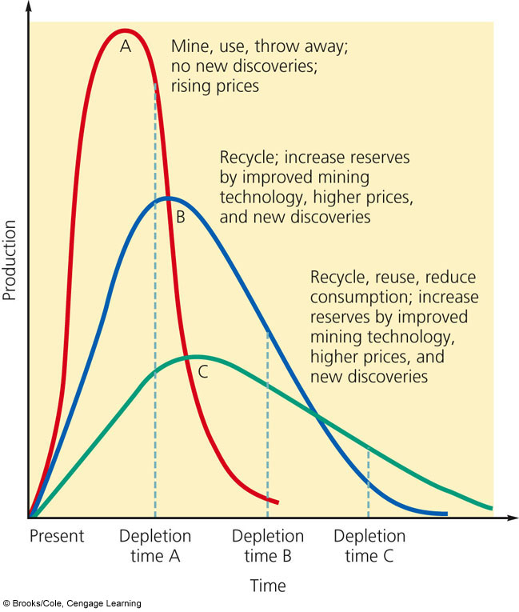

Depletion Time- time it takes to use
of 80% of the reserve at a given rate

Which curve represents the shortest
depletion time? Curve A

Which curve relies heavily on recycling or
hope that better mining technology will be
invented? Curve C

Most mineral prices are kept artificially low
because of government subsidies to
help promote economic growth.

US General Mining Law of 1872- some people have gotten rich off this little known law!
-designed to encourage mineral exploration and the mining of hard rock minerals on US lands to help develop the then sparsely populated West.
-allows people to buy land very cheap if they file a claim stating that they believe the land contains valuable minerals

Improvements for Mining:
- Extract minerals from lower grade ores to increase supplies
- Use bacteria that can extract minerals- “biomining”
- Hydrothermal ore- deposits form when super-heated water shoots out of vents in the ocean

14-5: How Can We Use Mineral Resources More Sustainably?
Materials Revolution- silicon, ceramics, and plastics are used in place of metals.
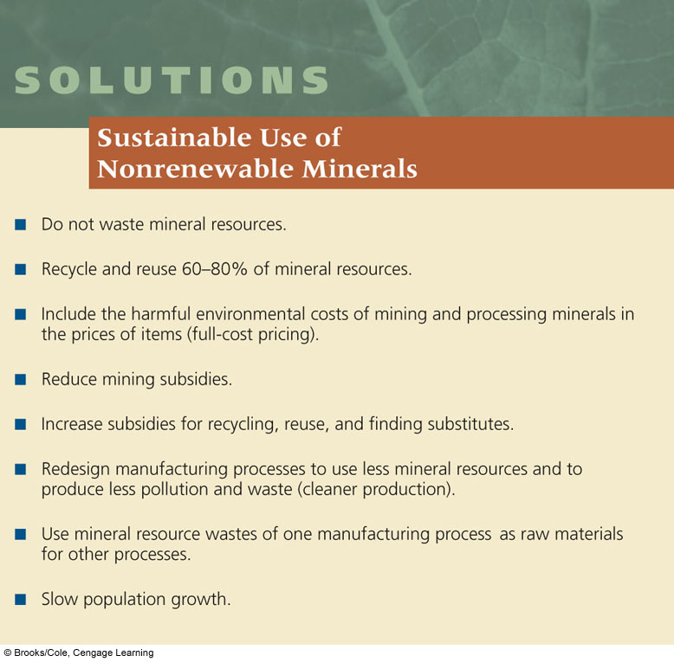
3M’s 3P Program:
- Redesigned equipment and processes
- Uses fewer hazardous materials
- Cut waste and air pollution

Mimic How Nature Deals With Waste:
-waste output becomes nutrient input for
another
-reuse or recycle mineral products
-resource exchange webs
-ecoindustrial parks- some are being
built on abandoned industrial sites,
called brownfields
-biomimicry

CHAPTER 7-1 Climate

Core Case Study: Blowing in the Wind: Connections between Wind, Climate, and Biomes
What is the general reason why some lands are deserts and others are forests?
a difference in climate, resulting mostly from long term differences in average temperature and precipitation caused by global air circulation

Wind is an indirect form of solar energy. Why is it an important factor in climate?
Wind circulates moisture, heat, plant nutrients, soil particles, and air pollutants.

Without wind, what would the Earth be like? The tropics would be unbearably hot and other regions would freeze.

Wind also transports nutrients. Give an example of why this is important.
Winds carry dust that is rich in phosphates and iron across the Atlantic Ocean from the Sahara Desert. These deposits help build agricultural soils in the Bahamas and Brazil.

Disadvantages to wind:
- Particles of iron-rich dust promote the outbreak of toxic algal blooms (red tides) in coastal waters. These red tides kill fish and contaminate shellfish, which we eat.

- Dust, soot, and other air pollutants from China are blown across the Pacific Ocean and can degrade air quality in the western US.

7-1: What Factors Influence Climate?
Weather vs. Climate
-local area’s short term -general pattern of atmospheric or weather
temperature, precipitation, conditions over a long period of time
humidity, wind speed, and cloud
cover

Climate varies in different parts of the world because of patterns of global air circulation and ocean currents distribute heat and precipitation unevenly.

3 Major factors that determine how air circulates in the lower atmosphere:
- Uneven heating of the Earth’s surface by the sun- the equator receives the greatest amount of heat

- Rotation of the Earth on its axis- the equator spins faster than the polar regions, therefore heated air masses rising above the equator and moving north and south to cooler areas are deflected to the west or east
The atmosphere over these areas are divided into huge cells distinguished by the direction of the air movement. The differing directions are called prevailing winds that help distribute air, heat, moisture, and dust.

- Properties of air, water, and land- heat from the sun evaporates ocean water and transfers heat from the oceans to the atmosphere, especially near the equator. This evaporation of water creates giant cyclical convection cells that circulate air, heat, and moisture.

Prevailing winds blowing over the ocean produces mass movements of water called currents, which redistribute heat from the sun from place to place, thereby influencing climate and vegetation.

What causes currents to flow in roughly circular patterns?
Differences in water temperature creates differences in water density.
Cold water sinks, warm water rises.
Prevailing winds and irregularly shaped continents interrupt these currents and cause them to flow in roughly circular patterns. (clockwise in the northern hemisphere and counterclockwise in the southern hemisphere)

What happens when ocean water mixes vertically in shallow and deep currents?
Colder seawater has a higher density and therefore sinks beneath warmer, less dense sea water.

This creates a connected loop of deep and shallow ocean currents that act as a conveyor belt that moves heat in the ocean.

The ocean and atmosphere are strongly linked in 2 ways:
- Ocean currents are affected by winds in the atmosphere.

- Heat from the ocean affects atmospheric circulation.

Describe El-Nino (ENSO event) and what it causes.
El Nino is a large scale weather phenomenon that occurs every few years when the prevailing winds in the Pacific Ocean weaken and change direction.
Result: The resulting above-average warming of Pacific waters can affect populations of marine species by changing the distribution of plant nutrients. It also alters the weather by bringing more rain in some areas and drought in other areas.

The Earth’s air circulation patterns, prevailing winds, and configuration of continents and oceans result in six giant convection cells. What do these do?
Warm, moist air rises and cools. Cool, dry air sinks.

Small amounts of gases like water vapor, CO₂, CH₄, and N₂O play a role in determining the Earth’s average temperature and climates.
These gases are called greenhouse gases because these gases hold in heat from the sun.

What would the Earth be like without the natural greenhouse effect?
The earth would be too cold for our survival.

The problem occurs when human activities like burning fossil fuels and burning forests
release more greenhouse gases into the atmosphere. This human enhanced global warming could cause climate changes in various places on earth, altered precipitation patterns, a shift in areas where crops can be grown, a rise in average sea level, a shift in habitats, and even a spread in habitat area of disease causing insects.

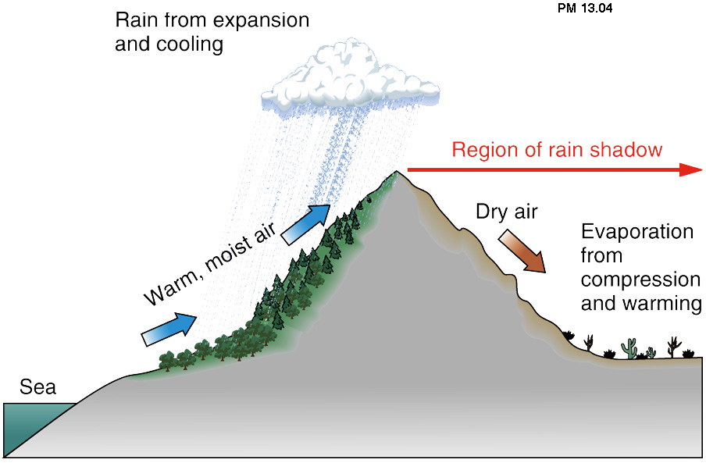
What creates sea breezes?
Heat is absorbed and released more
slowly by water than land. This difference
creates sea breezes.

Rainshadow Effect-
How do mountains affect weather and climate?
When moist air blowing inland from the
ocean hits a mountain, it is forced upward.

As it rises, it cools and expands and loses
Its moisture as rain or snow on the
windward side of the mountain.

As the drier air mass passes over the mountain it flows down the leeward side of the mountain, warms up, and sucks the moisture from plants and soil, resulting in a semi-arid region on this side of the mountain.

CHAPTER 13 Water Resources

Core Case Study: Water Conflicts in the Middle East
- Why are Ethiopia, Sudan, and Egypt fighting over water?
These countries face water shortages and there is tension over the water they must share from the Nile River. Egypt draws from the river a lot because of very little rainfall. Ethiopia and Sudan plan to divert some of the water from the Nile to meet water and food needs of its growing population. Upstream diversion would reduce the water available downstream.

- How can their conflicts be solved?
Negotiations on water agreements, slowing population growth, cutting waste water, raising water prices to encourage the improvement of irrigation efficiency, and increasing grain imports

13-1: Will We Have Enough Usable Water?
Why is access to water a global health issue?
The lack of water that is safe for drinking and sanitation is the world’s largest cause of illness. 1.6million+ people die each year from preventable waterborne diseases.

Why is access to water an economic issue?
Water is a vital for reducing poverty and producing food and energy.
Women & children are often the ones responsible for finding water in poor countries.

Why is access to water an environmental issue?
Excessive withdrawal of water from rivers and aquifers and pollution of water results in lower water tables, lower river flows, shrinking lakes, losses of wetlands, declining water quality, declining fish populations, species extinction, and degradation of ecosystem services.

What percentage of freshwater can we readily use? 0.024%

Define: Groundwater- precipitation that has infiltrated the ground and percolates
downward through spaces in soil, gravel, and rock until an
impenetrable layer of rock stops it
Zone of saturation- the spaces in soil that are completely filled with water
Water table- top of the groundwater zone
Aquifer- underground caverns and porous layers of sand, gravel, and bedrock
through which groundwater flows very slowly
How do aquifers recharge?
- Natural recharge- replenished by rain that percolates the soil
- Lateral recharge- rivers and streams replenish from the side
Surface water- rivers, streams, lakes, wetlands, estuaries, ocean
Surface runoff- precipitation that does not infiltrate the ground
Watershed (drainage) basin- the land from which surface water drains
Using Figure 13-3, what is the difference between a confined and unconfined aquifer?
Unconfined Aquifer- aquifer with a permeable water table
Confined Aquifer- bounded above and below by less permeable beds of rock

70% of withdrawn water is used to irrigate cropland.
20% of withdrawn water is for industry
10% of withdrawn water is for city and residential use

Where does most of our water get used:

EAST COAST |  | WEST COAST
Energy production, power plant cooling, manufacturing | MAJOR USE(S) FOR WATER | Irrigation of crops
Flooding, occasional urban shortages, occasional droughts | MAJOR WATER PROBLEM(S) | Shortages caused by low precipitation, high evaporation, and recurring droughts

Define: Drought- prolonged period in which precipitation is at least 70% lower and
evaporation is higher than normal

Water hotspot- areas in which competition for scarce water could trigger political and legal conflicts

According to figure 13-5, how many western states have water hotspots? 17
List the harmful environmental effects of long-term severe drought:
. dries out soil
. reduces stream flow
. decreases tree growth and biomass
. lowers NPP
. reduces crop yield

85% of Americans get their water from public utilities
What are 2 potential problems with full privatization of water resources?
- Private companies may ignore conservation methods in order increase profits.
- The poor will often have to go without water.

13-2: Is Extracting Groundwater the Answer?
Aquifers provide drinking water and irrigation water for farmers.

Why are water tables are falling in many areas of the world?
The rate of pumping water from the aquifers exceeds the rate of natural recharge.

Advantages | Withdrawing Groundwater | Disadvantages
- Useful drinking and irrigation  - Available year round  - Renewable if not over-pumped  - No evaporation losses | Withdrawing Groundwater | - Depletion from over-pumping  - Land subsidence  - Aquifers polluted  - Saltwater intrusion

Describe the problem of groundwater depletion in the United States, especially over the Ogallala aquifer.
Water is being pumped faster than it can be recharged. The Ogallala Aquifer is underneath 8 Midwestern States that constantly pumps massive amounts of water for irrigation.

List some other harmful effects of overpumping aquifers.
- Limits future food production
- Increased costs associated with the need for deeper wells, bigger pumps, and more electricity
- Land subsidence- sinkholes → damages roadways and buildings

Describe two ways to prevent or control groundwater depletion.
1. Waste less water
2. Set and enforce minimum stream flow levels

13-3: Is Building More Dams the Answer?
The main goal of a dam and reservoir system is to:
Capture and store runoff and release it as needed to control floods, generate electricity, and supply water for irrigation.

Advantages | Dams and Reservoirs | Disadvantages
- Provides irrigation water  - Provides drinking water  - Recreation and fishing  - Can produce cheap electricity (hydroelectricity)  - Reduces downstream flooding | Dams and Reservoirs | - Flooded land destroys forests and displaces people  - Large losses of water through evaporation  - Deprives downstream cropland of nutrient rich silt  - Disrupts migration and spawning of some fish

Describe some problems associated with the use of the Colorado River Basin.
- The Colorado River Basin includes some of the driest lands in the US and Mexico.
- Modest flow of water
- Legal pacts signed in 1922 allocated more water for human use than the river can supply.
- Since 1950, the amount of water flowing to the mouth of the Colorado River has dropped dramatically.
- The water available is likely to decrease more due to global warming.

Advantages | China’s Three Gorges Dam | Disadvantages
- Can supply a large amount of energy  - Helps hold back floodwaters from the Yangtze River  - Provides cheaper transportation routes for cargo | China’s Three Gorges Dam | - Displaced over 5 million people  - A large area had to be flooded for the construction of the dam  - Downstream farming areas will no longer receive nutrient rich sediments  - Many worry it will collapse because it is built on a seismic fault

13-4: Is Transferring Water from One Place to Another the Answer?
Describe the California Water Project and the controversy over this water transfer project.
-uses a maze of dams, pumps, and aqueducts to transport water from the water-rich northern California to the water-poor southern California’s heavily populated agricultural regions and cities

Arguments:
-sending water to the south degrades northern fisheries and reduces the river’s power to flush out pollutants
-however, sending water to the south will help support food production

Describe the Aral Sea Disaster.
-the shrinking Aral Sea is the result of a large scale water transfer project in the former Soviet Union
-since 1960, water has been transferred inland for agriculture
-this large scale water project has caused regional ecological and economic disaster
-the sea’s salinity has risen 7fold
-water levels have dropped by 72 feet
-89% of the volume of water has been moved
-turbidity of the water has increased
-deadly bacteria has contaminated the water

Describe China’s South-North Water Transfer Project.
-China has plans to transfer water from 3 southern river basins to its populous and dry northern regions

Concerns:
-the polluted southern waters will pollute the northern waters
-the southern ecosystems, especially wetlands, will be degraded

13-5: Is Converting Salty Seawater to Freshwater the Answer?
Define: Desalination- removing dissolved salts from ocean water or from brackish (slightly
salty) water in aquifers or lakes for domestic use

Saudi Arabia has the largest number of desalination plants.

Distillation | Methods For Desalinating Water | Reverse Osmosis
- Heating saltwater until it evaporates (leaving behind the salt) and condenses as freshwater | Methods For Desalinating Water | - Uses high pressure to force saltwater through a membrane filter with pores small enough to remove the salt

What are the limitations of desalination and how might they be overcome?
- High cost and large energy footprint
- Many marine organisms are killed during the process of pumping in the sea water.
- Produces a large quantity of brine (wastewater that contains a lot of salt) and dumping this back into the ocean increases the salinity at the dump site

13-6: How Can We use Water More Sustainably?
65-70% of the world’s water is wasted unnecessarily.
List two causes of this waste:
- evaporation
- leaks

Main causes of water waste:
- Low cost to users because of government subsidies
- Lack of government subsidies to improve efficiency for water use

Describe four irrigation methods. Sketching a picture of each may be helpful.
- Flood Irrigation- large amounts of water are pumped onto the land and gravity causes the water to flow through the field
**much more water is used than needed and about 40% is lost to evaporation
**this is the least efficient type of irrigation method

- Center Pivot Sprinklers- uses pumps to spray water on a crop in circular irrigated areas
**20% of water is lost to evaporation

- Low Energy Precision Application (LEPA) Sprinklers- another form of center pivot sprinklers that is even more efficient
**10% of water is lost to evaporation

- Drip Irrigation- consists of a network of perforated plastic tubes installed at the ground level, small holes deliver drops of water precisely to the crop
**only about 5% of water is lost due to evaporation
**this is the MOST efficient method

Describe ways you can reduce your own water waste.
-Use water saving toilets
-repair water leaks
-wash only full loads of clothes
-use recycled water (gray water) for watering lawns, houseplants, and washing cars
-water lawns only in the early morning or evening

13-7: How Can We Reduce the Threat of Flooding?
Floodplain:
What makes an area a floodplain? | Advantages of living on a floodplain. | Disadvantages of living on a floodplain. | How are humans making it worse?
Includes highly productive wetlands that help provide natural flood and erosion control, maintain high water quality, and recharge groundwater | -fertile soil  -ample water for irrigation  -nearby rivers can be used for transportation  -recreation area | -floods kill thousands each year  -possible property damage | -removal of water absorbing vegetation has led to severe flooding  -removing mangrove forests have increased flooding and damage from storms  -building on floodplins

Describe why Bangladesh is a dangerous place to live.
-massive flooding takes place every years or so and is intensified by deforestation, overgrazing, and unsustainable farming
-storm surges, tsunamis, and cyclones occur frequently as well

Describe two ways to reduce flood damage:
- Preserve forests and wetlands

- Build levees and dams

Soil- pg 281 in textbook, however we will cover this is in class.
Soil is a mixture of:
1. eroded rock 4. water
2. mineral nutrients 5. air
3. decaying organic matter 6. decomposers
Soil formation begins when bedrock is slowly broken down by these 3 types of weathering:
- Chemical Weathering- CO2, SO2, and some nitrogen compounds create an acid when mixed with water; acid react with rock and break it down
- Biological Weathering- mosses and lichen form a weak acid that dissolves rock, tree roots wedge in between rocks causing a breakdown
- Mechanical Weathering- rock is broken down physically by expansion of ice, erosion, geological movement, and from the effects of temperature causing slight expansion
Example tests that can be done on soil:
Chemical Physical
-pH -Porosity
-Salinity -Permeability
-N, P, K -Texture/Color
Soil is a key component of earth’s natural capital.
Importance of soil:
1. supplies nutrients for plant growth
2. purifies and stores water
3. removes carbon from atmosphere
Soil Type | Texture | Permeability | Porosity
Sand
Silt


Clay

Define:
Soil Profile- soil type, texture, and
composition
Soil Horizons- layers of soil

O Horizon- Organic layer, leaf litter
A Horizon- topsoil, bacteria, fungi
B Horizon- subsoil, inorganic matter C Horizon- parent material, bedrock

Humus- aka O Horizon

Porosity- space (pores) within soil
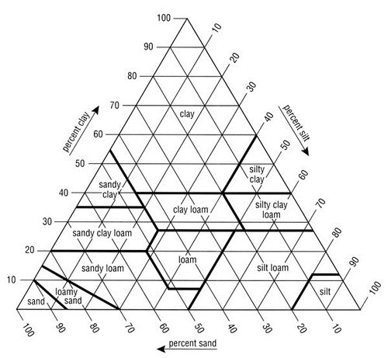

Permeability- how quickly water
passes through

Soil Triangle Practice:
- 20% clay, 40% sand, 40% silt = ________
- 10% clay, 70% sand, 20% silt = ________
- 50% clay, 20% sand, 30% silt = ________
- 35% clay, 30% sand, 35% silt = ________
- 15% clay, 70% sand, 15% silt = ________

