**CHAPTER 12 Food, Soil, and Pest Management**

**Core Case Study: Golden Rice: Grain of Hope or an Illusion?**

1. Poor children (especially in Africa and Southeast Asia) that lack Vitamin *A* are likely to go blind and are susceptible to common infectious diseases.
2. In 1999, how did scientists, Potrykus and Beyer, help solve this problem?

*-genetically engineered rice by transferring DNA from daffodils and a soil bacterium into the rice so that it would contain more beta carotene (which the body can convert to Vitamin A)*

*-by eating 1 cup of the rice a day, it will prevent blindness and protect against diseases*

**12-1: What is Food Security and Why Is It Difficult to Attain?**

Is there enough food in the world for everyone to have food security? *Yes, we produce more*

*than enough food for everyone, but 1 out of 6 go hungry.*

What is the root cause of food insecurity? *Food insecurity is living with chronic hunger and*

*malnutrition. The root cause of it is poverty. Political corruption and war are also reasons.*

To maintain good health, you need macronutrients and micronutrients:

|  |  |  |
| --- | --- | --- |
| **Macronutrient** | **Food Source** | **Function/Importance** |
| *Proteins* | *animals and some plants* | *build and repair body tissue* |
| *Carbohydrates* | *wheat, corn, rice* | *short term energy* |
| *Lipids (fats, oils)* | *animal fats, nuts, oils* | *build tissues, create hormones* |

Micronutrients include *vitamins* & *minerals.*

Consequences of undernutrition(chronic hunger) include

1. *mental retardation*

2. *stunted growth*

3. *dying from infectious diseases*

Complications from malnutrition (an unbalanced diet)

Too little Iron= *anemia (fatigue, blood can effectively carry oxygen, prone to disease)*

Too little Vitamin A= *blindness, prone to disease*

Too little Iodine: *stunted growth, goiter, mental retardation*

Famine (crop failures) leads to starvation, economic chaos, and social disruption

Occur from *drought, war, or other catastrophic events*

Results in *mass migration to other areas or refugee camps*

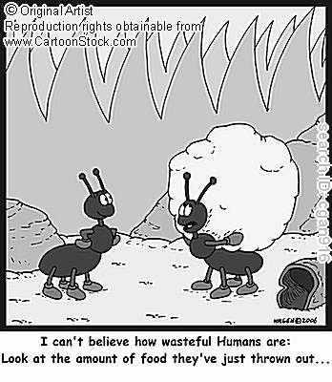

Consequences of Overnutrition

1. *lower life expectancy*

2. *susceptibility to disease*

3. *lower productivity and life quality*

*1* billion people are sick because they do not eat enough,   
*1.6* billion people are sick because they eat too much.

Annual Costs:

Money spent annually by Americans on weight loss: 50 billion

Projected cost per year to eradicate world hunger: 24 billion

**12-2: How Is Food Produced?**

Three systems produce most of our food

1. *Croplands produce grains* (77% of our food)

2. *Rangelands, pastures, and feedlots produce meat* (16% of our food)

3. *Fisheries and aquaculture* (7% of our food)

The three main grains worldwide are *wheat, rice, and corn.*

2/3 of the world’s people survive primarily on these 3 grains.

Risk: This type of food specialization makes the world vulnerable should these crops

fail due to *disease, environmental degradation, and climate change*.

Types of Agriculture:

1. High Input (Industrialized) Agriculture (produces 80% of our food)

Uses *heavy equipment*

Requires large inputs of: *financial capital, water, fossil fuels, fertilizers, and pesticides to grow monocultures (a single crop)*

Main goal is to *increase yield.*

Forms of Industrialized Agriculture:

|  |  |
| --- | --- |
| Plantation Agriculture | Greenhouses |
| *-used in tropical, developing countries*  *-grows cash crops like bananas, soybeans, sugarcanes, palm oil, etc*  *-grown mostly for export to developed countries*  *-these monocultures increase yield, but decrease biodiversity* | *-intended to make arid land more productive*  *-requires large inputs of water and energy to move water to these dry regions*  *-extensive and rapid development of greenhouse production on the south coast of Spain*  Hydroponics- more water efficient because plants are grown with roots in troughs of recycled water inside a greenhouse |

1. Low Input (Traditional) Agriculture

|  |  |
| --- | --- |
| Subsistence Agriculture | Intensive Agriculture |
| *-uses mostly human labor and draft animals to produce only enough food for the family* | *-increase inputs of human and draft animal labor, fertilizer, and water to obtain higher yields*  *-if possible, they produce enough food for their family and to sell for income* |

Why is it a good idea for farmers to grow polycultures (several crops on the same plot)? *The biodiversity reduces the chances of losing most or all of the year’s food supply to pests, bad weather, etc.*

Slash and Burn Agriculture involves *burning* and clearing small plots of land, growing a *variety* of crops for a few years until the soil is *depleted of nutrients*, and then shift to another plot. Polyculture with slash and burn agriculture can *reduce the need for fertilizers and pesticides.*

The Green Revolution

Goal: *increase food production by using high input agriculture*

1. Requirements:
2. *Develop and plant monocultures of selectively bred or genetically engineered varieties of crops like rice, wheat, and corn*

*2. Produce high yield by using a lot fertilizer, pesticides, and water*

*3. Increase the number of crops grown per year through multicropping*

The Second Green Revolution (since 1967)

*-fast growing, dwarf varieties of rice and wheat have been introduced in India and China to produce more food on less land*

*-protects biodiversity by saving large areas of forests, grasslands, wetlands, etc.*

Grain production has *tripled* due to the two Green Revolutions.

Genetic Engineering:

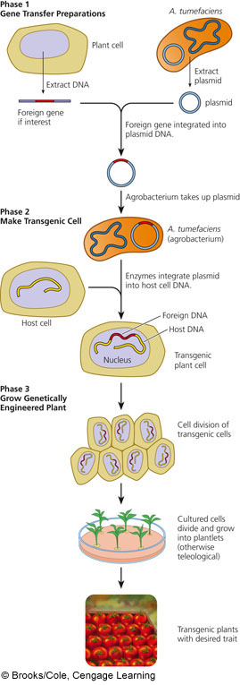

First Gene Revolution- *cross breeding and artificial*

*selection to improve crops*

Problems with traditional artificial selection

to get better varieties of food

*1. slow process*

*2. varieties remain useful for only 5-10*

*years before pests & diseases adapt*

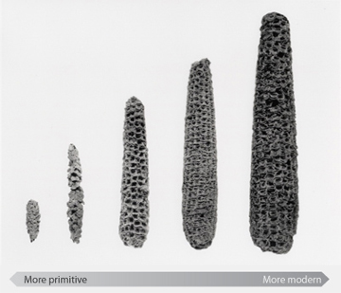

Second Gene Revolution- *use genetic engineering*

*to improve varieties by adding, deleting,*

*or changing segments of DNA to produce*

*desirable traits or eliminate undesirable*

*traits*

Scientists can *transfer genes* between species

that don’t interbreed and results in

*genetically modified organisms (GMOs).*

Meat Consumption:

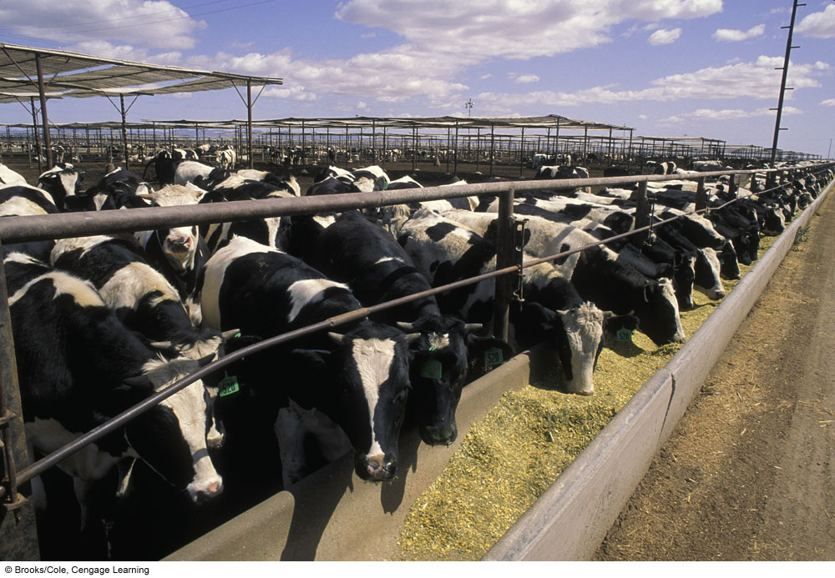

Livestock is raised in *rangelands/pastures* or

*feedlots (confined animal feeding operations (CAFOs).*

CAFOs (feedlots)- *livestock is fed with grain or fish in a*

*very small and crowded area*

Meat production has increased *fourfold* between 1961 and 2007.

Demand for meat will increase as *affluence increases*.

This will require more *grain imports* for feed.

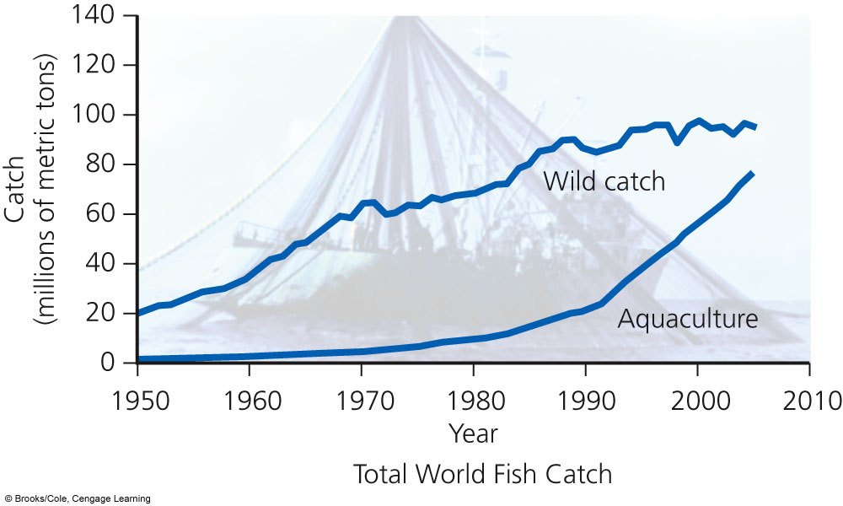

Fish and Shellfish Production:

Fishery- *concentration of certain aquatic species suitable*

*for commercial harvesting in a given ocean area*

*or inland body of water*

Aquaculture- *raising marine and freshwater fish in ponds*

*and underwater cages*; aka fish farming

Why is aquaculture sometimes called the blue revolution? *It is the world’s fastest*

*growing type of food production in which fish and shellfish are raised instead*

*of hunted*

Aquaculture mostly raises *herbivorous* species, so water is pumped with *manure and*

*other agricultural waste* to promote *phytoplankton growth* to use as feed. *Grain and fishmeal* is also used as feed.

This could be a problem because there is growing *competition* for these

resources between *food and biofuel producers*. This could limit the

production of aquaculture.

**12-3: What Environmental Problems Arise From Food Production?**

Using Figure 21-9, describe 5 major harmful environmental effects of food production.

|  |  |  |  |  |
| --- | --- | --- | --- | --- |
| Biodiversity Loss | Soil | Water | Air Pollution | Human Health |
| *-loss and degradation of grasslands, forests, and wetlands*  *-fish kills from pesticide runoff*  *-killing wild predators to protect livestock*  *-loss of genetic diversity when replaced by monoculture* | *-erosion*  *-loss of fertility*  *-salinization*  *-waterlogging*  *-desertification* | *-water waste*  *-aquifer depletion*  *-increased runoff, sediment pollution, flooding*  *-pollution from pesticides and fertilizers*  *-algal blooms and fish kills from fertilizer runoff* | *-greenhouse gas emissions (CO2) from fossil fuel use*  *-greenhouse gas emissions (N2O) from inorganic fertilizers*  *-greenhouse gas emissions (CH4) by cattle* | *-nitrates in drinking water (blue baby)*  *-pesticide residues in drinking water and food*  *-contamination of drinking and swimming water from livestock waste*  *-bacterial contamination* |

What is soil erosion and what causes it? *Movement of soil*



*components (mostly leaf litter and topsoil by the*

*actions of wind and water*

Two Major Harmful Effects of Soil Erosion:

1. *Loss of soil fertility through depletion of plant*

*nutrients in topsoil*

1. *Water pollution in the form of sediment* pollution

What is desertification?

*Occurs when the productive potential of soil*

*falls due to prolonged drought and human activities*

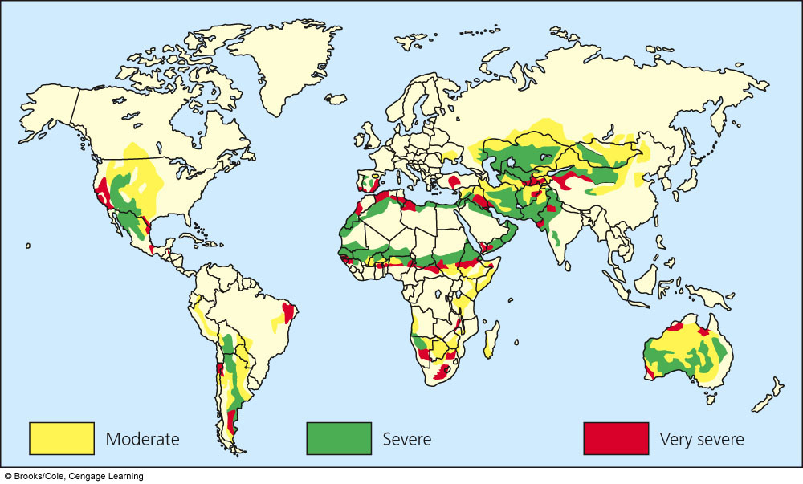

Irrigated cropland has tripled since 1950. Irrigation water is a dilute solution of natural *salts.*

Irrigated water that isn’t absorbed is *evaporated, leaving behind the salts.*

Problems with excessive Irrigation:

|  |  |
| --- | --- |
| Salinization | Waterlogging |
| *-occurs from repeated application of irrigated water in dry climates*  *-gradual accumulation of salts in soil layers*  *-stunts crop growth, lowers crop yield, and can ruin the land* | *-occurs when water accumulates underground and gradually raises the water table*  *-farmers often apply large amounts of water to leach salt deeper into the soil, and without proper drainage waterlogging occurs and envelops the deep roots of plants*  *-lowers productivity of crops* |

Industrialized Food Production Requires Huge Inputs of Energy:

Industrialized food production requires about *17%* of commercial energy in the US.

When considering the energy needed to grow, store, process, package, transport,

refrigerate, and cook all plant and animal food, about *10 units of nonrenewable energy are needed to put 1 unit of energy on the table.*

|  |  |  |
| --- | --- | --- |
| Advantages | Genetically Engineered  Foods  (aka GM foods) | Disadvantages |
| *-need less fertilizer*  *-need less water*  *-more resistant to insects, disease, frost, and drought*  *-grows faster*  *-can grow in slightly salty soils*  *-less pesticides*  *-tolerate higher levels of herbicides*  *-higher yields*  *-less spoilage* | *-irreversible and unpredictable genetic and ecological effects*  *-harmful toxins in food from possible cell mutations*  *-new allergens in food*  *-lower nutrition*  *-increase in pesticide resistant insects and plant diseases*  *-can harm beneficial insects*  *-lower genetic diversity* |

How does growing corn in the Midwest for ethanol production decrease production of

seafood in the Gulf of Mexico?

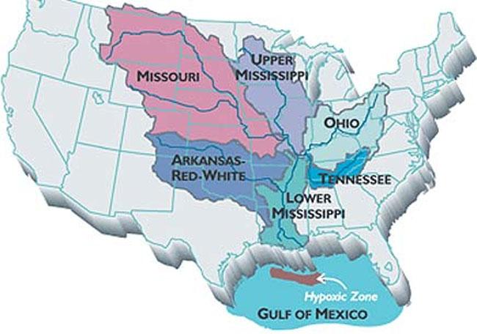

This all has to do with cultural eutrophication.

*The fertilizer used in the Midwest to produce*

*corn runs into the Mississippi and Ohio River*

*and end up over-fertilizing the Gulf of Mexico,*

*which creates a dead zone. This threatens 1/5*

*of the nation’s seafood yield.*

Industrialized Meat Production:

|  |  |  |
| --- | --- | --- |
| Advantages | Animal Feedlots | Disadvantages |
| *-increased meat production*  *-higher profits*  *-less land use*  *-reduced overgrazing*  *-reduced soil erosion*  *-protection of biodiversity* | *-large inputs of grain, fish meal, water, and fossil fuels*  *-greenhouse gas emissions (CO2, CH4)*  *-concentration of animal waste can pollute water*  *-use of antibiotics can increase genetic resistance to microbes in humans* |

What is done with all of the livestock’s manure in the US? *Half is returned back to land as*

*Fertilizer and the other half ends up as water and air pollution.*

Producing more meat will increase pressure on the *grain supply and fish supply*.

|  |  |  |
| --- | --- | --- |
| Advantages | Aquaculture | Disadvantages |
| *-high efficiency*  *-high yield in a small volume of water*  *-can reduce overharvesting of fisheries*  *-low fuel use*  *-high profits* | *-large inputs of land, feed, and water*  *-large waste output*  *-can destroy mangrove forests and estuaries*  *-dense populations are vulnerable to disease* |

**12-4: How Can We Protect Crops from Pests More Sustainably?**

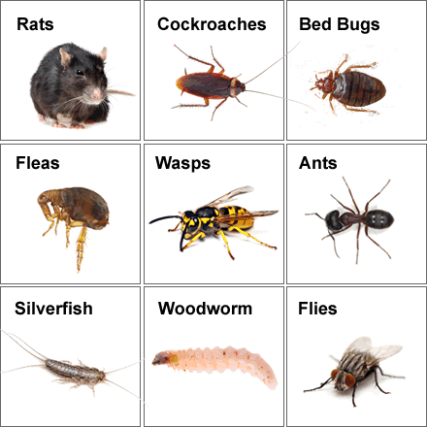

What are pests? *Any species that interferes with human welfare*

*by competing with us for food, invading lawns and gardens,*

*destroying building materials, spreading disease, invading*

*ecosystems, or simply a nuisance*

In what situations are pests actually a good thing?

*Some pests are natural predators that control*

*populations of more harmful pests.*

Pesticides:

|  |  |  |  |
| --- | --- | --- | --- |
| Insecticides | Herbicides | Fungicides | Rodenticides |
| *Kills insects* | *Kills weeds* | *Kills fungi* | *Kills rodents* |

Where did humans get the idea to use chemicals as pesticides?

*from plants that produce chemicals to ward off, deceive, or poison insects*

|  |  |
| --- | --- |
| First Generation Pesticides | Second Generation Pesticides |
| *-natural chemicals borrowed from plants*  *-example: nicotine sulfate from tobacco* | *-chemicals produced in a laboratory*  *-example: DDT* |

|  |  |
| --- | --- |
| Broad Spectrum Agents | Narrow Spectrum Agents |
| *-toxic to many pest and non-pest species*  *-examples: chlorinated hydrocarbons like DDT and organophosphates like malathion and parathion* | *-effective against only 1 or a small group of pests* |

Pesticides vary in their *persistence*- length of time they remain deadly in the environment

Why is Rachel Carson an important figure in environmental history?

*At the time, research on the environmental effects of pesticides was almost nonexistent. Rachel Carson brought attention to the harmful effects of DDT through her book, Silent Spring. Policy makers and the public embraced it, while chemical companies criticized it. Her work led to strict control and the banning of dangerous pesticides.*

|  |  |  |
| --- | --- | --- |
| Advantages | Modern Synthetic Pesticides | Disadvantages |
| *-save lives from disease transmitting insects*  *-increase food supplies*  *-profitable*  *-works fast*  *-health risks are low when used properly* | *-promote genetic resistance*  *-kill natural predators*  *-pollute the environment*  *-can harm wildlife and people*  *-expensive for farmers* |

The *EPA and the USDA* regulate the sale and use of pesticides under *FIFRA* (Federal

Insecticide, Fungicide, Rodenticide Act).

Is FIFRA working? *Only 10% of active ingredients in pesticides have been evaluated for*

*health effects. The EPA says funding is an issue.*

The *Food Quality Protection Act* requires the EPA to reduce allowable levels of pesticide in food by a factor of 10 when there is inadequate research on the health effects of that chemical.

Circle of Poison- There is also an issue with some pesticides being *allowed in one country and banned in another*. That is important to remember when you think about all of the *food that is imported into the US*. The wind can also carry persistent pesticides. The US has not signed the agreement to stop importing food that has been exposed to banned chemicals…

Alternatives to using pesticides:

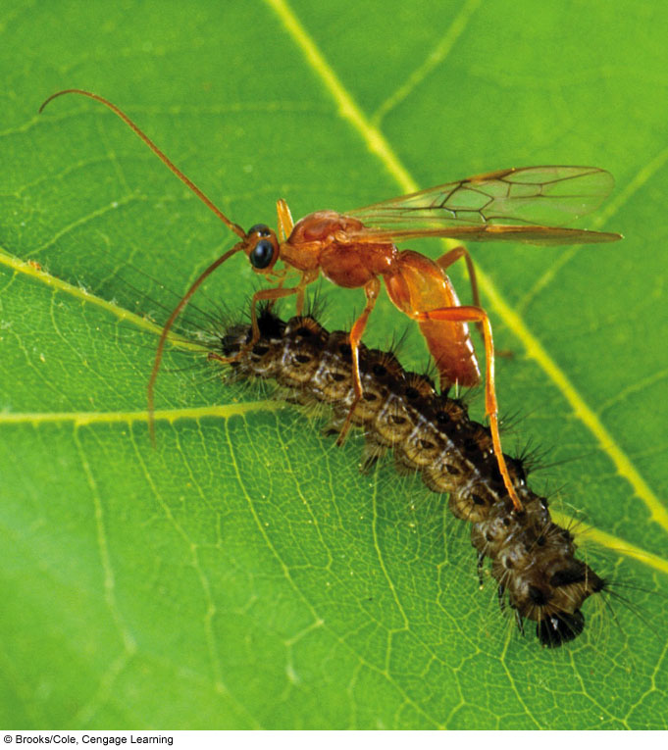

*1. Fool the pest by rotating crops or adjust planting times*

*2. Provide homes for pest enemies by the use of polyculture (many crops)*

*3. Implant genetic resistance by producing pest and disease resistant crops*

*4. Bring in natural enemies as a biological control*

*5. Use insect pheromones to lure pests into traps or to attract natural predators*

*6. Bring in hormones to control the development process and prevent reproduction*

*7. Scald them with hot water- this works for cotton, alfalfa, potatoes, and citrus*

Integrated Pest Management (IPM) program:

Goal- *reduce crop damage to an economically tolerable level in a sustainable way*

How- *each crop and pests are evaluated as part of an ecological system, farmers then*

*develop a program that uses a variety of alternative controls (mentioned above)*

Last Resort- farmers use a small amount of narrow spectrum insecticide if needed

Disadvantages- requires *expert knowledge* on all crops and pests, *slower*, can be more

costly because the government provides *subsidies to chemical pesticides*

**12-5: How Can We Improve Food Security?**

Governments use 3 main approaches to influence food production:

|  |  |  |
| --- | --- | --- |
| Control Prices | Provide Subsidies and Tax Breaks | Let marketplace decide |
| *-keeps food prices artificially low*  *-farmers are most effected with low wages* | *-keeps farmers in business and encourages increased production* | *-eliminates price control and subsidies to let farmers and fishers respond to demand, which may increase innovation*  *-the poor might suffer* |

**12-6: How Can We Produce Food More Sustainably?**

Define: Soil Conservation- *methods used to reduce soil erosion and restore soil fertility*

*mostly by keeping the soil covered with vegetation*

Methods farmers use to reduce soil erosion:

|  |  |  |  |
| --- | --- | --- | --- |
| Terracing | Contour and Strip Planting | Alley Cropping | Windbreaks |
| *-grows food on steep slopes without depleting topsoil*  *-converts steep land into broad, level terraces*  *-retains water for crops and reduces erosion by controlling runoff* | *-plowing and planting crops in rows across the slope of the land*  *-each row acts as a small dam to help hold topsoil and runoff* | *-crops are grown in strips or alleys between trees and shrubs that provide shade*  *-reduces water loss and evaporation* | *-trees are planted around crops to reduce wind erosion*  *-the trees also retain soil moisture and provide habitat for natural predators* |

|  |  |
| --- | --- |
| Strip Cropping | No Till Agriculture |
| *-planting alternating strips of a row crop (like corn) and a cover crop (like alfalfa)*  *-cover crop reduces topsoil erosion and runoff* | *-machinery drills seeds directly into the undisturbed soil*  *-increases crop yield, lowers use of water and tractor fuel*  *-costly machinery* |

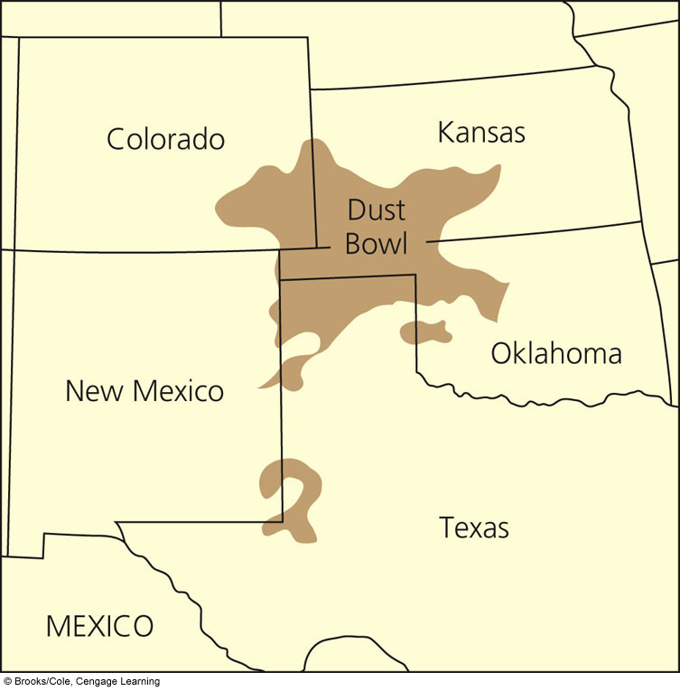

Case Study: Erosion in the US and Learning from the Past

*33%* of the US’s original topsoil is gone.

What happened during The Dust Bowl?

*-1930’s, much of the topsoil was lost in the*

*windy Midwestern states due to poor cultivation*

*practices and prolonged drought*

*-Turned much of the US Great Plains into a desert*

*when much of the native prairie grasses were*

*plowed, leaving the topsoil exposed*

Define: Organic Fertilizers- *made from plant and animal waste*

|  |  |  |
| --- | --- | --- |
| Animal Manure | Green Manure | Compost |
| *-dung and urine of cattle, horses, and poultry*  *-adds nitrogen and stimulates beneficial soil bacteria and fungi* | *-freshly cut or growing green vegetation that is plowed into the topsoil*  *-increases humus* | *-produced when microorganisms break down organic matter such as leaves, food waste, paper, and wood* |

Aquaculture can be practiced more sustainably by

1. *restricting the location of fish farms away from mangrove forests and estuaries*
2. *improving management of aquaculture waste*
3. *reduce escape of aquaculture species into the wild*

Polyaquaculture: raise fish or shrimp along with algae, seaweeds, and shellfish

*-the waste of the fish or shrimp feed other species*

*-natural nutrient cycling*

Describe how meat can be produced more efficiently and humanely.

*-reduce the amount of meat in your diet*

*-switching to more grain efficient meat like poultry and fish*

*-improved animal welfare and restrictions on feedlots*

Define: Organic Agriculture- *crops are grown with little or no use of synthetic pesticides,*

*synthetic fertilizers, or genetically engineered seeds; this is*

*the fastest growing sector of the agricultural economy*

What must happen for crops to be certified as organic?

*Fields must be free of chemicals for 3 years.*

Even though organic farming produces 20% less product, farmers make up for this by

*not having to pay for expensive chemical pesticides, herbicides, and fertilizers*.

Benefits to organic farming:

*1. Improves soil fertility and reduces soil erosion*

*2. Uses 30% less energy*

*3. Lowers CO2 emissions*

*4. Reduces water pollution by recycling livestock waste*

*5. Eliminates pollution from pesticides*

*6. Increases biodiversity*

*7. Benefits wildlife such as birds and bats*

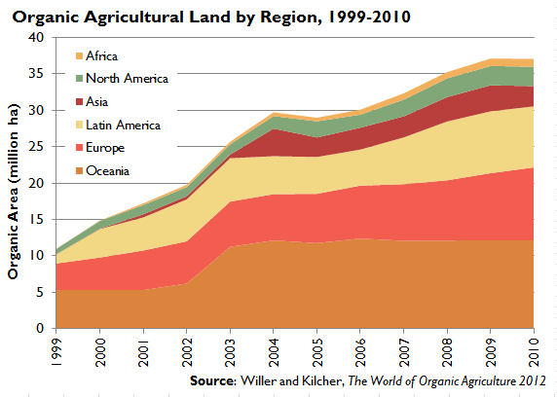 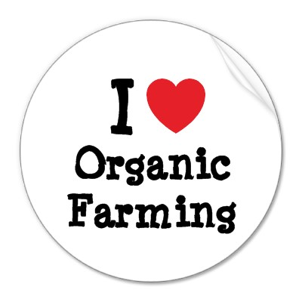



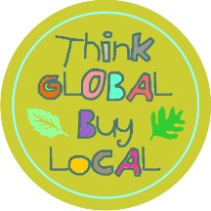

Why is buying locally grown food a good idea?

*-supports local economy*

*-reduces environmental impact of food production*

*-reduces effects of transportation*

*-fresher*

*-reduces greenhouse gas emissions*

**CHAPTER 10 Sustaining Terrestrial Biodiversity**

***Core Case Study: Reintroducing Gray Wolves to Yellowstone***

Between 1850 and 1900, what happened to most of the gray wolves?

*Shot, trapped, poisoned by ranchers, hunters, and government employees*

The gray wolf is considered a *keystone species because they control the population of bison, elk, caribou, and mule deer. They also provide uneaten meat for scavengers.*

What happened to the area when the wolf population declined? *Elk, moose, and mule deer populations expanded and devastated vegetation such as willow and aspen trees. This increased soil erosion and threatened habitats.*

Why are some people angry that the wolf population has been restored? *Ranchers feared the reintroduced wolves would attack their livestock, hunters feared the wolves would kill big game animals, and mining companies feared that operations would be shut down.*

**10-1: What Are the Major Threats to Forest Ecosystems?**

Natural and planted forests account for *30%* of the Earth’s surface. Tropical Rainforest account for *50%* of the world’s forested area.

|  |  |  |
| --- | --- | --- |
| Old-Growth Forest: | Forest managers and ecologists classify forests into 2 major types based on age and structure. | Second-Growth Forest: |
| *Uncut or regenerated forest that has not been seriously disturbed by humans or natural disasters in 200 years or more* | *Trees resulting from secondary succession after the area has been removed due to clearcutting, fires, hurricanes, or volcanoes* |

According to Figure 10-3, how long is the rotation cycle of cutting and regrowth of a monoculture tree plantation? *25-30 years*

How long is the rotation cycle for tropical countries? *6-10 years*

|  |  |  |
| --- | --- | --- |
| Tree Plantation a.k.a Tree Farm a.k.a Commercial Forest | | |
| What is it? What products are made? | What happens when the trees are cut down? | Repeated cycles of cutting and replanting can lead to |
| *Managed tract of land with uniformly aged trees* | *Land is replanted and clearcut again* | *Soil that is depleted of nutrients* |

Ecological Services and Economic Services that Forests Provide:

Ecological Services Economic Services

*-support energy flow and chemical cycling -fuelwood*

*-reduces soil erosion -lumber*

*-purifies water and air -pulp to make paper*

*-stores atmospheric carbon -livestock grazing*

*-wildlife habitats -recreation*

*-jobs*

Steps to harvesting trees:

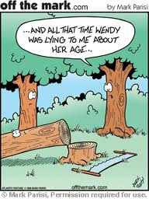

1. Build roads for access and timber removal.

What are some harmful effects of this? *increased erosion*

*sediment runoff, habitat fragmentation*

1. A variety of methods are used for harvesting the trees.

Selective Cutting- *intermediate-aged or mature trees are cut*

Clear Cutting- *removal of all trees from an area*

*-this is the most efficient type of forestry, but also the*

*most harmful*

Strip Cutting- *clearcutting strips of trees along the contour*

*of the land in narrow corridors to allow for regeneration*

*-this is the most sustainable and least damaging type of forestry*

|  |  |  |
| --- | --- | --- |
| Advantages: | Clear Cutting | Disadvantages: |
| *-higher timber yields*  *-maximum profits*  *-can reforest with fast growing trees*  *-good for tree species needing full or moderate sunlight* | *-reduces biodiversity*  *-destroys and fragments wildlife habitats*  *-increases water pollution, flooding, and erosion*  *-eliminates recreational value* |

|  |  |  |
| --- | --- | --- |
| Surface Fires: | Two Types of Fires that Affect Forest Ecosystems  *-fires are not a major threat to forest ecosystems if they’re part of the natural cycle*  *-serious threats in areas where fires are set intentionally which results in major habitat loss, air pollution, and increased atmospheric CO2* | Crown Fire: |
| *-burn only undergrowth and leaf litter on the forest floor*  *-kills seedlings and small trees, but mature trees are usually okay*  *-wild animals can most likely escape* | *-extremely hot fires that leap treetop to treetop*  *-usually occur in forests that have not experienced surface fires in several decades in which flammable ground litter has accumulated* |

What are ways to reduce the harmful impacts of tree diseases and insect pests on forests?

*-ban imported timber that may bring new diseases or pests*

*-clearcut infected and infested trees*

*-develop tree species that are genetically resistant to common diseases*

*-control pests using conventional pesticides or biological control*

How does global warming harm forests?

*-Some species are sensitive to heat (ex: sugar maple trees)*

*-increased temperature makes some forests more suitable for pests*

*-drier forests could increase incidences of forest fires, which further increases*

*atmospheric CO2 (positive feedback loop)*

Define: Deforestation- *temporary or permanent removal of forest for agriculture,*

*settlements, etc*

*46% of original forests have been removed- most has occurred in the last 60 years*

*-losses are concentrated in developing countries (especially tropical areas)*

*-coniferous forests (in Alaska, Canada, Russia, etc) are also being cut down at a rapid*

*rate- these areas store much of the carbon that plays a large role in the carbon*

*cycle and is a habitat to 70,000+ plant and animal species*

Problems associated with deforestation: *decreased soil fertility due to erosion, sediment*

*pollution into aquatic systems, loss of habitat for native species and migratory*

*organisms, release of CO2, flooding*

Case Study: Many Cleared Forests in the US Have Grown Back

*Today, forests cover more area than in the 1920s due to secondary succession.*

*-more wood is grown in the US than is cut down*

*-protected forests make up about 40% of the total forest area*

*-however, many old growth and second growth forests have been replaced with*

*simplified tree plantations which reduces biodiversity*

|  |  |
| --- | --- |
| Describe what is happening to the tropical forests: | Describe the causes (basic and secondary) of tropical deforestation: |
| *-mature tropical forests used to cover twice the land they do now, most have been removed since 1950s*  *-rapid deforestation in Africa, Southeast Asia, and South America*  *-Brazil and Indonesia have the most deforestation*  *-most cutting occurs for cattle ranching and large plantations of crops*  *-2004 estimates that Brazil clears about 11 football fields per minute!* | *Basic: not valuing ecological services, crop and timber exports, government policies, poverty, population growth*  *Secondary: roads, fires, settler farming, cash crops, cattle ranching, logging, tree plantations* |

**10-2: How Should We Manage and Sustain Forests?**

|  |  |
| --- | --- |
| List some ways to grow and harvest trees more sustainably: | *-identify and protect forest areas with high biodiversity*  *-rely more on selective cutting and strip cutting*  *-no clear cutting on steep slopes*  *-no logging of old growth forests*  *-reduce road building in uncut forests*  *-leave dead trees and fallen timber for habitat and nutrient cycling*  *-plant tree plantations on deforested area*  *-certify timber grown by sustainable methods*  *-include ecological services of forests in estimating their economic value* |

Who is Smokey the Bear and what is his role in managing forest fires?

*-mascot for the US Forest Service that has prevented many forest fires, saved lives,*

*and prevented billions of dollars in losses of trees, wildlife, and human structures*

*through education and awareness*

*-keep in mind that not ALL forest fires are bad*



List the 4 strategies for reducing fire related harm to forests.

1. *Prescribed Fires- small, contained surface fires that remove*

*flammable leaf litter and underbrush*

1. *Allow fires on public land to cut down on future, more*

*dangerous fires*

1. *Protect homes and other buildings in fire prone areas by*

*thinning a zone around them as well as eliminating highly*

*flammable building materials*

1. *Thinning of small fire-prone trees and dense underbrush*

What is the 2003 Healthy Forests Restoration Act?

*-passed by US Congress under lobbying pressure from timber companies, despite*

*much warning from forest scientists that this law actually increases forest fires and*

*other deforestation issues*

*-allows timber companies to cut down economically valuable medium and large sized*

*trees in national forests in return for clearing away smaller, more fire-prone trees*

*and underbrush*

*60%* of wood consumed in the US is wasted. This results from *inefficient use of construction*

*materials, excessive packaging, overuse of junk mail, inadequate paper recycling, and failure to reuse wood shipping containers*

How is paper most often made? *by using the pulp from trees*

What is tree-free paper made from? *Using rice straw, fibers from the kenaf plant, hemp,*

*and kudzu- each of these produce more paper pulp per hectare than trees…*

Explain why cutting trees for fuelwood is a problem, especially in tropical areas.

*-about half of the wood harvested each year is for fuelwood*

*-fuelwood and charcoal made from wood are used for heating and cooking by more*

*than 2 billion people, thus wood is being cut at an unsustainable rate*

Haiti was once a tropical paradise and now it is an ecological disaster. What happened?

*-most trees were cut for fuelwood which caused soil to erode and therefore difficult*

*to grow crops*

*-this, in part, has led to a downward spiral of poverty, disease, social injustice,*

*crime, and violence*

List 4 ways to reduce the severity of the fuelwood crisis in developing countries:

1. *Establish small plantations of fast growing fuelwood trees and shrubs*
2. *Burn wood more efficiently cheap, fuel efficient wood stoves, biogas units that run on methane from crop and animal waste, solar ovens and hotplates*
3. *Burn the renewable, sun-dried roots of gourds and squash plants*
4. *Use non-wood charcoal from the fibers of sugar cane processing waste*

Individuals Matter: Who is Wangari Maathai and why is she important?

*-first woman to earn a Ph.D. in Kenya and organized The Green Belt Movement*

*-spent years being abused, harassed, and jailed for opposing government policies*

*-Main of goal of The Greenbelt Movement: organize poor women to plant and protect*

*millions of trees to combat deforestation and provide fuelwood, provides a small*

*income to women*

*Debt-For-Nature Swaps*- can make it financially attractive for countries to protect their

tropical forests in exchange for foreign aid and debt relief

|  |  |  |
| --- | --- | --- |
| Sustaining  Tropical Forests: | Prevention | Restoration |
| *-protect the most diverse and endangered areas*  *-educate about sustainable agriculture and forestry*  *-subsidize only sustainable practices*  *-certify sustainably grown timber*  *-reduce poverty*  *-slow population growth* | *-encourage regrowth through secondary succession*  *-rehabilitate degraded areas*  *-concentrate farming and ranching in already cleared areas* |

**10-3: How Should We Manage and Sustain Grasslands?**

|  |  |  |  |
| --- | --- | --- | --- |
| Grasslands provide the following ecological services: | What is a rangeland? | What is a pasture? | What is overgrazing and why is it a problem? |
| *-soil formation*  *-erosion control*  *-nutrient cycling*  *-storage of atmospheric CO2 in biomass* | *-unfenced grasslands in temperate and tropical climates that supply forage for grazing animals* | *-managed grasslands or enclosed meadows planted with domestic grasses* | *-when too many animals graze for too long and exceed the carrying capacity of the land*  *-reduces grass cover, exposes soil to erosion, compacts the soil* |

Describe in detail methods used for more sustainable management of rangeland.

*-Rotational Grazing- control the number of grazing animals and the duration of*

*grazing in which animals are confined to one area for a short time and then moved to a new location*

*-Protect riparian zones- the thin strips of vegetation found alongside rivers and*

*streams*

*-suppress the growth of unwanted invader plants with herbicides or controlled fires*

*-replant barren areas with native grass*

**10-4: How Should We Manage and Sustain Parks and Nature Reserves?**

Name 3 threats that National Parks Face:

1. *Many suffer from invasive species*
2. *Most parks in developing nations are not protected meaning that local people may enter the parks illegally in search of wood, cropland, game animals, etc*
3. *Loggers, miners, and poachers operate illegally on this land*

Describe stresses on US Public Parks:

1. *Popularity- The Great Smoky Mountains National Park has 9 million visitor/year*
2. *Off-road vehicles destroy vegetation and disturb wildlife habitats*
3. *Damage from the migration or deliberate introduction of invasive species*
4. *Native species are illegally hunted*
5. *Many parks have become islands of biodiversity that have been surrounded by commercial developments*

Science Focus: Reintroducing Gray Wolf to Yellowstone National Park

The return of the gray wolf, a keystone species, has had many ecological effects: *-the elk (herbivores) population has declined*

*-leftovers of elk killed by wolves provide a food source for grizzly bears and*

*other scavengers*

*-regrowth of aspen, cottonwoods, and willow trees since elk population has*

*decreased which has increased populations of songbirds*

*-the regrowth of trees has stabilized and shaded stream banks, which lowers*

*water temperature, making it a better habitat for trout*

Conservation Biologists believe the best way to preserve biodiversity is *to create a worldwide network of protected areas*, but the problem is it requires *action and funding*

*from national governments , private groups, bottom up political pressure, etc.*

Describe the buffer zone concept. A sketch may be helpful.

-protects an inner core of a reserve by establishing two buffer zones in which local

people can extract resources sustainably without harming the inner core

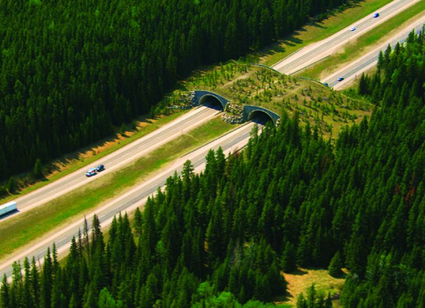

What are habitat corridors?

*set up between isolated*

*reserves to allow migration by*

*vertebrates that need large ranges*

|  |  |
| --- | --- |
| Why is Costa Rica a global leader in conservation? | *-mid 1970’s established a system of nature reserves and national parks that included ¼ of all of its land*  *-the parks and reserves are put into 8 zoned megareserves that contains a protected inner core surrounded by buffer zones that can be used by the locals for logging, farming, fishing, etc*  *-receives about $1 billion a year in tourism and ecotourism*  *-stopped providing subsidies for unsustainable practices* |

What is wilderness and what did Theodore Roosevelt say about it?

*Wilderness-legally setting aside undeveloped land*

*“Leave it as it is. You cannot improve it.” -Roosevelt*

Case Study: Describe why wilderness conservation is controversial.

*Wilderness Act 1964- allowed government to protect undeveloped public land from*

*development (only about 2% of land in the continental US is protected wilderness)*

*However, politically powerful oil, gas, mining, and timber industries have sought*

*entry to these areas. In 2005, more wilderness area has been opened by the government for these industries to access.*

**10-5: What Is the Ecosystem Approach to Sustaining Biodiversity?**

The idea of this chapter is that we have to protect our ecosystems.

The ecosystem approach is a four point plan:

* 1. Map ecosystems and create an *inventory* of the species in them and the *ecological services* that they provide.
  2. Locate and protect the most *endangered ecosystems and species*.
  3. Seek to restore as many *degraded ecosystems* as possible.
  4. Make development *biodiversity-friendly* by providing financial incentives like *tax breaks* who agree to help protect ecosystems.

In reality, few countries are physically, politically, or financially able to set aside and protect large biodiversity reserves…

|  |  |
| --- | --- |
| Define: Biodiversity Hotspots- | List 6 biodiversity hotspots in the US: |
| *-areas that are especially rich in plant species that are found nowhere else and are in great danger of extinction* | *Hawaii, San Francisco Bay, Southern Appalachians, Death Valley, Southern California, Florida Panhandle* |

Define: Ecological Restoration- *the process of repairing damage caused by humans to the*

*biodiversity and dynamics of a natural ecosystem*

Examples: *replanting forests, resotirng grasslands, restoring wetlands and stream banks, reclaiming urban industrial areas (brownfields), reintroducing native species, removing invasive species*

Measures that can be taken to speed up repair operations:

1. *Restoration*- returning a degraded habitat to a condition as similar as possible to its natural state
2. *Rehabilitation*- turning a degraded ecosystem into a functional or useful ecosystem without trying to restore it to its original condition
3. *Replacement*- replacing a degraded ecosystem with another type of ecosystem
4. *Creating artificial ecosystems*- for example, creating artificial wetlands to reduce flooding

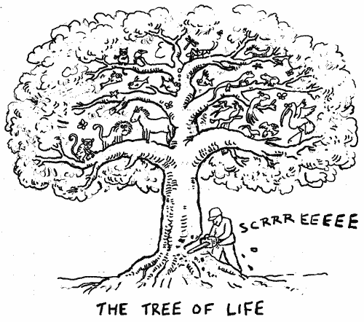

1. *Reconciliation*- inventing, establishing, and maintaining new

habitats in places where people work and live, “community

based conservation” in which the locals work to preserve

their own environment

**CHAPTER 11 Sustaining Aquatic Biodiversity**

**Core Case Study: A Biological Roller Coaster Ride in Lake Victoria**

Until the 1980’s Lake Victoria, found in East *Africa* had about *500* species of fish, but since then about *200* of the lake’s cichlid fish species have gone extinct.

Describe 2 reasons why this has happened:

1. *The Nile Perch (a large predatory fish) was intentionally introduced during the 1950’s to stimulate exports of the fish to several European countries; this new mechanized fishing industry put many small scale fishers out of business, thus increasing poverty and malnutrition of the locals*
2. *Frequent algal blooms due to nutrient runoff from surrounding farms and deforested land, sewage spills, and the decline in algae eating cichlids*

**11-1: What Are the Major Threats to Aquatic Biodiversity?**

3 General Patterns about Marine Biodiversity:

1. Greatest marine biodiversity is found in *coral reefs, estuaries, and the deep ocean floor.*
2. Biodiversity is higher near *coasts* than *open sea* because of the greater variety of *producers* and *habitats*.
3. Biodiversity is higher in the bottom region of the ocean because of the *greater variety of habitats and food sources.*

|  |  |  |
| --- | --- | --- |
| **Major HIPPCO Threats to Aquatic Biodiversity** | | |
|  | Explanation | What is happening? (examples) |
| H | *Habitat loss* | *-Habitat destruction of the ocean floor due to bottom trawling and dredging*  *-Dams and excessive water withdrawal* |
| I | *Invasive Species* | *-many invaders arrive in the ballast water stored in tanks in cargo ships*  *-the Asian Swamp Eel invaded south Florida from the dumping of a home aquarium*  *-the Purple Loosestrife from Europe was imported as an ornamental plant in gardens and has now reduced wetland biodiversity by replacing native plants*  *-natural predators of the plant (like a weevil) has now*  *been introduced to control the purple loosestrife* |
| P  P | *Population Growth*  *Pollution* | *-by 2020 80% of the world will live along or near coasts!*  *-this increases pressure on aquatic natural resources*  *-80% of all ocean pollution comes from land based activities like fertilizer runoff, plastic litter, & industrial runoff*  *-eutrophication in Lake Victoria allowed for the takeover of the invasive Nile Perch since it allowed for the cichlids to have an increased food supply (algae)* |
| C | *Climate Change* | *-sea levels have risen 4-8 inches during the last 100 years from the melting of glaciers and sea ice*  *-this may destroy coral reefs, low lying islands, & wetlands* |
| O | *Overfishing* | *-large scale commercial fishing has depleted our populations of fish, shellfish, etc*  *-the human demand for seafood is outgrowing the sustainable yield*  *-overfishing can lead to commercial extinction* |

Define- Commercial Extinction: *the population of fish has become so small*

*due to overfishing that it is no longer profitable*

Define- Bycatch: *non-target species that are accidentally caught while the*

*commercial fishing vessel is targeting a certain type of fish, 1/3 of all fish*

*caught are considered bycatch, the bycatch is thrown back either dying or*

*dead; examples are sea turtles, seals, and dolphins*

Case Study: Industrial Fish Harvesting Methods

Commercial fishing uses *highly efficient fleets, however this industry has decreased marine*

*biodiversity, degraded marine ecosystems, and most are fishing beyond their sustainable*

*yield*

|  |  |  |  |
| --- | --- | --- | --- |
| **4 Major Types of Commercial Fishing** | | | |
| Fishing Type | Types of Fish Targeted | How it Works | Disadvantages |
| Trawlers | *-Fish and shellfish that live on or near the ocean floor*  *-shrimp, cod, flounder, scallops* | *-Involves dragging a large funnel shaped net along the ocean floor*  *-Some nets are as large as 12 jet planes* | *-The net is weighted down so as it moves it scrapes along the floor destroying everything in its path*  *-it is almost like “clear cutting” a forest* |
| Purse Seine | *-Surface dwelling species and schooling fish*  *-tuna, mackerel, anchovies, and herring* | *-A spotter plane locates a school of fish and the fishing vessel circles around it with a large net* | *-bycatch, like dolphins, are sometimes caught in the nets as well* |
| Long Line | -Open ocean species  -Swordfish, tuna, sharks  -Can also be used on the bottom to catch cod | -ships put out a very long line (sometimes up to 80 miles long!) that have thousands of baited hooks | -bycatch, like sea turtles, dolphins, and seabirds are accidentally hooked |
| Drift Net  “gill net” | *-Open ocean species*  *-Tuna, swordfish, salmon* | *-Huge drift nets are lowered into the ocean and hang as deep as 50 feet down and 40 miles long*  *-Fish then run into the net and are caught by their gills* | *-Can quickly lead to overfishing and a lot of bycatch*  *-Air breathing bycatch cannot escape and therefore suffocate* |

Other equipment used in industrial fishing: *global satellite positioning equipment, sonar,*

*spotter planes, gigantic refrigerated factory ships*

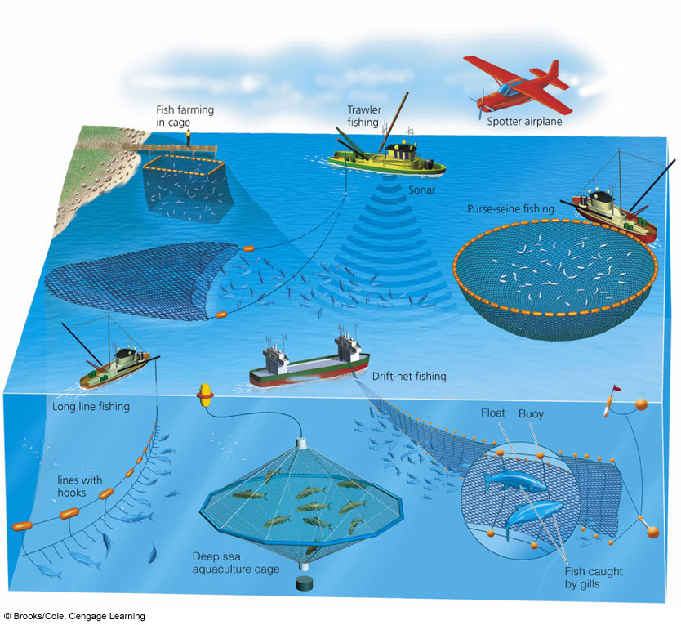

Science Focus: Sustaining Ecosystem Services by Protecting and Restoring Mangroves (pg 255)

Explain two reasons why mangrove

forests need to be protected:

1. *Mangrove Forests reduce the impact of rising sea levels*
2. *These forests also protect against storm surges*

**11-2: How Can We Protect and Sustain Marine Biodiversity?**

Describe reasons why protecting marine biodiversity is difficult and makes the ocean vulnerable to overexploitation.

*-The human ecological footprint and fishprint are expanding rapidly into aquatic*

*areas, making the impacts difficult to monitor.*

*-The damage to the ocean bottom is not visible to many people, therefore it doesn’t*

*seem like an urgent issue.*

*-Many people incorrectly view the sea as an inexhaustible resource that can absorb*

*infinite amounts of waste and pollution.*

National and International Laws and Treaties that protect marine species:

* *CITES (Convention on International Trade in Endangered Species)*
* *1979 Global Treaty on Migratory Species*
* *US Marine Mammal Protection Act of 1972*
* *US Endangered Species Act of 1973*
* *US Whale Conservation and Protection Act*

Case Study: Protecting Whales

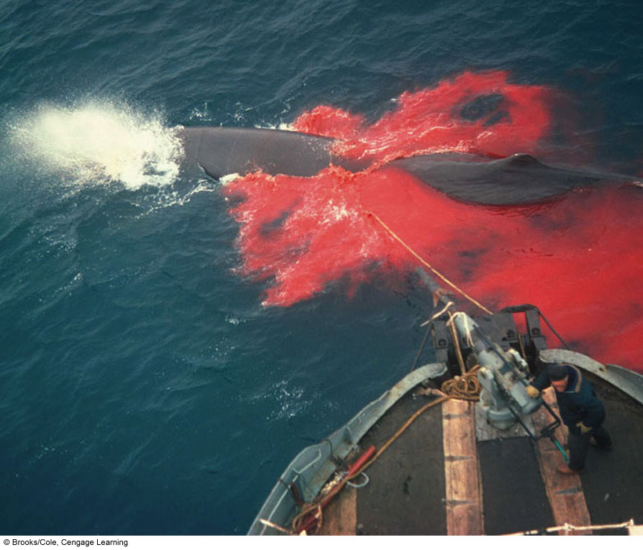

Examples of cetaceans:

*Toothed Whales- porpoise, sperm whale, orca*

*Baleen Whales (filter feeders)- humpback whale,*

*blue whale, minke whale, gray whale*

Why are whales fairly easy to kill? *because of their*

*size and they need to come to the surface to*

*breathe; whalers killed about 1.5 million whales*

*between 1925-1975 leading to 8 out of 11*

*becoming commercially extinct*

What is going on with Blue Whales? *These whales have been hunted to near biological*

*extinction for its oil, meat, and bone. Blue whales are K-selected and take*

*about 25 years to mature sexually. Their low reproductive rate has made it difficult for the species to recover.*

*-have not been hunted commercially since 1964 and are classified as an*

*endangered species*

1946 The IWC- (*International Whaling Commission*)

Mission was to regulate whaling by setting *annual quotas*, but the problem was

*the quotas were based on inaccurate data or were ignored by whaling*

*countries*.

1970 The US stopped all commercial whaling & banned *all imports of whale products*.

Name 2 countries that continue to hunt whales: *Japan* still hunts thousands of

cetaceans per year and claims it is for “scientific purposes.” However, the

whale meat is sold to restaurants for around $30,000 per whale!. *Norway* also openly defies the international ban.

Case Study: Holding Out Hope for Marine Turtles

*6* out of 7 marine species of turtles are endangered.

The leatherback sea turtle survived a giant asteroid, but may not survive human

impacts. Describe ways humans are contributing to the death of sea turtles:

*Bottom trawlers destroy coral gardens that serve has their feeding grounds.*

*The turtles are hunted for their meat and eggs.*

*Turtles can mistake pollution, like plastic bags, for jellyfish and choke.*

*Rising sea levels can flood nesting and feeding habitats.*

What is being done to help sea turtles recover? *nesting areas are roped off, bottom*

*trawlers must use TEDs (Turtle Excluder Devices) on their nets, community*

*based programs to educate on the importance of protection of sea turtles*

What is the problem with high seas? *High seas are oceans beyond the legal jurisdiction of a*

*country, and laws and treaties are difficult to monitor and enforce. Therefore,*

*overfishing occurs often.*

Instead of focusing on saving individual species, scientists and policy makers are now

focusing on an *ecosystem* approach.

*We must establish a global network of marine reserves. These reserves are off-limits*

*to human activities to allow ecosystems to recover.*

What are some things individuals and communities can do to continue to protect marine

biodiversity? *closely monitor fishing and coastal land development, prevent pollution from*

*land based activities as much as possible, purchase sustainably harvested seafood*

**11-3: How Should We Manage and Sustain Marine Fisheries?**

The first step to protecting and sustaining fisheries is to estimate fish populations.

Define: Maximum Sustainable Yield- *maximum number of fish that can be harvested*

*annually without causing a population to drop*

*However, it is difficult to estimate populations and growth rates as well as*

*account for the impact of other species that interact together.*

Define: Optimum Sustainable Yield- *this approach takes into account interactions*

*among species to provide more room for error*

*Comanagement*- when coastal communities and the *government* work together.

The government sets *quotas* and divides it out among communities.

Limit fishing *seasons* and regulates types of fishing gear to be used.

Community then allocates quota among its members.

Government Subsidies help fishers buy things like *ships, fuel, and equipment* to help keep their business running; the rest goes towards *research and management of fisheries*.

Some scientists argue that these subsidies actually encourage *overfishing and expansion of*

*the large commercial fishing industry.*

Some countries *use ITRs (Individual Transfer Rights)* in which each vessel owner gets a percentage of the *TAC (total allowable catch)* for a fishery each year. Owners can buy, sell, or lease their fishing rights.

Problems with ITR:

1. *Publically owned waters are now privately owned, yet the public pays for the enforcement and management of the ecosystem.*
2. *Puts small fishing companies out of business because they might not have the capital to purchase ITRs.*
3. *The TAC is often set too high to prevent overfishing.*

Consumers can demand *sustainable* seafood which encourages more responsible fishing practices. Seafood should be labeled to inform consumers how and where fish are caught.

**11-4: How Should We Protect and Sustain Wetlands?**

Why have countries such as New Zealand and Italy lost almost all of their wetlands?

*People have drained, filled in, or covered over swamps, marshes, and other wetlands*

*for agriculture, city expansion, building roads, mining, oil extraction, etc.*

Remember that wetlands serve as natural filters, so when they’re destroyed that leads to more water pollution, contamination of drinking water, and fish kills.

A policy known as *mitigation* banking allows destruction of existing wetland as long as *an equal area of the same type of wetland is created or restored*. The problem with this is *around half of these new or restored wetlands fail or do not provide the same ecological functions as a natural wetland*.

Case Study: Can We Restore the Florida Everglades?

What has caused much of the Everglades to “disappear”? *To support a growing human*

*population, much of the land has been drained, paved over, polluted with*

*nutrients for agriculture (leading to algal blooms), and invaded by non-native species. This significantly reduced wildlife populations in the area.*

What has been done to restore the everglades? *The US government established the*

*Everglades National Park, but this did not help restore the everglades because massive water projects to the North restricted the flow of water into the protected areas. Other, newer solutions, such as the Comprehensive Everglades Restoration Act is also struggling to actually restore the area.*

**11-5: How Can We Protect and Sustain Freshwater Lakes, Rivers, and Fisheries?**

Case Study: Can the Great Lakes Survive Repeated Invasions by Alien Species?

Many invasive species have entered through the bilge water from oceangoing ships. These species then travel through the St Lawrence Seaway to enter the lakes.

One of the biggest threats to the Great Lakes is the *sea lamprey*, which attaches itself to any kind of fish and *kills by sucking out its blood*. The US and Canada have controlled lamprey population by *applying a chemical that kills lamprey larvae in their spawning streams* ($15million/year!).

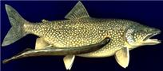

*Zebra Mussels* arrived in the Great Lakes from the ballast water of a European ship. It has no known predators in the Great Lakes and has affected the area by *displacing and depleting the food supply of other mussel species, clogged irrigation pipes, spread to other freshwater communities, etc .*

What is a positive effect the zebra mussels have had? *They have increased water clarity by consuming algae, thus allowing more photosynthesis.*

What problems have the Columbia River dams caused to certain species? *It has blocked the*

*path of migratory fish, like salmon thus reducing their ability to reproduce.*

To protect our lakes and streams from inputs of excess nutrients and pollution, we must protect its *watershed*. Land and water are always connected.

What has been done to protect freshwater fisheries? *The National Wild and Scenic Rivers Act protects certain free flowing rivers from widening, dredging, filling, and damming. However this only protects about 2% of the US Rivers. By regulating the fishing season and placing limitations on the number and size of fish that can be removed has also helped with overfishing.*

**11-6: What Should Be Our Priorities for Sustaining Biodiversity and Ecosystem Services?**

Edward O. Wilson proposed priorities for protecting world’s remaining ecosystems and species: *1. Complete the mapping of the world’s species.*

*2. Keep old growth forests in-tact.*

*3. Preserve biodiversity hotspots.*

*4. Protect and restore freshwater ecosystems.*

*5. Make conservation financially rewarding.*