**CHAPTER 15 Nonrenewable Energy**

**Core Case Study: How Long Will Supplies of Conventional Oil Last?**

1. Oil supplies about *1/3* of the world’s energy.
2. When do geologists predict that oil reserves will be 80% depleted? *2050-2100*
3. How come we are not sure how many oil reserves the Earth has? *Oil companies and many governments are secretive about oil reserves.*
4. If the Earth is to continue to use oil its current rate, what must happen for us to sustain this rate? *We would have to discover global oil reserves equivalent to a new Saudi Arabia every 5 years.*

**15-1: What Major Sources of Energy Do We Use?**

The *sun* provides almost all of the energy that heats the Earth.

What types of other indirect solar energy does the sun provide?

*Wind (moving air masses heated by the sun)*

*Hydropower (flowing water kept fluid by heat from the sun)*

*Biomass (solar energy converted to chemical energy and stored in plants)*

What is commercial energy? *Energy sold in the marketplace that comes from extracting and*

*burning nonrenewable energy resources obtained from the Earth’s crust (mostly*

*fossil fuels like oil, coal, and natural gas)*

According to figure 15-3, what % of commercial energy use in the US comes from

nonrenewable sources? *93%*

Which countries are the 3 largest users of fossil fuels? *US, China, European Union*

Give a brief history of human energy use. (Watch video within Prezi or read pg 372-373)

Science Focus: Why is the statement “It takes energy to get energy” so important?

*It is important to understand that energy will be expended in order to make fossil*

*fuels useful for us. For example, oil must be pumped from the ground, transferred to*

*a refinery, converted to useful fuels, transported to users, and burned for energy.*

What is the first law of thermodynamics? *Energy can’t be created or destroyed, it can*

*only change form.*

What is the second law of thermodynamics? *As energy changes form, the quality*

*degrades.*

Define: Net Energy- *The total amount of useful energy minus the energy needed to*

*find, extract, process, and transport that energy to consumers.*

Explain what a net ratio of 10/8 means. *It takes 8 units of energy to produce 10 units*

*of useful energy, therefore a net of 2 energy units.*

Why is a net energy ratio less than 1 bad? *That would mean there is a net energy loss.*

**15-2: What Are the Advantages and Disadvantages of Oil?**

What is petroleum (crude oil) and how is it formed? *Crude oil refers to the oil that comes*

*out of the ground. It is a thick and gooey liquid consisting of hundreds of different*

*combustible hydrocarbons along with small amounts of sulfur, oxygen, and nitrogen*

*impurities.*

|  |  |  |  |  |
| --- | --- | --- | --- | --- |
| Source: | How is it extracted and processed? | Location: Which countries have the largest supply? | Advantages: | Disadvantages: |
| Petroleum & Crude Oil | *Extracted by a well drilled into the deposit on land and sea.*  (Once a well has been pumped for a decade or so, the pressure drops and production declines to a point called peak production.)  *After extraction, crude oil is transported to a refinery by pipeline, truck, or ship. It is heated and distilled to separate components with different boil points.*  *Some products of oil distillation are called petrochemicals that are raw materials for other products.* | *Saudi Arabia (25%)*  *Canada (15%- mostly oil sand)*  *Most oil reserves are controlled by government owned companies. Private companies like BP, Exxon, and Chevron have a declining influence over oil supplies and prices.* | *Ample supply for 42-93 years*  *Low cost*  *High net energy yield*  *Easy to transport*  *Low land use*  *Technology is well developed* | *Need to find substitutes within 50 years*  *Large government subsidies*  *Environmental costs not included in market price*  *Artificially low price encourages waste and discourages search for alternatives*  *Pollutes air when produced and burned*  *Releases CO2 when burned*  *Can cause water pollution* |

From a refining perspective, what is the difference between gasoline & aviation fuel?

*Gasoline is refined at a lower boiling point than aviation fuel.*

How are petrochemicals used? *Petrochemicals are raw materials for industrial chemicals,*

*cleaning fluids, pesticides, plastics, synthetic fibers, paints, etc.*

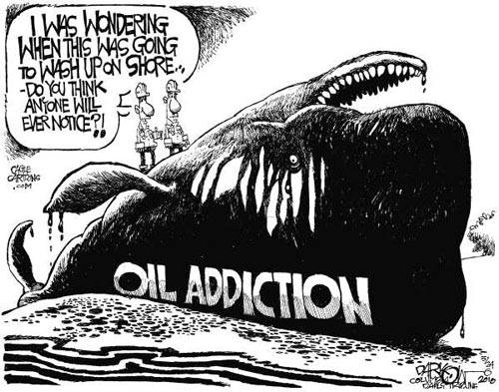

Who is OPEC? *Organization of Petroleum Exporting Countries*

*These countries hold 60% of the world’s crude oil*

*reserves.*

Algeria, Angola, Indonesia, Iran, Iraq, Kuwait, Libya,

Nigeria, Qatar, Saudi Arabia, United Arab Emirates,

Venezuela

If oil prices rise, the cost of what other goods will also rise?

*Increase in food prices, plastics, asphalt, airfares*

How much of the US energy comes from fossil fuels? *85%* from oil? *39%*

How much of the world’s oil do we (US) use? *24%* How much do we produce? *9%*

Describe the importance of ANWR? *Arctic National Wildlife Refuge is a very important land*

*area for ecosystem functioning in the fragile tundra since it serves as a vital habitat and*

*nesting community for many species and migratory animals.*

*Oil companies want to drill on this land because they believe it may contain oil and natural*

*gas deposits. Advocates say this will decrease dependence on imported oil. Experts believe*

*that this will increase profits, but will not significantly increase supplies.*

*Opponents argue that the relatively little oil that would be recovered would not be worth the environmental degradation to this fragile and unique ecosystem, potential oil spills, and habitat fragmentation.*

What is oil sand/tar sand and who has a lot of this?

*Oil sand, and tar sand is a mixture of clay, sand and water and a combustible organic*

*material called bitumen—a thick, sticky, heavy oil with a high sulfur content that makes up*

*about 10% of the gooey mixture.*

*Northeastern Alberta in Canada has three-fourths of the world’s oil sand resources in sandy*

*soil under a remote boreal forest.*

How does this type of oil production work?

*Oil sand can be strip mined, therefore the boreal forest must be clear cut, wetlands*

*must be drained, and surface water must be diverted.*

*Next, the overburden must be removed and gigantic electric shovels dig up the oil*

*sand.*

*Finally, the oil sand is transported to a plant in which the bitumen is extracted. The*

*bitumen is then converted to a low-sulfur crude oil that is then sent to the refinery.*

What are the major environmental issues associated with this type of production?

*Huge volumes of toxic mine tailings and other wastes are stored in sludge*

*ponds, which are toxic to aquatic life and migratory birds.*

*This process uses large amounts of water.*

*Oil Sand production results in more water pollution and air pollution than the*

*extraction and processing of conventional oil. Production also releases 3x more*

*CO2 than conventional oil.*

Shale oil= *oily rocks that contain a combustible mixture of hydrocarbons called kerogen*

*Most shale oil is found in the western US and experts estimate that we could recover*

*enough oil from this area to equal 4x that of Saudi Arabia’s oil reserves.*

*Here is the catch: The net energy is too low because the oil is locked away in rocks*

*that would require a large amount of energy to mine. It would also take a massive amount of water during the mining process.*

**15-3: What Are the Advantages and Disadvantages of Natural Gas?**

What is natural gas? *Mixture of gasses that is 50-90% methane and contains other*

*hydrocarbons like ethane, propane, and butane*

LNG= *Natural gas is converted to Liquefied Natural Gas so that it can be transported.*

|  |  |  |  |  |
| --- | --- | --- | --- | --- |
| Source: | How is it extracted and processed? | Location of largest supply | Advantages: | Disadvantages: |
| Natural Gas | *Lies above most reservoirs of crude oil*  *When a natural gas field is tapped, propane and butane gases are liquefied and removed as Liquefied Petroleum Gas (LPG).*  *The rest of the gas (mostly methane) is dried to remove water vapor, cleansed of poisonous hydrogen sulfide, and pumped into pipelines for distribution.* | *Russia (27%)*  *Iran (15%)* | *Ample supply*  *High net energy yield*  *Low cost*  *Less air pollution than other fossil fuels*  *Lower CO2 emissions than other fossil fuels*  *Easily transported by pipeline*  *Low land use* | *Nonrenewable resource*  *Releases CO2 when burned*  *Government subsidies*  *Environmental cost not included in market price*  *Methane (a greenhouse gas) can leak from pipelines*  *Difficult to transfer from one country to another*  *Can be shipped across the ocean as highly explosive NG* |

Where is methane hydrate located? *Methane hydrate refers to methane trapped in icy,*

*cage-like structures of water molecules; buried in some areas of the tundra and deep*

*beneath the ocean floor*

What is the major environmental concern with producing methane hydrate?

*At this point it costs too much to get natural gas from methane hydrate and it also*

*Releases methane (a greenhouse gas) into the atmosphere which will speed up global*

*Warming.*

**15-4: What Are the Advantages and Disadvantages of Coal?**

What is coal and where does it come from?

*Coal is a solid fossil fuel that formed out of the remains of plants that were buried*

*300-400 million years ago and subjected to intense heat and pressure.*

*Coal is the world’s most abundant fossil fuel.*

|  |  |  |  |  |
| --- | --- | --- | --- | --- |
| Source: | How is it extracted and processed?  (Review Ch 14 mining) | Location of largest supply: | Advantages: | Disadvantages: |
| Coal | *Coal is mined through mountain top removal and strip mining.*  *Coal is burned to boil water and produce steam which turns a turbine that is connected to a generator that produces electricity.* | *US (25%)*  *Russia (15%)* | *Ample supplies*  *High net energy yield*  *Low cost*  *Well developed technology*  *Air pollution can be reduced with improved technology* | *Severe land disturbance as pollution and water pollution*  *Severe threat to human health when burned*  *Environmental costs not included in market price*  *Large government subsidies*  *High CO2 emissions when produced and burned*  *Radioactive particle and toxic mercury emissions* |

**BOTTOM LINE: Coal is cheap (as long as environmental costs are not included), plentiful, and distributed over much of the planet.**

What are the 3 largest coal burning countries in order? *China, US, India*

Give the percentage breakdown for electricity production by source in the US.

*Coal (49%), Natural Gas (21%), Nuclear Power (19%), Renewable (9%), Oil (2%)*

List the types of coal from least to greatest energy (heat) content.

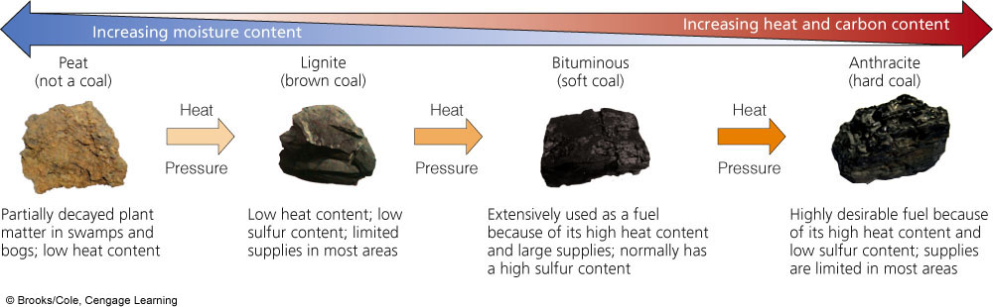

How is China’s coal consumption affecting the environment?

*China is the world’s leading source of sulfur dioxide and nitrogen oxides which can*

*cause respiratory diseases and acid rain. This pollution from coal also contributes to*

*their terrible air quality.*

Solid coal can be converted into *Synthetic Natural Gas* through coal gasification. The gas is

then turned to liquid fuel (synfuel).

**15-5: What Are the Advantages and Disadvantages of Nuclear Energy?**

**Big Idea:** Uses nuclear fission to produce enough heat to boil water to produce steam to spin

a turbine that is connected to a generator.

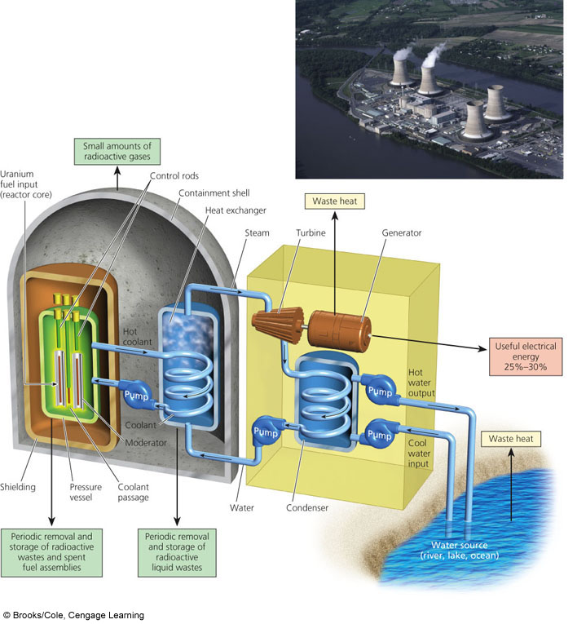

The nuclear fission reaction takes place in the *reactor.*

The fuel for the reactor is from uranium ore that is mined from the Earth. *Uranium-235* is most commonly used.

Uranium-235 is then processed into small pellets that are packed into *fuel rods* that are placed into the core of a reactor.

*Control rods* control the rate of the nuclear fission reaction.

A *coolant* (usually water) circulates through the core to remove heat to prevent a meltdown of the reactor.

A *containment shell* (thick concrete wall) surrounds the reactor to prevent radiation leaks.

*Spent (used) fuel rods* that are extremely radioactive are stored outside the rector in water filled pools or dry casks. There is no perfect long term storage solution at this time!

List the steps of the nuclear fuel cycle:

*1. Mining the uranium*

*2. Processing and enriching the uranium to*

*make fuel.*

*3. Using the uranium in a reactor.*

*4. Safely storing the radioactive waste.*

*5. Decommissioning an old reactor “safely”*

What countries are large nuclear power users?

*France, Japan, South Korea*

Why has nuclear power production grown so slowly?

1. Very high construction costs

2. High operating costs

3. Low net yield from the near fuel cycle

4. Public concerns about safety

Two major nuclear disasters (list place and year)

1. *3 Mile Island, PA- 1979; one of the two reactors lost its coolant water because of a series of mechanical failures and human error; this caused a partial meltdown of the reactor; luckily the containment building kept most of the radioactivity contained; this lead to intense public fear of nuclear energy*
2. *Chernobyl, Ukraine- 1986; worst nuclear accident; a series of explosions in a reactor blew the roof off the reactor building which lead to the release of radiation 100x that of an atomic bomb; today these areas are still dangerously contaminated- high cancer rates, undrinkable water, and fruit that cannot be eaten*

|  |  |
| --- | --- |
| Advantages of Nuclear | Disadvantages of Nuclear |
| *Large fuel supply (uranium)*  *Low environmental impact (without accidents)*  *Emits much less CO2 than coal*  *Moderate land disruption and water pollution*  *Low risk of accidents because of multiple safety systems* | *Cannot compete economically without huge government subsidies*  *Low net energy yield*  *Potential for major disaster if an accident occurs*  *No widely acceptable solution for long term storage of radioactive waste* |

How long must nuclear waste be stored?

*10,000 – 240,000 years depending on the radioactive isotopes!*

Where do we *plan* to store the radioactive wastes?

*Deep burial underground, however no country has built such a repository*

1985- the Dept Of Energy announced a plan to build an underground storage site in the *Yucca Mountain Desert region*; clearly there is much opposition to this plan that has yet to come to fruition

What are some of the problems with this plan? *Possible leaks due to natural*

*disasters, water leaks, corrosion of the containment vessels*

*There is also concern about the shipment of radioactive material that would*

*have to take place in order to get the waste to this “dump site”*

What are three options for dealing with a worn-out nuclear power plant?

*1. Store large volumes of radioactive material in high level storage facilities*

*2. Install a physical barrier around the*

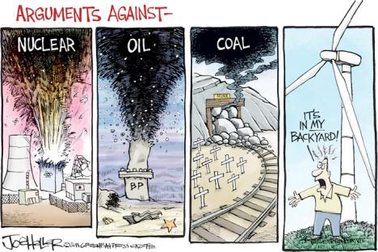

*plant and set up full time security*

1. *Enclose the entire plant for several*

*thousand years*

What does NIMBY stand for? *Not In My Backyard*

**CHAPTER 16 Energy Efficiency & Renewable Energy**

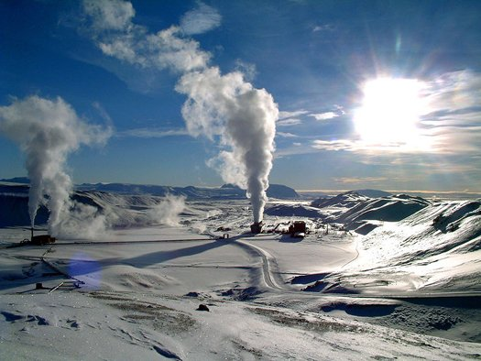

**Core Case Study: Iceland’s Vision of a Renewable-Energy Economy**

Because Iceland sits on the boundary of the Eurasian and

North American *tectonic plates*, it has 20

active *volcanoes*.

Iceland gets ¾ of its energy from renewable sources like

*geothermal* energy which is superheated

*groundwater* and steam found close to the Earth’s

surface. The other renewable source they use for electricity,

etc. is *hydropower*.

By 2050-2060, Iceland plans to be the first country to run its economy entirely on

*renewable* energy.

“Dr. Hydrogen” said in the 1970’s, that Iceland could use hydrogen fuel cells as an energy

source. Explain how this works.

*Hydrogen is combined with oxygen in fuel cells to produce electricity.*

What is only byproduct of burning hydrogen fuel? *Water vapor*

Royal Dutch Shell was the first to open a commercial *hydrogen* filling station.

**16-1: Why is Energy Efficiency an Important Energy Resource?**

Define: Energy Conservation- *a decrease in energy use primarily by reducing unnecessary*

*waste*

Energy Efficiency- *measure of how much work we can get from each unit of energy*

*we use*

|  |  |  |
| --- | --- | --- |
| Less Energy Efficient than US: | United States | More Energy Efficient than US: |
| *Canada*  *Most developing countries* | *Japan*  *Germany*  *France* |

Advantage to reducing energy waste: It is the quickest, cleanest, and usually cheapest way to provide more *energy*, reduce *pollution*, slow *global warming*, and increase economic security.

Four widely used devices that waste large amounts of energy:

1. *Incandescent* lightbulbs- uses only *5-10*% of the

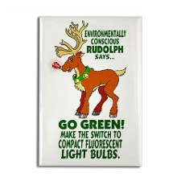

electricity it draw in to make light. It is more like a

“heat bulb!”

1. A car’s internal combustion *engine* wastes *94*% of

energy in its fuel!

1. A *nuclear* power plant wastes ~*83*% of the energy in

nuclear fuel.

1. A *coal* fired power plant wastes 66% of the energy when

coal is burned to make electricity.

Alternatives for each of the four devices listed above:

1. Compact *fluorescent* bulbs and *LED* lights.

2. *Fuel cells* to power cars and provide heat and electricity to buildings.

3. *Wind and solar* cell farms to produce electricity

Remember, the only energy that really

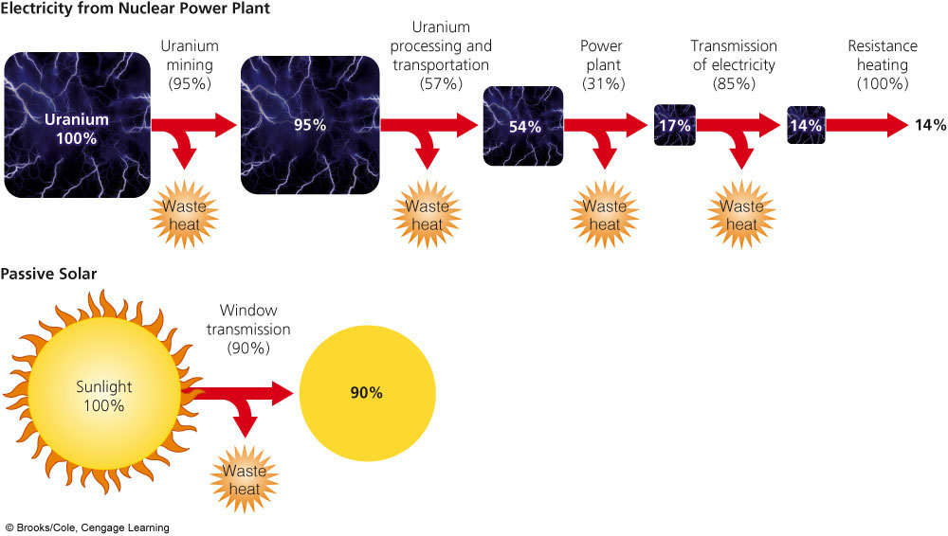

counts is *net energy.*

The figure 16-4 to the right represents a home heated with electricity produced at a nuclear power plant and a home heated with direct solar energy. Which is obviously more efficient?

**16-2: How Can We Cut Energy Waste?**

*Industry* accounts for 38% of the US’s energy consumption mostly from the production of *metals, chemicals, cement, and paper*. The largest consumer of energy is the *petrochemical industry that produces fertilizers, plastics, and detergents.*

Methods companies used to save energy and money. Describe each.

1. *Cogeneration*- aka combined heat and power. Both steam and electricity are produced from the same fuel source. The heat used to produce electricity is also used to heat the building.
2. Replace energy-wasting electric *motors*.
3. Recycling materials like *steel and other metals.*
4. Change lighting- Switch from *incandescent* lighting to fluorescent or *LED*.

Utility companies have been rewarded for selling *more kwh*. California, for example, has implemented a financial reward for using *less* kwh.

Fuel efficiency for vehicles *rose* sharply between 1973 and 1985 because of government-mandated corporate average fuel economy (*CAFE*) standards. However, since 1985 fuel efficiency *decreased*  because there has not been any pressure from CAFÉ standards and also the popularity of *SUVs* and trucks have increased. A 2008 law raised CAFÉ standards in the US to bring fuel efficiency to *35* mpg by 2020. This is still lower than average in Europe, Japan, China, and Canada.

*35+* mpg = a fuel efficient vehicle. Toyota Prius Hybrid-Electric gets *46-50 mpg*.

A gallon of gas should technically cost $*16* if environmental and health costs were added into the price.

Describe the idea of Lovin’s feebate. *Fuel inefficient vehicles would be taxed heavily and the resulting revenue would be given to buyers as rebates who choose fuel efficient cars.*

Describe how each of these works.

|  |  |  |  |
| --- | --- | --- | --- |
| Conventional Hybrid: | Plug-in Hybrid: | Energy Efficient Diesel Car: | Hydrogen Fuel Cell Car: |
| *Has a traditional gasoline motor and an electric motor; battery charged through regenerative braking* | *A hybrid with a second, more powerful battery that can be plugged in to recharge* | *Runs on diesel rather than gasoline, emits 20% less CO2*  *Diesel can be made from coal or biodiesel from cooking oil.* | *Uses hydrogen as the fuel to produce electricity; only emission is water vapor* |

The Design of Buildings Can Save Energy and Money!

Orienting a building to get more heat from the sun can save *20*% on heating costs.

A well-insulated and airtight building can save *75*% on heating costs.

Describe how the Georgia Power headquarters in Atlanta is energy efficient.

*The largest surface of the building faces south to capture solar energy- this blocks out the higher summer sun to reduce air conditioning costs, but allows the lower winter sun to heat the building. Also, energy efficient compact fluorescent bulbs are used*

Green architecture makes use of natural *lighting*, passive *solar* heating, *geothermal* heat pumps for heating and cooling, *cogeneration*, natural *ventilation*, *energy efficient* building materials, *motion* censored lighting, *rainwater* collection, *composting* toilets, *recycled wastewater*, and *nontoxic* paints.

*Green* roofs are covered with soil and *plants*. It saves energy, improves *air* quality, reduces *storm water* runoff, which helps reduce pollution elsewhere.

Why is superinsulation so important? *Superinsulation refers to a house that is so*

*heavily insulated and air tight that heat from direct sun, appliances, and*

*human bodies can warm it with little or no need for a heating system. This saves on energy costs and reduces indoor and outdoor air pollution.*

Why would someone want a straw bale house? *These stacked straw bales act as*

*superinsulators.*

How are green buildings certified? *The LEED program certifies green buildings as*

*silver, gold, or platinum ratings.*

What makes China’s Ministry of Science and Technology a platinum rated

building? *The surrounding area is paved with porous bricks that allow water to*

*flow through them to replenish the aquifer. Solar provides a portion of*

*the building’s energy and they have a green roof. The concrete building*

*blocks are filled with insulating foam.*

Describe how each improvement can increase energy efficiency.

|  |  |  |
| --- | --- | --- |
| Insulate and plug leaks: | Use energy efficient windows: | Stop other heating and cooling losses: |
| *About 1/3 of heated air escapes through leaks!*  *This also lets heat in during hot weather.*  *Plugging these leaks saves a tremendous amount of energy from heating and cooling.* | *Energy efficient windows can cut expensive heat loss by 2/3 which can reduce cooling costs and reduce CO2 emissions.* | *Leaky heating and cooling ducts in attics and crawl spaces are also costly.*  *Light colored roof shingles also cut electricity needed for cooling.* |
| Heat water more efficiently: | Use energy efficient appliances: | Use energy efficient lighting: |
| *Roof mounted solar hot water heaters and tankless instant water heaters use significantly less energy.* | *Efficient frost free refrigerators, clothes dryers with moisture sensors, front loading washers that use less water, and electronics that go into standby mode use less water and energy.* | *Compact fluorescent bulbs use less energy than incandescent bulbs* |

Incandescent and fluorescent bulbs may soon be replaced with *LED lights*.

Looking at the house on pg 409, list 3 things *you* could do at your house to improve energy efficiency.

1.

2.

3.

Why is energy said to be artificially cheap? What does this cause? *Fossil fuels are artificially*

*cheap because market prices do not include environmental and health costs of its*

*production and use. People are more likely to waste energy and less likely to invest*

*in improving efficiency if the cost is cheap.*

Renewable energy includes solar energy and geothermal energy. Describe two things that will happen as a result of shifting to locally available renewable energy.

1. *Result in a more decentralized and efficient energy economy that is less vulnerable to supply cutoffs from terrorist attacks and natural disasters.*
2. *Improve national security for many countries by reducing need for import.*
3. *Greatly reduce greenhouse gas emissions that lead to climate change.*
4. *Create large number of jobs.*

Describe how inequitable subsidies and inaccurate pricing keep nonrenewable energy use high.

*This keeps the price of nonrenewable energy cheaper than renewable. If these things were to go away, we would likely see that renewable energy sources are cheaper than fossil fuels and nuclear energy.*

**FOR NOTES ON SECTIONS 16-3 to 16-8 REFER TO YOUR ALTERNATIVE ENERGY ADS CHART.**

**Depending on the quality of work from your classmates, you may need to consult your textbook for extra information on the following types of renewable energy:**

**16-3 to 16-8: Alternative Energy Sources**

|  |  |  |  |  |  |
| --- | --- | --- | --- | --- | --- |
|  | **Description** | **Best Used For** | **Best Locations** | **Advantages** | **Disadvantages** |
| Passive Solar |  |  |  |  |  |
| Active Solar |  |  |  |  |  |
| Solar Thermal |  |  |  |  |  |
| Solar Cells (PV Cells) |  |  |  |  |  |
|  | **Description** | **Best used for** | **Best Location** | **Advantages** | **Disadvantages** |
| Hydroelectric |  |  |  |  |  |
| Tidal Power |  |  |  |  |  |
| Wind |  |  |  |  |  |
| Biofuels |  |  |  |  |  |
| Geothermal |  |  |  |  |  |
|  | **Description** | **Best used for** | **Best Location** | **Advantages** | **Disadvantages** |
| Hydrogen Fuel Cells |  |  |  |  |  |

**16-9: How Can We Make A Transition to a More Sustainable Energy Future?**

Questions to consider when creating energy policy.

1. *How much energy is likely to be available in the next 25 years? 50 years?*
2. *What is the net energy*
3. *How much will it cost to develop, phase in, and use the resource?*
4. *How will dependence on the resource affect natural and global economies?*
5. *How will the use of this resource affect ecosystems?*

Our future energy depends on which energy resources *the government and private*

*companies decide to promote, coupled with political and economic pressure from*

*citizens and consumers.*

Energy experts have concluded that

1. *There will be a gradual shift from large, centralized macropower systems to smaller, decentralized micropower systems such as wind turbines, fuel cells for cars, household solar panels, rooftop solar water heaters, etc.*
2. *A combination of greatly improved energy efficiency and the use of natural gas and sustainably produced biofuels will best help us to make the transition to a diverse mix of locally available renewable energy resources.*

List one solution to transition to a more sustainable energy future from each category in Figure 16-33.

*Increase fuel efficiency standards in cars, buildings, and appliances.*

*Provide large subsidies and tax credits for use of renewable energy.*

*Cut coal use 50% by 2020 and phase out coal subsidies.*

Describe 3 strategies governments can use to dampen the short and long term use of particular energy resources.



1. *Keep prices of selected energy sources*

*artificially low to encourage use.*

1. *Keep prices artificially high for selected*

*energy resources to discourage use.*

1. *Emphasize consumer education.*

What has California done to improve energy

efficiency? *California charges very high prices for*

*electricity to discourage waste and very strict building*

*standards for energy efficiency.*