CHAPTER 18 Air Pollution

Core Case Study: South Asia’s Massive Brown Cloud
- The Asian Brown Cloud covers India, Bangladesh, parts of China, and the open sea. What is in this brown cloud? Dust, smoke, and ash, acidic compounds, soot, toxic metals (like mercury and lead), and organic compounds
This cloud is 2 miles thick and covers an area about the size of the US!

- Describe negative effects the Asian Brown Cloud has had on life in these areas and other areas.
Reduction in photosynthesis
Acids in the haze fall the ground and damage crops, trees, and aquatic life
Warms the atmosphere above the cloud
Pollutants spread to other regions of the world

18-1: What Is the Nature of the Atmosphere?
The layers of the atmosphere are characterized by abrupt changes in temperature, differences in absorption of solar energy, density, and atmospheric pressure.

Air density and atmospheric pressure decrease with altitude.

The Four Layers of the Atmosphere:
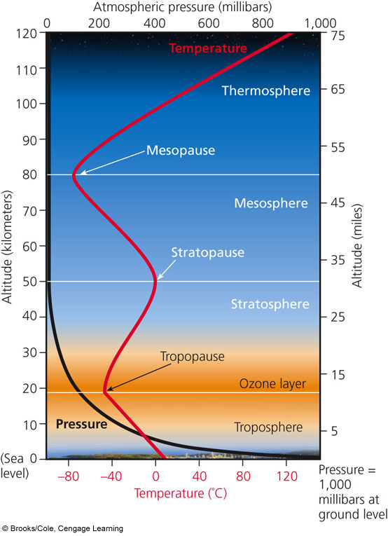
Stratosphere:
- Concentration of ozone (O3) is higher here called the ozone layer
- Describe how stratospheric ozone is produced: when O₂ interacts with UV radiation, O₃ is produced
3O₂ + UV 2O₃
- Why is ozone called the “global sunscreen?”
Keeps about 95% of the sun’s harmful UV rays from reaching the Earth
- Ozone in this layer of the atmosphere protects us from: sunburns, skin and eye cancer, cataracts

Troposphere:
- 80% of earth’s air mass
- Closest to the surface of earth
- Air we breathe is 78% Nitrogen and 21% Oxygen
- Air currents and wind cause weather and climate to happen in this layer

18-2: What Are the Major Outdoor Air Pollution Problems?
Air pollution is the presence of chemicals in the atmosphere high enough to harm organisms, ecosystems, or human-made materials.

Natural Sources | Sources of Air Pollution | Human Sources
-dust blown from wildfires and volcanic eruptions  -Volatile Organic Compounds (VOCs) released by plants |  | -most are generated by burning fossil fuels in industrial plants (stationary source) and cars (mobile source).
Case Study: Air Pollution in the Past- The Bad Old Days
Air pollution probably began when humans discovered fire and were breathing in unhealthy smoke and soot.
The Industrial Revolution (late 1700’s) brought even worse air pollution when coal was burned to power factories and heat homes. This brought an increase in cases of asthma, bronchitis, and allergies.

History of Air Pollution in London-
1880: prolonged coal fog killed 2,200 people in London.
1905: the word smog was invented to describe the mixture of smoke and fog
1952: a dangerous yellow fog lasted 5 days and killed nearly 10,000 Londoners
*This tragedy prompted the Clean Air Act of 1956.

History of Air Pollution in the US-
1948: Donora, Pennsylvania- pollution from coal burning factories, zinc smelter, and a sulfuric acid plant became trapped in dense fog that stagnated over the area for 5 days. 6,000 became ill and 20 died. This was the result of a temperature inversion.

Primary Pollutants | Categories of Air Pollution | Secondary Pollutants
-harmful chemicals emitted directly into the air from natural processes and human activity |  | -happens when primary pollutants react with each other and form new harmful chemicals

If there are more factories and cars in urban areas, why do rural areas still have to deal with some primary and secondary pollutants? Prevailing winds can spread air pollutants from urban areas to rural areas.
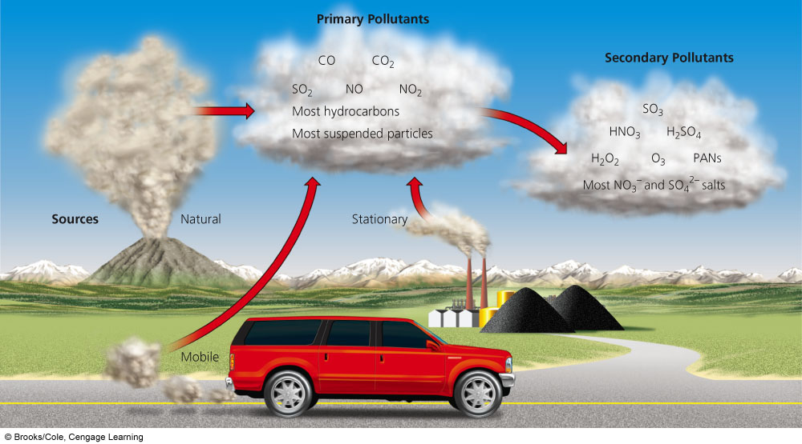

Major Outdoor Air Pollutants
Name | Characteristics | Sources | Effects
Carbon Oxides | ______- colorless, odorless gas; highly toxic  ______- colorless, odorless gas | CO- car exhaust, burning forests or grasslands, tobacco smoke, open fires, inefficient stoves  CO₂- most is from the result of the natural carbon cycle;  the rest is from burning fossil fuels, clearing CO2 absorbing forests | CO- reacts with hemoglobin in red blood cells and reduces blood’s ability to transport O₂. Chronic exposure leads to asthma, emphysema, mental impairment, coma, death  CO₂- global warming and climate change  Catalytic Converters- converts dangerous CO emissions from cars to CO₂
Nitrogen Oxides and Nitric Acid  NO_{x} refers to NO and NO₂ | ____- colorless gas that forms when nitrogen and oxygen gas react  In the air, NO reacts with O₂ to form NO₂ (a reddish brown gas)  ___________- NO₂ reacts with water vapor to form nitric acid (component of acid rain)  _____- greenhouse gas | NO- combustion engines and coal burning power plants  (Lightening and bacteria can also produce NO as part of the nitrogen cycle.)  N₂O- emitted from fertilizers, animal waste, and from the burning of fossil fuels | NO- photochemical smog, can irritate eyes, nose, and throat and aggravate asthma , suppress plant growth  Nitric Acid- photochemical smog, acid deposition  N₂O- leads to an increase in global warming
Sulfur Dioxides and Sulfuric Acid | ____- colorless gas with irritating odor  ________ acid- SO₂ in the air is converted to sulfuric acid (H₂SO₄) and sulfate salts | SO₂- combustion of coal, oil refining, and smelting of sulfur oxides | Both SO₂ and Sulfuric Acid- acid deposition, reduce visibility, aggravate breathing problems, damage crops, trees, soil and aquatic life, corrode metals, and damage paint and stone on buildings and statues.
Name | Characteristics | Sources | Effects
Particulates | Suspended ________________ Matter (SPM)  Variety of solid particles and liquid droplets that remain suspended | Most comes from natural sources like dust, wildfires, and sea salt  Human sources- coal burning plants, industrial plants, cars, unpaved roads | SPM is linked to adverse respiratory effects, reduce visibility, corrode metals  Fine Particles- <10micrometers in size  Ultrafine- <2.5micrometers in size  These are the most dangerous particulates: irritates nose and throat, damages lungs, asthma,  Toxic Particulates- lead, cadmium, and PCBs can cause mutations, reproductive problems, etc
Ozone | _____- Colorless, highly reactive gas- major component of photochemical smog | Secondary pollutant  Humans are INCREASING ozone in the troposphere and DECREASING ozone in the stratosphere | Ozone in the TROPOSPHERE= BAD ozone  -breathing problems, aggravate  lung and heart disease, irritate  eyes, damages plants  Ozone in the STATOSPHERE= GOOD ozone  -protects us from harmful UV rays
Volatile Organic Compounds (VOCs) | -Exist as gases in the air  -Most are hydrocarbons  -Benzene | Plants, wetlands, termites, rice paddies, landfills, oil wells, cows belching  Industrial solvents, dry cleaning fluids, gasoline, plastics, paints | Can cause leukemia (from benzene exposure), blood disorders, dizziness, death
Case Study: Lead is a Highly Toxic Pollutant-
Lead (Pb) is a potent neurotoxin that does not break down in the environment.
Exposure causes nervous system impairment, lowered IQ, shortened attention span, etc.
Between 1976 and 2000, there has been a huge drop in lead poisoning cases because the government banned leaded gasoline and leaded paint.
Some children are still being exposed because of: leaded paint found in homes built before 1960 and illegal use that continued through 1978 as well as toys that are made overseas in countries that have not banned lead paint.

Science Focus: Detecting Air Pollutants
One way to detect air pollutants is through a biological indicator- Lichen
Lichen forms from a mutualistic relationship between fungi and algae.
They are good indicators because they continually absorb air.
Highly Polluted Area= grey-green crusty lichen or none at all
Moderate Air Pollution= orange crusty lichen
Clean Air Areas= leafy lichen on walls and trees
“Old Man’s Beard” Lichen and “Evernia” Lichen are sensitive to sulfur dioxide.

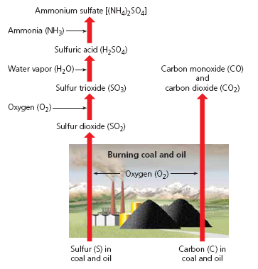

Burning coal produces INDUSTRIAL SMOG:
-When coal and oil are burned:
1. Carbon is converted to CO and CO₂
2. Sulfur reacts with O₂ to produce SO₃
3. Some of the SO₂ reacts with water vapor to
produce sulfuric acid (H₂SO₄)
4. Some of the H₂SO₄ reacts with NH₃ to
form solid ammonium sulfate
5. Unburned carbon goes into atmosphere is
known as particulates (soot).
*All of these chemicals and particulates give
smog the gray color.

-Today Industrial smog is less of problem in developed countries because of pollution control, such as tall smokestacks to blow pollution downwind to rural areas. It is still a problem in developing countries that still burn coal in houses and factories with inadequate pollution control. China has highest levels of industrial smog.
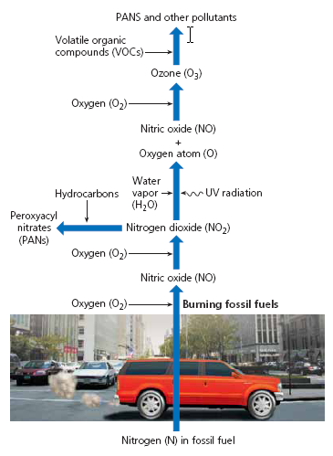
PHOTOCHEMICAL SMOG- mixture of primary
and secondary pollutants under the influence of UV
radiation.
- Exhaust from car releases NO & VOCs, and
the NO is converted to a reddish brown NO₂.
- UV radiation causes a reaction between NO₂
and VOCs
- The resulting photochemical smog is a mixture of
ozone, nitric acid, aldehydes, PANs.
Collectively, these chemicals oxidize certain
compounds in the atmosphere & your lungs!
*Hotter days leads to higher levels of smog.
*Cities in sunny and dry climates with lots of cars
have higher levels of smog. Ex: Los Angeles, Denver

Factors that REDUCE Air Pollution | Natural Factors That Influence Outdoor Air Pollution | Factors that INCREASE Air Pollution
1. Particles heavier than air settle due to gravity  2. Rain and snow cleanse the air of pollutants  3. Salty sea spray from oceans wash out pollutants from air that flows over the ocean  4. Winds sweep pollutants away, diluting it with cleaner air  5. Some pollutants are removed by  chemical reactions |  | 1. Urban buildings can slow wind speed and reduce dilution of pollutants  2. Hills and mountains reduce flow of air in valleys so pollutants build up at ground level  3. High temperatures promote photochemical smog  4. Emissions of VOCs from certain trees and plants helps form photochemical smog  5. Grasshopper Effect- air pollutants are transported by evaporation and winds to the polar regions  6. Temperature Inversions (see below)

TEMPERATURE INVERSION
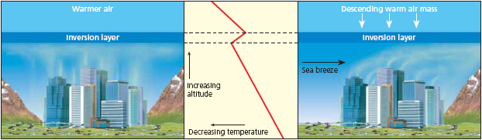

Temperature Inversions- can cause pollutants to build to a high level
Cities that are built in valley are subject to temperature inversions that can trap pollutants over a city for days or weeks. This occurs when a layer of warm air sits atop cooler polluted air over a city and prevents the cool air from rising and dispersing the pollutants. Cities with a sunny climate, light winds, and mountains on 3 sides (ex: Los Angeles) are also vulnerable.

18-3: What is Acid Deposition (aka Acid Rain) and Why Is It a Problem?
Acid Deposition is the result of humans disrupting the Sulfur and Nitrogen cycles.

Tall Smokestacks are used to emit SO₂, particulates, and NO_{x} high into the air where wind can mix, dilute, and disperse them. This reduce local air pollution, but increases regional air pollution downwind.
As primary pollutants are emitted and travel downwind, they mix and form secondary
pollutants like sulfuric acid and nitric acid vapor.
- These acidic substances remain in the air for days and can descend to the earth’s surface in 2 ways:
- Wet Deposition – acidic rain, snow, fog, cloud vapor with a pH <5.6
- Dry Deposition- acidic particles

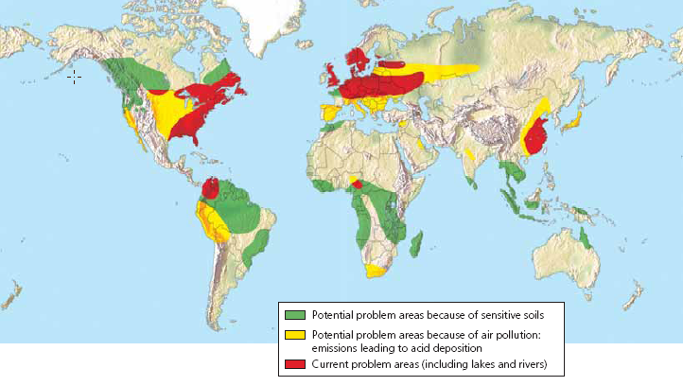
It is a regional problem for areas downwind from coal burning facilities and urban areas.

Some soils contain basic compounds (like CaCO₃ or limestone) that act as a buffer to neutralize acid.

Areas with thin, acidic soil and areas that have lost buffering ability due to decades of acid rain are most sensitive to acid deposition.

Harmful Effects of Acid Deposition
- Respiratory disease
- damages statues, monuments, buildings, metals, car finishes
- decrease visibility
- can leach toxic metals (lead and mercury) from soils and rocks into lakes and
accumulates in the tissues of organisms (pregnant women shouldn’t eat fish for risk of mercury
contamination)
- makes some aquatic ecosystems too acidic- most fish can’t live below a pH of 4.5
- harm crops if soil pH is below 5.1
- affects forests by leaching essential plant nutrients (calcium and magnsium) from soils and releasing aluminum, lead, and mercury which are toxic to trees- weakens the trees; mountain top trees are the hardest hit

SOLUTIONS TO ACID DEPOSITION
Prevention | Clean Up
- Reduce coal use  - Burn low-sulfur coal  - Increase use of renewable energy sources  - Remove SO₂ and NO_{x} from smokestack gases  - Remove NO_{x} from car exhaust  - Tax emissions of SO₂ | - Add lime to neutralize acidified lakes  - Add phosphate fertilizer to neutralize acidified lakes

18-4: What Are the Major Indoor Air Pollution Problems?
Indoor Air Pollution:
- Biggest pollution threat to the poor in developing countries
- caused by burning wood, charcoal, etc.in poorly ventilated areas
- Sick Building Syndrome- buildings that have air pollutant counts high
enough to cause health issues

Examples of Indoor Air Pollutants
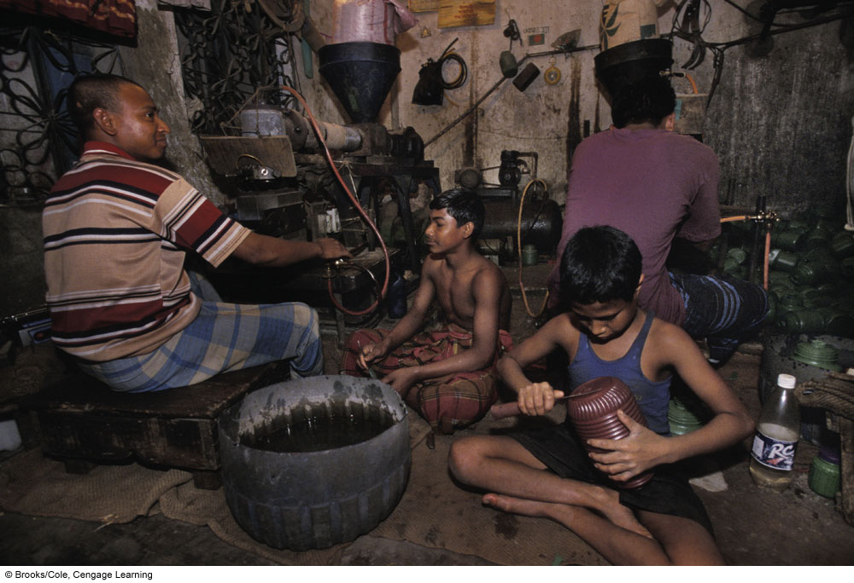
- Pesticides and lead brought in your shoes
- Living organisms and their excrements
- dust mites , cockroach droppings
- Airborne spores of mold and mildew
- Tobacco smoke
- Formaldehyde- causes most difficulty in people in developed countries
- Radioactive radon gas
- Very fine particles

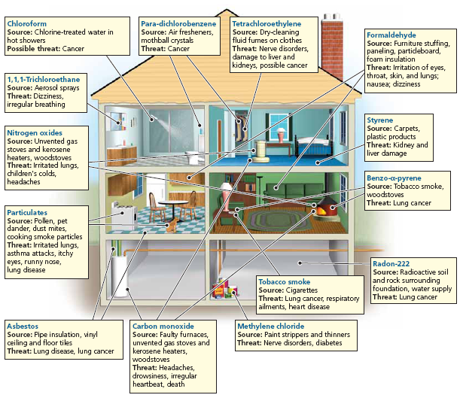
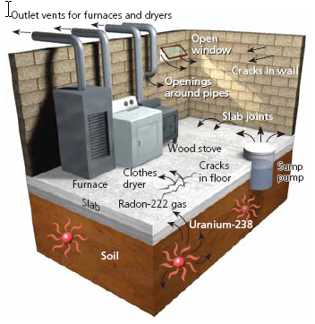

Case Study- Radioactive Radon Gas
- Produced by natural radioactive decay of
Uranium-238 in rocks and soils
- Enters a home through the cracks in the
foundation and walls
- Constant exposure can lead to lung cancer
18-5: What Are the Health Effects of Air Pollution?
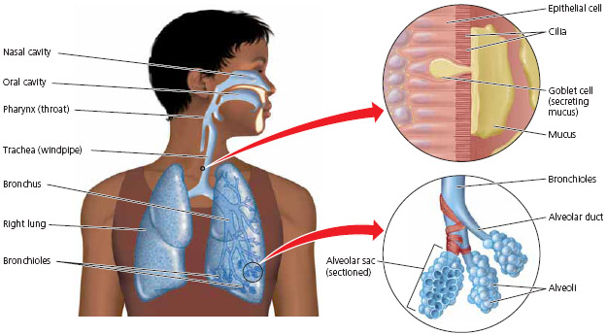
The Respiratory System is a good line of defense against air pollution:
- Nose hair filters large particles
- Mucus captures smaller particles
- Sneezing and coughing expel air pollutants too
- small, hair-like cilia
Prolonged exposure to air pollutants can overload or break down these natural defenses.
Fine and Ultrafine (most dangerous) particulates get lodged deep in the lungs and contribute to lung cancer, asthma, and emphysema.
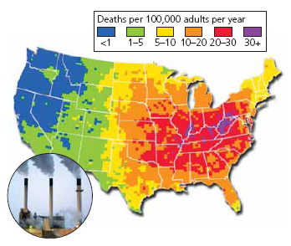

Air Pollution is a Big Killer:
- The World Health Organization (WHO) estimate
that 2.4 million people die each year due to the
effects of air pollution.
- 2.2 million of those deaths are due to indoor
air pollution.

18-6: How Should We Deal with Air Pollution?
EPA has established
*The 6 outdoor criteria air pollutants:
- Carbon Moxide 4. Nitrogen Dioxides
- Particulates 5. Ozone
- Sulfur Dioxide 6. Lead
*Hazardous Air Pollutants (HAPS)- emissions standards
*Toxic Release Inventory (TRI)- factories, mines, refineries must report their release
of toxic chemicals

Congress has passed air pollution laws, but there is room for improvement:
- US relies mostly on pollution clean up, rather than prevention
- We have failed to increase fuel efficiency in cars
- Little regulation of oceangoing ships
- Airports are exempt from regulations
- Laws don’t regulate emissions of CO₂
- Ultrafine particles are not regulated
- Does not deal with indoor air pollution

Outdoor | Air Pollution Solutions | Indoor
- Emissions Trading (aka:  Cap and Trade) allows major “polluters” to buy and sell emissions allotments to help reduce SO₂ emissions  - Burn low sulfur coal  - Disperse emissions above thermal inversion layer with tall smokestacks.  - Use mass transit  - Give large tax breaks for those who buy low polluting vehicles  - Inspect car emissions throughout the year  - Rely more on renewable energy sources  - Improve energy efficiency  - Carbon Capture and Storage (aka Carbon Sequestration)- captures CO₂ emissions from power plants, transports that CO₂, and then stores it underground. |  | - Ban smoking  - Stricter formaldehyde emissions from carpet and furniture companies  - Use office machines in well ventilated areas  - Less polluting cleaning supplies  - Circulate buildings air through rooftop greenhouses  - Use exhaust hoods for stoves  - Prevent radon infiltration  - Distribute cheap, efficient stoves or solar cooker to developing countries  - Develop cheap tests for indoor air pollutants  - Radon detectors

CHAPTER 20 Water Pollution

Core Case Study: Lake Washington
- What was being dumped into Lake Washington by the mid-1950s? wastewater
- What did the growth of cyanobacteria do to the lake?
The cyanobacteria grew quickly and darkened the water due to the high phosphorus levels from the wastewater. This eventually led to the decrease of fish populations.

- What was done to help rectify the situation?
The wastewater effluent was diverted to the Puget Sound so that the tides could mix and dilute it with ocean water

20-1: What are the Causes & Effects of Water Pollution
Define water pollution: any chemical, biological, or physical change in water quality that harms living organisms or makes water unusable for desired uses.
Point Source | WATER POLLLUTION | Non-Point Source
-comes from a single point  -easy to identify, monitor, and regulate  -developed countries have laws to regulate most of this | What Is It? | -broad and diffuse areas from which pollutants enter water or air  -difficult to identify and control  -there has been little progress to control this type of pollution
-pollution from drainpipes, ditches, or sewer lines  -factories, sewage treatment plants, underground mines, oil tankers | Examples | -runoff of chemicals and sediments from croplands, feedlots, logged forests, urban streets, parking lots, lawns, and golf course

What are the 3 biggest sources of water pollution?
- Agricultural activities
- Sediment eroded from agricultural lands is the largest source
- Fertilizers & pesticides
- Bacteria from livestock & food processing waste
- Industrial facilities
- organic & inorganic chemicals
- Mining
- Erosion of sediments & runoff of toxic chemical

How have parking lots become a major source of nonpoint pollution? Grease, toxic metals, and sediments collect on the impervious surfaces and runoff into rivers and lakes

A new form of water pollution is in the form of plastics. The polymers of plastic break down very slowly and pollute many waterways.

One of the major water pollution problems people face is exposure to infectious disease organisms through contaminated drinking water.

How many diseases can be spread through water vectors? 500
3.2 million die every year from water diseases. Most are under age 5.
1.2 billion worldwide have no access to clean drinking water (this almost is 1 in every 7!!)
The consequence of diarrhea and dehydration is the major killer from these diseases.

Table 20-1 is extremely important for this chapter!
Type and Effect | Examples | Major Sources
PATHOGENS- cause disease | Bacteria, viruses, protozoa, parasites | Human and animal waste
OXYGEN DEMANDING WASTE- depletes DO needed by aquatic species | Biodegradable animal wastes and plant debris | Sewage, animal feedlots, food processing facilities
PLANT NUTRIENTS- excessive algae growth (algal blooms) | Nitrates and Phosphates | Sewage, animal waste, inorganic fertilizer
ORGANIC CHEMICALS- adds toxins to aquatic systems | Oil, gasoline, plastics, pesticides, cleaning solvents | Industry, farms, households
INORGANIC CHEMICALS- adds toxins to aquatic systems | Acids, bases, salts, metal compounds | Industry, households, surface runoff
SEDIMENTS- disrupts photosynthesis and food webs | Soil, silt | Land erosion
HEAVY METALS- cause cancer, disrupt immune and endocrine system | Lead, mercury, arsenic | Unlined landfills, household chemicals, mining refuse, industrial discharges
THERMAL- makes some species vulnerable to disease | Heat | Electric power plants (coal burning, nuclear, etc) and industrial plants

Table 20-2: List 4 diseases transmitted through water that cause diarrhea:
- Typhoid Fever 2. Cholera 3. Dysentery 4. Giardiasis

Science Focus: Testing Water for Pollutants
- Fecal coliform bacteria from human and animal waste indicate water contamination. To be deemed safe for drinking, water can have 0 colonies; for swimming 200 colonies. Raw sewage has several million colonies.
- Levels of dissolved oxygen (DO) can indicate the presence of bacteria.
- Two indicator species for water pollution are plants, like cattails, and bottom dwelling species, like mussels and other macroinvertebrates.
- Define turbidity: the amount of suspended sediments in water; the cloudiness of water

20-2: What are the Major Water Pollution Problems in Streams and Lakes?
Rivers and streams can naturally recover from wastes through dilution
and biodegradation by bacteria.
This recovery process does not work when: streams become overloaded with
pollutants, or when drought, damming, and water diversions reduce the flow of water.

What is an oxygen sag curve? In a flowing stream, the breakdown of biodegradable wastes
by bacteria depletes DO and creates an oxygen sag curve.
This reduces or eliminates the populations of organisms with high O₂
requirements until the stream is cleansed.

Label the diagram of the oxygen sag curve below:
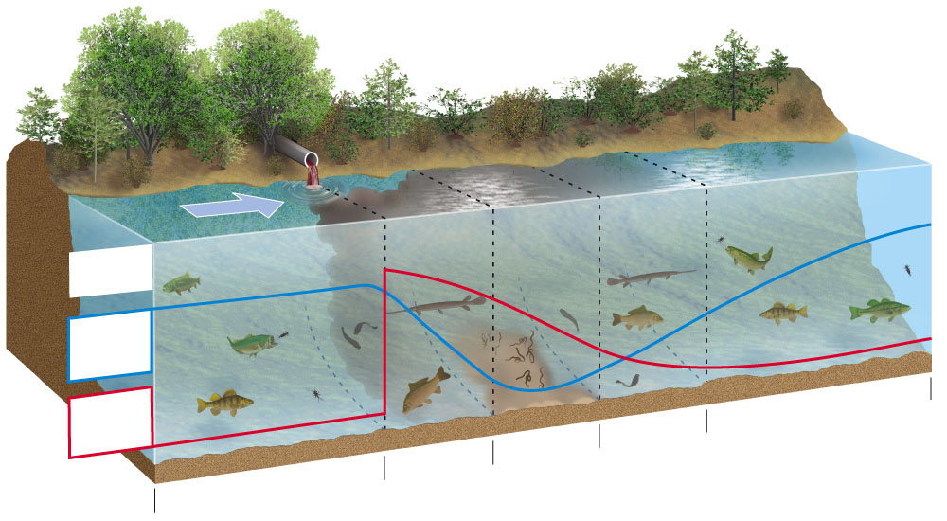

Stream Pollution in Developed Countries
Water pollution laws were set in the 1970s.
Successful clean ups of the Cuyahoga River:
It was once so polluted that it caught fire! The new laws limited industrial discharge
of waste and funds were provided to improve wastewater treatment facilities.

Stream Pollution in Developing Countries
Most of the world’s polluted river are in developing countries because they cannot afford to build wastewater/sewage treatment plants and/or do not have laws or the ability to enforce them.
80-90% of raw sewage is dumped directly into rivers, lakes, and streams
Industrial and sewage waste pollutes 2/3 of India’s rivers
In China about 300 million people do not have access to drinkable water
India’s Ganges River:
According to the Hindu people, the Ganges is a holy river. People use it to bathe, drink from or take a dip. But it is highly polluted by the people and the industries in the 29 cities in the basin. Complicating the situation, Hindus believe they must cremate the dead. Putting the ashes in the Ganges increases chances of getting to heaven. However, many people cannot afford enough money for cremation, so the bodies are dumped into the river.
** Decomposition of these bodies depletes DO and adds disease carrying
bacteria and viruses to the water.
Another religious custom is to throw painted statues into the water which releases
toxic metals such as lead and mercury into the water.

Lakes are less effective at diluting pollutants because:
- The stratified layers of the lake rarely mix vertically.
- They have little no flow of water

Define: Eutrophication- the natural nutrient enrichment of lakes and estuaries
**Cultural eutrophication is caused by HUMAN impact.

Oligotrophic- a lake that is low in nutrients, therefore very clear water

The most common culprits for cultural eutrophication are plant nutrients (nitrates and phosphates)
Explain how cultural eutrophication kills fish: (Remember we’ve done this before!)
- High levels of nitrates and phosphates (from fertilizers, animal waste, and mining sites) cause algal blooms and overgrowth of aquatic plants.
- The dense plant life then reduces the lake’s productivity because of the sun’s inability to penetrate the water.
- When the algae die, they are decomposed by aerobic bacteria that use oxygen in order to function, therefore depleting the water of dissolved oxygen.
- Aquatic life that needs oxygen will begin to die off.
**If excess nutrients continue to flow into the lake, then anaerobic bacteria take over and produce smelly, toxic hydrogen sulfide and methane.

How to fix cultural eutrophication:
- Use advanced wastewater treatment to remove nitrates and phosphates before wastewater enters the lake.
- Banning or limiting the use of phosphate containing detergents.

What two lessons can be learned from the story of Lake Washington?
- Severe water pollution can be reversed in a fairly short amount of time if pollutant inputs are sharply reduced.
- Citizen action and scientific research works to spark change.

Briefly describe the history of the Great Lakes as far as being affected by water
pollution.
1960’s- many areas are suffering from cultural eutrophication, fish kills, and
contamination from bacteria and toxic industrial waste
Since 1970’s- US and Canada have spent more than $20 billion on pollution control by
upgrading sewage treatment plants, better treatment of industrial waste, and
bans on detergents and cleaners that contain phosphates.
2000’s- Scientists report that:
      - raw sewage is still being dumped or overflowing into the lakes.
      - There has also been an increase in runoff of fertilizer and pesticides fueled by population growth.
      - Biological Pollution- invasion of zebra mussels threaten native species
      - Half of the toxic compounds entering the water are coming from atmospheric deposition.
      - Water is filled with toxic flame retardant chemicals and pharmaceuticals.

20-3: What Are the Major Pollution Problems Affecting Groundwater and Other Drinking
Water Sources?

Name several common pollutants that pollute groundwater:
-fertilizers -pesticides -gasoline -organic solvents

Describe why it is difficult and costly to remove contaminants from groundwater.
-flows very slowly so contaminates are not diluted or dispersed.
-very low levels of DO and small populations of decomposing bacteria
-the cold temperature of groundwater slows down decomposing chemical reactions

Toxins dumped underground pose a risk to our aquifers:
The EPA says that 1/3 of the industrial waste ponds in the US have no liners, therefore toxic waste is likely leaking underground.
2/3 of our liquid hazardous wastes are injected into deep disposal wells that can leak
into aquifers.
Inside those leaky tanks are: gasoline, oil, MBTE (a gasoline additive and carcinogen),
and nitrate ions.
      - Nitrate ions in drinking water can cause Blue Baby Syndrome which kills infants because the blood can’t carry oxygen.

How does drinking water become polluted with arsenic?
Naturally: Arsenic can contaminate drinking water if a well is dug in an area with rocks and soil that are naturally rich in arsenic.
Human Caused: Mining and ore processing
Arsenic can cause: skin, lung, and bladder cancer

Describe prevention and cleanup solutions to groundwater pollution.
Prevention: Install monitoring wells near landfills, require leak detectors in
underground tanks, store harmful liquids above ground

Clean Up: pump groundwater to surface, clean, and return water to aquifer, inject
micro-organisms to clean the water

Describe how each purifies drinking water:
Developed Countries | Sewer Wastewater | Tropical Countries | The LifeStraw
-water is left in a reservoir and then pumped to a purification plant to be treated | -some areas are directly purifying their wastewater into drinking water  “toilet to tap” system | -expose a clear, plastic bottled to intense sunlight  - the UV rays can kill infectious microbes  -decreases chance of diarrhea by 40% | -portable water filter that removes viruses and parasites  -used in Africa  -you can even buy one online for hiking!

How has New York City protected its watershed in order to have pure water?
Several major cities have avoided spending $ on water treatment facilities and have instead invested in protecting the watershed and wetlands.
Forests cover ¾ of New York’s watershed and underground tunnels transport water to the city.

What is the US Safe Water Drinking Act? Is it working?
The EPA has established national drinking water standards, however it is estimated that 1/5 of Americans are drinking water from facilities that violate these safety standards. Scientists are also hoping in the future this law will ban lead from being used in the water pipes.

Is drinking bottled water worth it?
Probably not… About ¼ of bottled water is actually just ordinary tap water.
Government testing standards are much lower for bottled water than for tap water.
List a few harmful impacts bottled water has on the environment.
The plastic bottles thrown away each year could circle the equator 8 times!
Toxic gases and liquids are released during the manufacturing of the bottles.

20-4: What are the Major Water Pollution Problems Affecting Oceans?
40% of the world lives on or near the coast, with 14 of the world’s 15 largest
metro areas being on the coast.
80% of marine pollution is from the land.

Using Figure 20-15, pick 3 to describe below:
3 Examples of Sources of Marine Pollution
1. Industry | 2. Farms | 3. Urban Sprawl
-NOx from cars and smokestacks, heavy metals from effluents flow into bays and estuaries | -runoff of pesticides, manure, and fertilizers add toxins and excess nitrates and phosphates | -bacteria from sewers contaminate beaches, fertilizer runoff from lawns adds nitrates and phosphates

How are cruise ships contributing to marine pollution?
Cruise ships generate as much waste as a small city. Toxic pollutants from dry cleaning, benzene from paints and solvents, plastic garbage and human waste are sometimes illegally dumped into the sea.

What causes oxygen-depleted zones?
Runoff of sewage- aerobic decomposers work overtime to break down waste, thus
depleting the water of dissolved oxygen, waste can also contain high levels of
nitrates and phosphates which also lead to algal blooms and oxygen depletion

Runoff of fertilizers- adds excess nitrates and phosphates into the water which sparks
algal blooms, the algae blocks sunlight and uses up all of the nutrients, once
algae and plants begin to die, the aerobic decomposers have to work overtime
to break down the dead waste, thus depleting the water of oxygen.

Red Tides- excessive nitrogen causes explosive growth of toxic algae that poisons fish and
some marine mammals

Ocean Oil Pollution:
What happened to the Exxon Valdez oil tanker in 1989?
The oil tanker went off course, hit rocks, and released 10 million gallons into
Alaska’s Prince William Sound. The oil killed a large number of seabirds, fish,
and otters. The cleanup and settlement claims cost the company over $4 billion!

What is actually the largest source of ocean oil pollution?
Oil spills get a lot of publicity, but urban and industrial runoff is actually the largest source of oil pollution in the ocean.

What affect does oil have on marine life?
Volatile Organic Hydrocarbons immediately kill many aquatic organisms, globs of oil coat the feathers of birds and fur of marine mammals which destroys their natural heat insulation and buoyancy, causing many of them to drown.

Heavy oil that sinks to the bottom of the ocean smothers benthic organisms like crabs, oysters, mussels, and clams.

Oil slicks that wash onto beaches can have a massive economic impact.

Options for cleaning up Oil Spills:
Floating booms, skimmer boats, dispersant chemicals, fire, oil eating bacteria

List prevention and cleanup solutions to coastal water pollution.
Prevention: Ban dumping of waste by ships, reduce input of toxic chemicals, separate
sewage and storm lines, ban ocean dumping of hazardous materials
Clean Up: Improve oil spill cleanup capabilities, use nanoparticles on sewage to
dissolve the sewage, require secondary treatment of coastal sewage water, use wetlands to treat sewage

20-5: How Can We Best Deal With Water Pollution?
Ways to reduce water pollution from nonpoint sources:
Reduce soil erosion by keeping cropland covered with vegetation.
Reduce fertilizer runoff by using slow release nitrogen fertilizer, not using fertilizer on steeply sloped land, and planting buffer zones (riparian zones).
Organic farmers use manure instead of synthetic nitrogen based fertilizers.
Apply pesticides only when needed and use an Integrated Pest Management (IPM) Plan as often as possible.
Farmers control runoff of animal waste by planting buffers and locating feedlots away from sloped land, surface water, or flood zones.

What is the Clean Water Act and what types of improvements has it led to since1992?
Sets standards for allowed levels of key water pollutants and requires polluters to get permits limiting how many pollutants can be discharged into aquatic systems.
- # of Americans served by community water systems that met federal standards increased from 79% to 94%
- % of streams that are swimmable and fishable increased from 36% to 60%
- Amount of topsoil erosion cut by 1 billion tons/year
- US population served by sewage treatment increased from 32% to 74%
- Annual wetland losses decreased by 80%

Some homes have septic tanks. Describe how this works. See figure 20-18.
Septic tanks are sometimes used in rural and some surburban areas.

Household sewage is pumped into a settling tank where grease and oil rise to the top and solids fall to the bottom where they are decomposed by bacteria. The partially treated wastewater is then discharged into an absorption field where the soil filters out pollutants and soil bacteria continue to decompose waste.

Ever few years, the tank become full and must be pumped where it is then taken to a sewage treatment facility.

**Chlorine bleaches and antibacterial soaps shouldn’t be used in these systems! Why do you think that is?

Many homes send their wastewater to sewage treatment plants. The steps are:
  - STEP ONE: PRIMARY Sewage treatment is a physical process
    - Goal: removes solids
    - Pieces: by using screens, grit tanks, and settling tanks
    - Does not remove: pathogens, nitrates, phosphates, salts, radioisotopes, or pesticides
  - STEP TWO: SECONDARY Sewage treatment is a biological process
    - Goal: aerobic bacteria removes oxygen demanding waste, most toxic metals, most nitrates and phosphates
    - Pieces: aeration tanks with bacteria, settling tanks, chlorine disinfection tanks that kills the bacteria that was put into the water during this step
    - Does not remove: pathogens, some pesticides, radioisotopes
  - BEFORE DISCHARGE: water is subject to bleaching (to remove color from water) or disinfection to remove bacteria and viruses.
This is mostly done with chlorine, however this chlorine can react with other organic materials to form chlorinated hydrocarbons that can cause cancer, increase the risk of miscarriage, and damage the nervous and endocrine system.

Some treatment plants are using ozone or UV light to disinfect the water instead.
  - STEP THREE: TERTIARY (ADVANCED) Sewage treatment is a chemical process
    - Goal: removes specific pollutants left in the water
    - Pieces: special filters and chemicals to remove nitrates and phosphates
** This is not widely used because of the cost and it is not required by law.

Describe a few issues that may arise in wastewater treatment plants in the US.
- By law, the sewage treatment plants must have the primary and secondary treatment but in some cases towns can be exempt from secondary treatment if the cost becomes too much of a burden.
- Removing the chlorine disinfecting step (for fear of cancers and body system damage) can increase risk of diseases like cholera!
- Some cities have combined stormwater drains and sewer drains because it is cheaper. However, heavy rains can cause overflow and sewage contamination.
Solutions to Water Pollution:
-prevent groundwater contamination, reduce nonpoint runoff, reuse treated wastewater for irrigation, work with nature to treat sewage
CHAPTER 17 Health & Toxicity

Core Case Study: The Global HIV/AIDS Epidemic
Describe why people die of AIDS if AIDS itself is not deadly.
AIDS destroys the immune system, therefore people will die from other diseases that
the body could not fight off.

List 3 ways the virus is transmitted person to person.
- Unsafe sex 2. Sharing needles 3. Infected mothers pass to babies

Explain how AIDS has impacted the populations of African regions.
-AIDS has reduced the life expectancy in Africa from 62 to 47 years old.
-The premature death of teachers, healthcare workers, soldiers, etc has led to diminished education, healthcare, and food production.
-Millions of children are orphans.

17-1: What Major Health Hazards Do We Face?
Define: Risk- probability of suffering harm from a hazard that can cause injury, disease,
death, economic loss, or damage

Risk Assessment- using statistical methods to estimate how much harm a hazard
has to human health or the environment

Risk Management- deciding whether or how to reduce a risk and at what cost

5 Major Types of Hazards:
Biological Hazards | from more than 1,400 pathogens that infect humans  EX: bacteria, viruses, protozoa, parasites, fungi
Chemical Hazards | from harmful chemicals in the air, water, soil, and food
Physical Hazards | fire, earthquakes, volcanic eruptions, floods, and storms
Cultural Hazards | unsafe working conditions, unsafe travel, poverty
Lifestyle Choices | moking, eating too much, drinking too much alcohol, unsafe sex

17-2: What Types of Biological Hazards Do We Face?
Disease | Caused By… | Examples
- Nontransmissible | something other than a living organism and does not pass person to person | heart disease, most cancers, asthma, malnutrition
- Infectious  -Transmissible | A pathogen, such as bacteria, viruses, or parasites, that invade the body multiplies in its cells and tissues | Flu, HIV, tuberculosis, measles
 | An infectious disease that can be transmitted from one person to another | Flu, HIV, tuberculosis, measles

According to figure 17-4, the 3 major causes of death are:
cardiovascular disease, infectious disease, cancers

Why has the average life expectancy increased in most countries?
The #1 cause of death used to be from infectious disease. This has been reduced by
better healthcare, the use of antibiotics, and the development of vaccines.

List the major pathways for infectious diseases in humans:
pets, livestock, wild animals, insects, food, water, air, other humans

Epidemic vs. Pandemic
-large scale outbreaks -a global outbreak
in one region or country

Tuberculosis:
Prevalence: | Why has there been an increase in TB? | How can we slow the spread of TB? | What is multi-drug resistant TB?
9.2 million people per year | -too few TB screenings and control programs  -many strains have developed genetic resistance to antibiotics  -increased global travel | -early identification and treatment  -use of 4 inexpensive drugs that must be taken for 6-8 months | A deadly and incurable strain of TB has formed because it is now resistant to medication.  Those infected must be quarantined.

Science Focus: Genetic Resistance to Antibiotics is Increasing
- What is causing bacteria to become resistant to antibiotics?
-bacteria multiplies rapidly, increased international travel, availability of antibiotics without a prescription are taken improperly, antibacterial handsoaps

- What is MRSA and why has it become a problem?
-MRSA is a staph infection that has become resistant to antibiotics and is being found more often in public places.
-The infection causes painful, pus filled bumps on the skin.
-MRSA can cause a form of pneumonia, flesh eating wounds, and death if it gets into the blood.

Describe each of the deadly viruses below:
Influenza | HIV | Hepatitis B | West Nile | SARS

Prevalence: | Caused by: | Symptoms: | Malaria-prone areas: | Why is malaria increasing? | What is being done to help?
Kills 1-2 million per year | The parasite, plasmodium, infects mosquitos that bite humans | Destroys red blood cells causing fever, chills, anemia, abdominal pain, weakness | Sub-Saharran Africa, India, South Ameria | -clearing of tropical forests  -the Anopheles mosquito has become resistant to insectidies  -global warming | -development of new antimalarial drugs, vaccines, and biological control  -genetically engineering a malaria resistant mosquito that will outcompete the other mosquitos  -mosquito nets
Malaria:

Solutions to infectious diseases do you believe are most important?
-increase research on tropical diseases and vaccines
-reduce poverty
-decrease malnutrition and improve drinking water
-reduce unnecessary use of antibiotics
-reduce antibiotic use in livestock

17-3: What types of Chemical Hazards Do We Face?
List the 5 most toxic substances to human health:
- arsenic 2. lead 3. mercury 4. vinyl chloride 5. PCBs

Describe the 3 major types of toxic agents:
Carcinogens | Mutagens | Teratogens
-causes cancer  EX: arsenic, benzene, chloroform, formaldehyde, PCBs, radon, UV light | -causes mutations in DNA  EX: some preservatives in food | causes harm or birth defects to a fetus or embryo  EX: ethyl alcohol, lead, formaldehyde, mercury, PCBs

PCBs:
- What was it used for? A class of 200 chlorine containing compounds that were widely used as lubricants, hydraulic fluids, electrical insulators, ingredient in paints, fire extinquishers, fire retardants in fabrics, and pesticides.

- Why was it banned? Banned in 1977 by the US Congress because it has been linked to liver cancer and learning disabilities in children

- Why are PCBs still causing issues even after it has been banned? PCBs are persistent chemicals that breakdown very slowly and are fat soluble and can be biomagnified. Therefore, it can still be found in our soil, air, and water.

Briefly describe how chemicals affect each of the body systems:
Immune System | Nervous System | Endocrine System
-some chemicals like arsenic, methylmercury, and dioxins weaken the immune system to the point where it can’t fight off diseases | -chemicals that are neurotoxins can cause behavioral changes, learning disabilities, retardation, ADD, and paralysis | -Endocrine disruptors  -some chemicals are HAA (hormonally active agents) that mimic hormones that impair reproductive development as well as physical disorders  EX: atrazine, DDT, PCBs, BPA  -some chemicals are hormone blockers

Mercury:
- Where does it come from?
Natural Sources- released from rocks, soil, volcanos
Human Sources- coal burning power plants, waste incinerators, metal ore
smelters
- Why is New York a hotspot for Mercury?
-coal burning power plant emissions

- How are humans exposed to Mercury?
- Inhale vaporized mercury
- Eat fish that are contaminated (mercury biomagnifies through food chain)

- What problems can Mercury cause?
-it is a teratogen and neurotoxin

- List 3 solutions to Mercury Pollution.
- Phase out waste incineration
- Remove mercury from coal before it is burned
- Switch to more renewable sources of energy

Bisphenol A (BPA):
- Where can BPA be found?
Found in plastics, baby bottles, plastic bottles, microwave dishes, etc

- What is its effect on humans?
Brain damage, prostate disease, breast cancer, early puberty, type 2 diabetes

17-4: How Can We Evaluate and Deal with Chemical Hazards?

Define: Toxicology- study of harmful effects of chemicals

Toxicity- measure of how harmful a substance is

Dose- amount of chemical that has been ingested or absorbed

Persistence- a chemical’s resistance to breaking down
Biological Magnification- the concentration of some toxins increase as it moves
through the foodchain

Response- the damage to health caused by chemicals

Why are infants and young children most susceptible to effects of toxic substances?
less developed immune systems; kids eat, drink, and breathe more per unit of body weight; more likely to put toys and soil into their mouths

Why are mice and rats widely used in laboratory testing?
Mice and rats are mammals that have body systems similar to ours and reproduce rapidly.
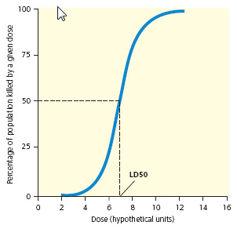
Dose-Response Curve:
What is LD50 and why is it an important number?
LD50= lethal dose to 50% of population

The dose response curve helps scientists determine
the effects of various doses.

Non-threshold dose- any dosage causes harm
Threshold dose response- a certain dosage must
Be reached before any harm is detected.

Describe 4 potentially harmful chemicals that could be found in your home.
1. Vinyl toys contain phthalates
2. Water bottles can contain BPA
3. Mattress contains flame retardant chemicals
4. Imported fruit contains pesticides

Chemical Toxin | Sources | Human or Wildlife Health Impact
PCBs | - Used as electrical insulators, fire retardant materials, pesticides, and as adhesives | - Neurotoxin causing brain damage in fetuses  - Endocrine disruptor causing reproductive cancers
DDT | - A commonly used pesticide in the US prior to banning it in 1972  - Still used in developing countries to control malaria and pests | - Biomagnifies in the food chain of ecosystems  - Causes reproductive damage and cancers in avian (bird) populations
Phthalates | - Group of chemicals used in the production of plastics  - Used as solvents in many products such as vinyl flooring, adhesives, detergents, and some personal care products like shampoo and soap | - Causes reproductive damage and cancers
Atrazine | - One of the most widely used pesticides in the US  - Herbicide primarily used to control weed populations in the Midwest | - This pesticide is currently being monitored by the EPA to determine if it is linked to endocrine cancers
Bisphenol A (BPA) | - A chemical building block for plastic consumer goods such as water bottles, food containers, and microwavable dishes | - Some evidence suggests exposure can lead to neurological damage and reproductive cancers
Heavy Metals (mercury, arsenic, lead, cadmium) | - Heavy metal pollution is often generated from smelting metals and incineration of municipal waste  - Elemental mercury is used in batteries and fluorescent lights  - Inorganic mercury released from coal burning is converted to toxic methyl mercury by bacteria | - Heavy metals often biomagnify in the food chain  - Cause neurological damage especially to fetuses  - Can be carcinogenic
Benzene | - Emissions from burning coal and oil and tobacco smoke | - Short-term exposure causes dizziness and nausea  - Long-term exposure causes damage to the liver and reproductive system, cancer, and birth defects
Vinyl Chloride | - Is a precursor to making PVC, which is commonly used in building materials and many consumer products | - Causes cancers, especially liver cancers  - Can do damage to central nervous system  - Is known to cause birth defects
Asbestos | - A naturally occurring silicate mineral formerly used in insulation materials for its fire-retardant properties | - Known to cause cancer
Dioxins | - A class of chemical compounds formed during incineration of waste materials and also in the manufacturing process of some herbicides | - Accumulate in fatty tissue of organisms (bioaccumulation)  - Carcinogen  - Causes reproductive damage
CHAPTER 21 Solid and Hazardous Waste

Core Case Study: E-waste- an Exploding Problem
What is e-waste?
Discarded TVs, cell phones, computers, electronic toys, etc

Where does most e-waste end up and why is that an issue?
Most e-waste ends up in landfills and incinerators. This waste includes high-quality
plastics and valuable metals. E-waste is also a source of toxic and hazardous
pollutants like PVS, brominated flame retardants, lead, and mercury that can contaminate the soil, air, and water.

70% of e-waste is shipped to China, India, and parts of Africa where labor is cheap
And environmental laws are almost non-existent.

The European Union uses a “cradle-to-grave” approach. What does this mean?
Cradle-to-Grave requires manufacturers to take back electronic products for repair, remanufacture, or recycle. The EU has also banned e-waste from landfills and incinerators.

Since recycling and reuse won’t be enough to deal with the issue, what should electronic companies focus on doing to help deal with this problem?
The only real long term solution is prevention that gets toxic metals out of ewaste
through green design.

21-1: What Are Solid Waste and Hazardous Waste, and Why Are They Problems?
Why is there no waste in nature?
The waste of one organism becomes nutrients for another.

How do humans differ from this principle?
Humans produce a tremendous amount of waste that goes unused and pollutes the
environment.

Categories of Waste | Definition
- Solid Waste | Any unwanted or discarded material that is not liquid or gas
- Industrial Solid Waste | Produced by mines, agriculture, and industries
- Municipal Solid Waste (MSW) | aka “garbage” from homes and businesses  EX: paper, cardboard, food waste, cans, glass, yard waste, plastic, etc
- Hazardous (Toxic) Waste | Threatens human health or the environment because it is poisonous, dangerously chemically reactive, corrosive, or flammable.  EX: industrial solvents, hospital medical waste, batteries, incinerator ash, radioactive waste from nuclear power plants

**In developed countries, most MSW is buried in landfills or burned in incinerators.
In developing countries, most MSW ends up in open dumps or surface water.

Two reasons to sharply reduce the amount of solid and hazardous wastes we produce:
- At least ¾ of these materials represent unnecessary waste.
Instead, we collect, mix, crush, and bury many potentially valuable resources.
- In producing the products we use and often discard, we create huge amounts of air pollution, greenhouse gases, water polluter, and land degradation.

The US leads the world in producing solid waste. Most solid waste produced in the US is mining waste (76%), agriculture (13%), and industry (9%).
A desktop computer requires 700 different materials. 1 lb of electronics creates 8,000 lbs of solid and liquid wastes!
The US leads the world in trash production. Each day the average American produces 4.5 lbs of MSW. The good news is that production of MSW has leveled off due to increased recycling and lighter products.
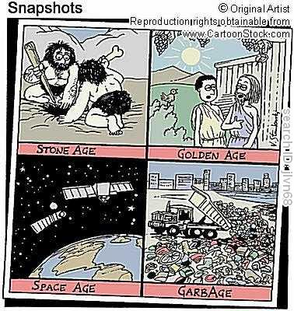

Case Study: Trash Production and Recycling in NYC
Describe why trash has decreased in NYC since 1940.
- MSW used to be really high because of
the amount of coal ash produced from
people burning coal in the home for
heat and cooking.
- NYC passed a mandatory recycling law
in 1999.

**In 2001, NYC ran out of landfill space and now
trucks all of their trash to New Jersey,
Pennsylvania, and Virginia…

21-2: How Should We Deal with Solid Wastes?

Dealing with Solid Wastes:
Waste Management | Attempt to reduce the impact of MSW without trying to reduce the amount of waste produced
Waste Reduction | Attempt to reduce waste and pollution; the waste is viewed as a resource that can potentially be reused, recycled, or composted.
Integrated Waste Management | A variety of strategies for waste management and waste reduction  First Priority: Primary Pollution and Waste Prevention  -change industrial processes to eliminate use of harmful chemicals  -use less of the harmful product  -reduce packaging  -make products last longer  Second Priority: Secondary Pollution and Waste Prevention  -reuse, repair, recycle, compost  Last Priority: Waste Management  -treat waste to reduce toxicity  -incinerate waste  -bury waste in landfills

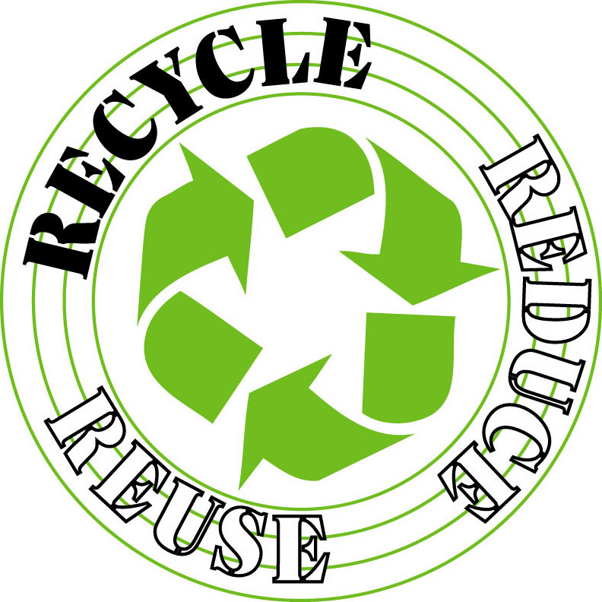
Waste Reduction is based on 3Rs
Reduce | Reuse | Recycle
-Consume less  -Live simpler | -Rely more on products that can be used repeatedly  -Use refillable cups | -separate and recycle paper, glass, cans, plastics, metal, etc  -buy only recyclable products

Seven strategies individuals and communities can reduce resource use, waste, and pollution:
- Redesign manufacturing processes and products to use less material and energy

- Redesign manufacturing processes to produce less waste and pollution.

- Develop products that are easy to repair, reuse, remanufacture, compost, or recycle.
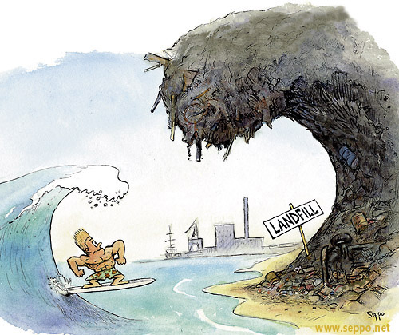
- Eliminate or reduce unnecessary packaging.

- Use fee-per-bag waste collection systems.

- Establish cradle-to-grave laws

- Restructure urban transporation.

21-3: Why is Reusing and Recycling Materials So Important?

Name some examples of reuse.
Reuse involves cleaning and using materials over and over.
-salvaging auto parts from junkyards, yard sales, flea markets, thrift stores,
rechargeable batteries

What are the 5 major types of materials that can be recycled?
1. Paper products
2. Glass
3. Aluminum
4. Steel
5. some Plastics
Two types of recycling:
Primary (closed loop) Recycling: | Secondary Recycling:
Materials are recycled into new products of the same type  EX: turning an aluminum can into a new aluminum can | Waste materials are converted into different products  EX: used tires can be shredded and turned into road or playground surfaces

Switzerland and Japan recycle 50% of their MSW.
The US recycles 25% of their MSW.

Approaches to dealing with recycling:
Materials Recovery Facilities (MRFs or “murfs”) | Source Separation | Fee-Per-Bag
-machines or workers separate the mixed waste to recover valuable materials  -the remaining waste is recycled or burned to produce steam that spins a turbine to create electricity to run the facility! (However, this does not solve the issue of toxic pollutants from burning trash) | -requires homes and businesses to separate their own trash into recyclable categories  -this approach saves time, money, and produces less water and air pollution  -however, some people may not be willing to do this and will just throw it away instead | -charges homes and businesses for the amount of waste picked up by the trash company  -it does not charge for separated recyclable materials

What is it? | Composting | What is the end product?
A form of recycling that mimics nature’s recycling of nutrients by allowing decomposers to recycle yard waste, food waste, and other biodegradable materials |  | Organic soil fertilizer, topsoil, or landfill cover

Case Study: Recycling Paper
Which type of paper is easiest to recycle? Newspaper and cardboard
What is the process for recycling paper?
-the ink, glue, and coating is removed and then reconverted into pulp

Case Study: Recycling Plastics
How many different types of plastics are used? 46
What problems occur when plastic is thrown away?
Plastic often ends up as litter on the ground or in water causing problems with
wildlife ingesting the plastic.

3 reasons why we don’t recycle plastic very much:
- Many plastics are hard to isolate from other waste. The resin is hard to separate.

- Recovering individual plastic resins does not yield much material.

- Inflation adjusted price of oil used to produce petrochemicals for making plastic resins is low enough to make the cost of making virgin plastic resins much lower than that of recycle resins.

Advantages | Recycling | Disadvantages
-reduces air and water pollution  -saves energy  -reduces mineral demand  -reduces greenhouse gas emissions  -reduces solid waste production and disposal  -helps protect biodiversity  -can save landfill space |  | -can cost more than burying waste in an area with ample landfill space  -may lose money for items such as glass and some plastics  -reduces profits for landfills and incinerator owners  -source separation is inconvenient for some people

Science Focus: What are bioplastics?
-made from biologically based chemicals like soybeans, corn, and switchgrass

How can we encourage reuse and recycling?
Government can increase subsidies and tax breaks for reusing and recycling materials
and decrease subsidies and tax breaks for making items from virgin resources.

Use the fee-per-bag waste collection system.

Label products as recyclable or not.

21-4: What Are the Advantages and Disadvantages of Burning or Burying Solid Waste?

Advantages | Burning  Solid Waste | Disadvantages
-reduces trash volume by 90%  -less need for landfills  -low water pollution  -concentrates hazardous substances into ash for burial |  | -expensive to build  -costs more than short distance hauling  -difficult to site because of citizen opposition  -older facilities release large amounts of air pollution  -creates dioxin (a super toxin that is a carcinogen)

Describe the process of waste to energy incinerator.
You will want to look at Figure 21-13.
The MSW is burned to make steam to spin a turbine to create energy.
The ash is sent to a landfill.
A scrubber and electrostatic precipitator are used to reduce SO2 emissions and particulate emissions.

Two types of Landfills:
Open Dumps | Sanitary Landfills
-fields or holes in the ground where garbage is deposited  -very rare in developed countries, but widely used in developed countries | -solid wastes are spread out in thin layers, compacted, and covered daily with a fresh layer of clay that helps keep the material dry and reduces leakage of contaminated water (leachate)

21-5: How Should We Deal With Hazardous Waste?
Describe the Integrated Management of Hazardous Waste Approach:
Produce Less Hazardous Waste | Convert To Less or Non- Hazardous Substances | Put in Perpetual Storage
-Change industrial processes to reduce or eliminate hazardous waste production | -Natural decomposition  -Incineration  -Chemical, physical, and biological treatment  -Dilution in air or water | -landfill  -underground injection wells  -surface impoundments  -underground salt formations
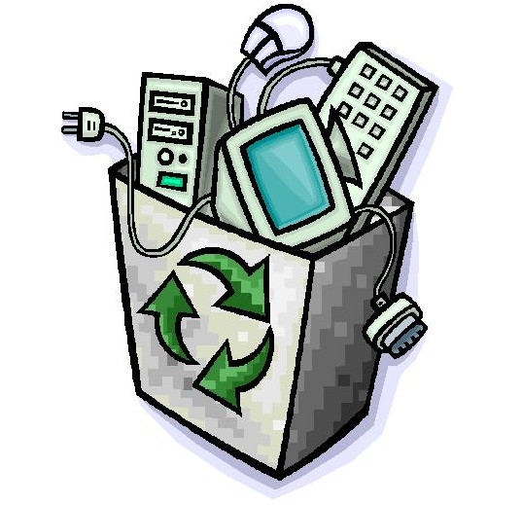
Case Study: What is e-waste and why is it a problem?
e-waste recycling programs in poor nations often
involve child workers that are being exposed to
toxic chemicals

workers usually do not wear masks or gloves and work in
rooms with no ventilation

some electronics are burned to expose copper, lead,
and other metals

after the valuable metal is removed, the leftover parts are burned or dumped

Ways to detoxify hazardous waste:
Physical Method | Chemical Method | Biological Method | Phytoremediation | Plasma Arc Torch
Using charcoal or resin to filter out harmful solids and distilling liquids to filter out toxins  Deadly waste can be encapsulated and stored in secure storage sites | Converts hazardous chemical waste into less hazardous chemicals  Cyclodextrin can remove solvents and pesticides from contaminated soil or groundwater | Bioremediation- uses bacteria and enzymes to destroy toxins to convert to harmless compounds  Takes longer, but costs less | Uses natural or genetically modified plants to absorb, filter, and remove contaminants from soil and water  EX: Sunflowers, willow trees, poplar trees | Passes hazardous waste through an electrical current at a very high temperature to create plasma  This decomposes hazardous waste into ions and atoms that can be converted to a syngas

Describe in detail the different types of Phytoremediation. Look at Figure 21-18.
- Rhizofiltration- roots of plants, such as sunflowers, can absorb radioactive strontium and cesium, and various organic chemicals.
- Phytostabilization- plants, such as willows and poplars, can absorb chemicals and keep them from reaching groundwater
- Phytodegredation- plants, such poplars, can absorb toxic organic chemicals and break them into less harmful compounds
- Phytoextraction- roots of plants, such as indian mustard, absorb toxic metals like lead and arsenic and then store them in their leaves
Storage of Hazardous Waste:
Deep Well Disposal | Surface Impoundments | Secure Hazardous Landfills
Liquid hazardous waste is pumped through a pipe into dry, porous rock formations beneath the aquifer.  Theoretically, the liquids soak into isolated rock, however there are cases where leakage into groundwater has occurred. | Ponds, pits, or lagoons are lined and hazardous waste is stored within.  As the water evaporates, the waste settles to the bottom.  These can leak into groundwater if the liner fails and heavy storms can cause it to overflow. | Hazardous waste is put into drums or other containers that are buried and carefully designed and monitored
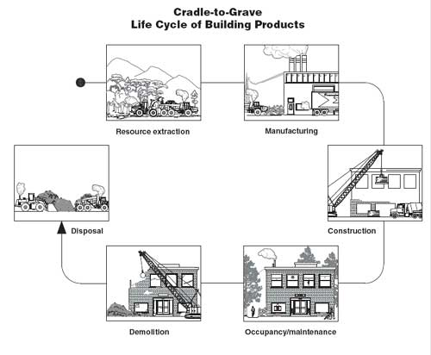
Case Study: Hazardous Waste Regulation in the US
Resource Conservation and Recovery Act-
Sets standards for management of
hazardous waste and issues permits
to companies allowing them to
produce and dispose of a certain
amount of waste

Companies will use the
cradle-to-grave system.

CERCLA- aka Superfund Act
Goal is to identify sites where
hazardous waste has contaminated
the environment and to clean them
up on a priority basis.

The cost of cleaning up 10,000 sites would cost $1.7 trillion!

Citizens have also been given the right to know what toxic chemicals are present in their community= Toxic Release Inventory

Brownfields= abandoned industrial and commercial sites such as factories, junkyards, and gas station
-can be cleaned up and turned into a park, nature reserve, etc

21-6: How Can We Make the Transition to a More Sustainable Low-Waste Society?

How have grassroots led to better waste management?
Individuals have organized to prevent the construction of hundreds of incinerators, landfills, treatment plants for hazardous and radioactive waste, etc near their communities. This has forced companies to look for better/more efficient methods.

What is environmental justice and why is it important?
Every person is entitled to protection from environmental hazards, regardless of race, gender, age, national origin, incomes, social class, etc.

Studies show that a disproportionate amount of polluting factories and waste dump sites are located in communities population by the poor.

What are POPs?
Persistent Organic Pollutants that biomagnify through the food chain and persist in the environment for a very long time.

What is the “dirty dozen?”
It is a list of 12 POPs that includes DDT, PCBs, dioxins, and furans. The long term health effects are widely unknown.

