CHAPTER 19 Climate Change and Ozone Depletion
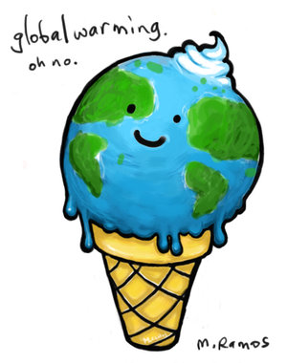
Core Case Study: Studying a Volcano to Understand Climate Change
- In 1991, Mount Pinatubo erupted, which allowed
scientists to further study global climate change.
- Scientists studied that amount of SO₂ released by the
volcano to determine if pollutants would indeed change the
climate of the Earth on a larger scale. It does.

19-1: How Might the Earth’s Temperature and Climate Change in the Future?
For the past 900,000 years the Earth has experienced period of global cooling and global warming. For the past 1,000 years the temperature has been stable, but has begun to rise in the last century when people began clearing forests and burning fossil fuels.
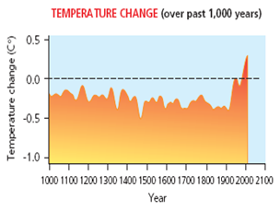
How are past temperatures determined?
- Radioisotopes in rocks and fossils
- Bubbles of ancient air in ice cores
- Temperature taken at different depths in Earth
- Historical records

Life on Earth wouldn’t be possible without the natural
Greenhouse Effect:
- warms the Earth’s lower atmosphere
and surface due to greenhouse gasses like
CO₂, water vapor, and CH₄ that trap heat from the sun
The problem is when we have too many greenhouse gases and human activities have led to this increase.
- Mainly due to agriculture, deforestation, and burning fossil fuels.
- At our current rate of emission of CO₂ we will have a concentration of 560ppm by 2050, and according to research the tipping point is450 ppm.
* Top 2 CO₂ emitting countries:
China and the US
- Data from ice cores also shows that 60% of methane emissions is due to humans activity from extracting fossil fuels, landfills, and livestock.
- Nitrous Oxide levels have also increased due to use of Nitrogen fertilizers (releases NOx in the air during the decomposition process).

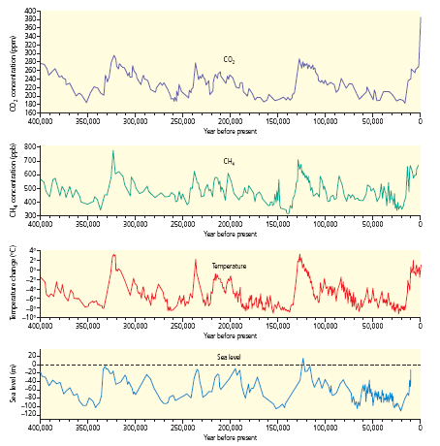

Evidence that Supports Climate Change:
- Between 1906-2000, average global surface temp has increased by 1.3° F
- Greenhouse gas emissions has risen 70% since 1970
- Arctic temps have risen twice as fast in the past 50 years
- Glaciers and floating sea ice are melting
- Rainfall patterns are changing
- Sea level has risen by 4-8 inches

What Role Does the Ocean Play?
- Oceans absorb half of all of the CO₂ released and help moderate temperature
- Some Carbon is converted to carbonate salts that are buried in the sediments for millions of years
- Solubility of CO₂ decreases with warmer temperatures
- As water heats, the CO₂ isn’t absorbed as easily and could amplify global warming= positive feedback loop
- Higher levels of CO₂ increases the acidity of the ocean, which decreases the ability of corals to make calcium carbonate shells
**Bottom Line: Temperature, acidity, and ability to absorb CO₂ from atmosphere are changing as a result of human activities

19-2: What are Some Possible Effects of a Warmer Atmosphere?
Ice and Snow are Melting:
Sea Levels are Rising:
Browning of the Earth:

Permafrost is Likely to Melt:
Ocean Currents Changing:
Extreme Weather:

Health:
Agriculture:
Threat to Biodiversity:

19-3: What Can We Do to Slow Climate Change?
Why this complex problem is difficult to tackle:
- The problem is global- much international cooperation
- Effects of climate change will last a long time- CO₂ stays in atmosphere 120 years.
- It is a long term political issue.
- Impacts of climate change are not spread evenly across the globe.
- Phasing out fossil fuels will change our lifestyles, & disrupt economies and lifestyles.

Solutions: Three Major Prevention Strategies-
- Improve energy efficiency to reduce fossil fuel use.
- Shift from nonrenewable C based fossil fuels to a mix of Carbon free renewable energy resources.
- Stop cutting down tropical rainforests.
** Effectiveness of these strategies would be enhanced by reducing population and reducing poverty.

Climate Stabilization Wedges:
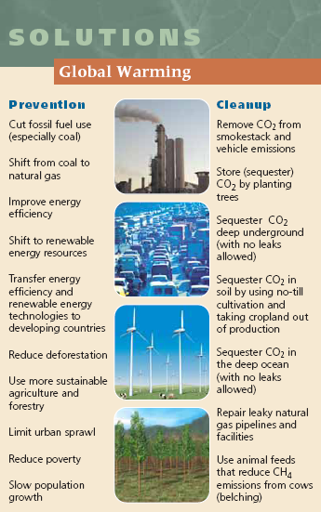
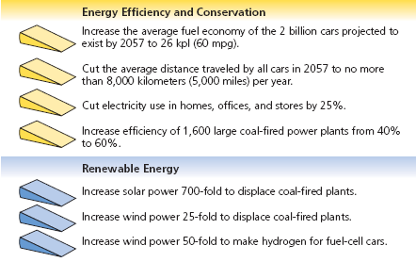
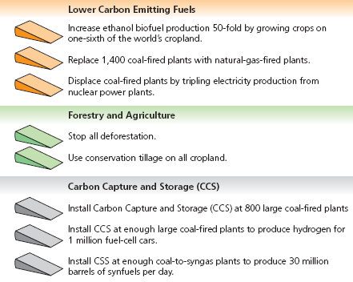
1. Massive tree planting on degraded
land in the tropics.
2. Plant fast growing perennial plants like
switchgrass- stores CO₂ in soil to be
harvested for biofuels.
3. Carbon Capture & Storage (CCS)- removing
CO₂ from smokestacks and pumping it
deep into coal beds or abandoned oil or
gas fields
-CCS is expensive and could raise prices
-require large inputs of money to
operate= counterproductive
-earthquakes, war, etc could cause a
leak; even a small leak would be
disastrous
Random Suggestions:
- Inject sulfate particles into stratosphere -reflects sunlight to cool troposphere
- “Re-ice” the Arctic
- Deep sea pipes to bring up nutrients for algal blooms which can take in CO₂
Output Strategies for Reducing Climate Change:
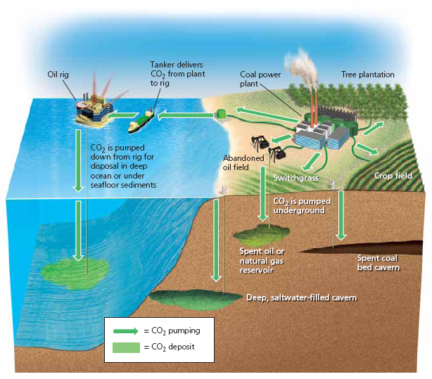

19-4: How Have We Depleted Ozone in the Stratosphere and What Can We Do About It?

What Can the Government Do to Slow Climate Change?
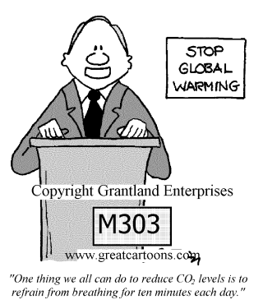
- Strictly regulate CO₂ and methane pollutants.
- Carbon taxes
- Cap and Trade Approach
- Subsidies to businesses who use green
technologies
- Technology transfer to developing countries

*Kyoto Protocol- a treaty to slow climate change (2005)
-required countries to cut emissions of CO₂, CH₄, and N₂O by 5.2%
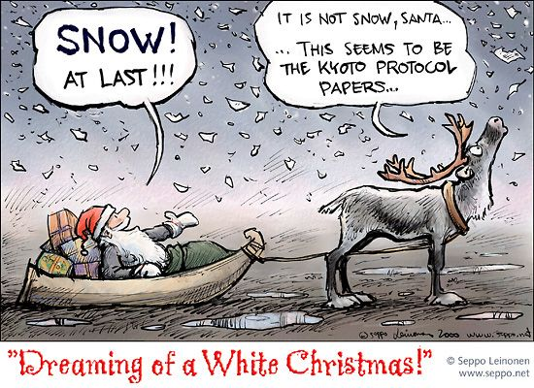
of their 1990 levels by 2012. Did it work?
-countries can trade greenhouse gas emissions- the “cap
and trade” system
-174 countries agreed to this. The US did not.
*George W. Bush decided not to comply because he felt it
would harm the economy and he did not like how
rapidly developing countries (like China) were
exempt.

Who’s been successful?
- Costa Rica aims to be the first carbon free country. They currently generate 78% of their electricity from renewable hydroelectric power and 18% from wind and geothermal energy!
- Some US States are tired of waiting on the federal government to take charge.
  - Portland, Oregon- 1st city to cut greenhouse gas emissions back to 1990 levels.
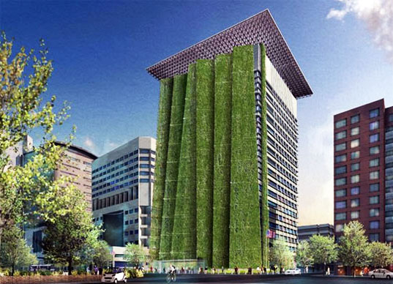
    - The city promotes energy efficient buildings and use of electricity from wind and solar sources.
    - Has built many bicycle trails & has greatly expanded mass transit.
    - This has actually produced an economic boom and has saved the city $2million/year in energy costs!
  - California- 12th largest producer of greenhouse gases (GHG) in the world!
    - 2006- CA passed a law to cut GHG to 25% below 1990 levels by 2020.
    - Set fuel efficiency and carbon emissions standards and let the free market find the best ways to meet standards- EPA refused this request. CA and 17 other states are now suing the federal government to allow states to set tougher CO₂ emission standards.
  - Companies and Schools are reducing their Carbon Footprints
    - DuPont, IBM, Toyota, & Walmart have cut GHG emissions

What Can You Do to Reduce Your CO₂ emissions?
- ______________________________________________________________________
- ______________________________________________________________________
- ______________________________________________________________________
Preparing for the Harmful Effects of Climate Change:
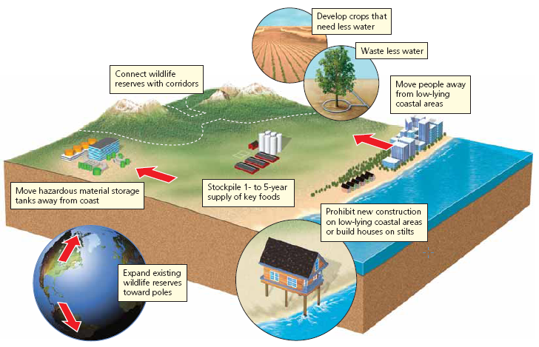
Global climate models say we must make a 50-85% cut in GHG emissions by 2050 to prevent Earth from heating up more than 3.6°F, which will likely be difficult to do. Therefore, analysts have compiled a list of things we need to do to prepare for the long-term effects of climate change. See Picture.

19-4: How Have We Depleted Ozone in the Stratosphere and What Can We Do about It?
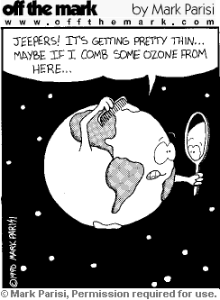
Not only is there considerable thinning of the ozone in the
polar regions, but there is overall thinning everywhere as well.
Ozone depletion in the stratosphere poses a serious threat to humans, animals, and primary producers.
Chlorofluorocarbons (CFCs)
*Discovered in 1930s and use expanded rapidly
*Trade name = Freons
*Thought to be the dream chemical because it is chemically unreactive, nonflammable, nontoxic, inexpensive, and noncorrosive
*Became popular as coolants in ACs, refrigerators, cleaners for electric parts, propellant in spray cans, etc.
*Too good to be true: 1974- “CFCs destroy ozone in stratosphere” said Rowland and Molina
-CFCs rise and remain in atmosphere
-Once CFCs reach atmosphere, it breaks
down under the influence of the UV light
which releases a highly reactive chlorine
which break O₃ into O₂ and O
-CFCs persist in atmosphere for 65-385
years depending on conditions
-It took Rowland and Molina 14 years to
convince DuPont to stop production

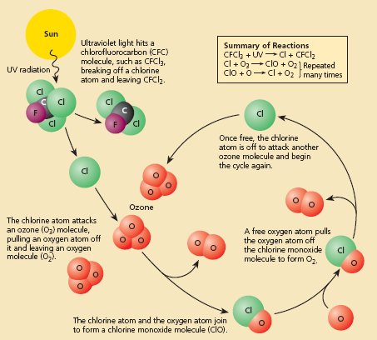

Why Should We Worry about Ozone Depletion?
- More damaging UV-A and UV-B
radiation reaches the Earth’s surface.
- Sunburns, skin cancer
- Destroy phytoplankton- they play a key role in removing CO₂ and are
the base of ocean food web
How Can We Reverse Stratospheric Ozone Depletion?
- Stop use of all ozone depleting chemicals
- Montreal Protocol- treaty’s goal is to cut CFCs emissions by 35%

CHAPTER 9 Sustaining Biodiversity: The Species Approach

Core Case Study: The Passenger Pigeon: Gone Forever
Describe in detail the 2 main reasons why passenger pigeons were once the most numerous bird species, but are now extinct.
- Uncontrolled commercial hunting- they tasted delicious, their feathers made good pillows, and their bones were used as fertilizers
-they were easy to kill because they traveled in large flocks
- Habitat loss as forests were cleared to make room for farms and cities

9-1: What Role Do Humans Play in the Premature Extinction of Species?
During the last 3.65 billion years that life has existed on Earth, there has been a continuous, low level of extinction called background extinction.

Extinction Rate is expressed as a percentage or # of species that go extinct.
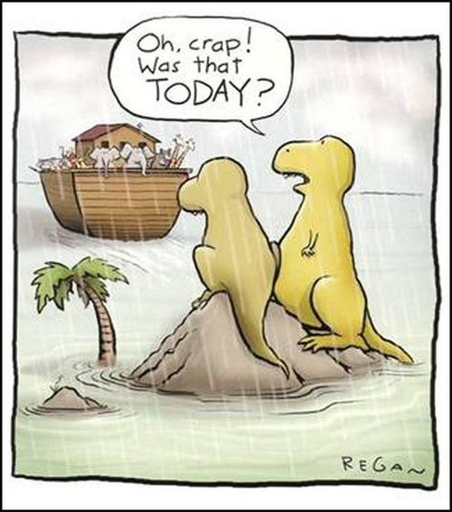
Define: Mass Extinction- extinction of many animals in a
short amount of time

How many mass extinctions has the Earth gone through?
5
What are some of the possible causes of these past
mass extinctions?
The causes are poorly understood, but most likely
due to global changes in environmental conditions.
(like asteroids)

Local Extinction- | Ecological Extinction- | Biological Extinction-
When a species is no longer found in an area it once inhabited but can still be found elsewhere | When so few members of a population are left that it can no longer play its ecological role in the community | No longer found anywhere in the world

Conservation biologists project that extinction rate will increase to 10,000 times the normal background extinction rate due to habitat loss, climate change, and other human activities. This equates to an annual extinction of about 1% per year.

Extinction experts consider extinction rates of 0.01%-1% to be conservative because:
- Rates of extinction and biodiversity loss will likely increase due to an increasing size of the human population.

- Current and projected extinction rates are higher than the global average in parts of the world that are highly endangered centers of biodiversity (hotspots).

- We are eliminating, degrading, fragmenting, and simplifying many biologically diverse environments such as the tropical forests, reefs, wetlands, and estuaries.

Endangered Species
Definition:  So few individual survivors that the species could soon become extinct over all or most of its natural range | Examples:  Giant Panda, Siberian Tiger, Whooping Crane, California Condor, Bluefin Tuna

Threatened Species
Definition:  Still abundant in its natural range but, because of declining numbers, it is likely to become endangered in the near future | Examples:  Polar Bear, African Elephant, Great White Shark

The International Union for the Conservation of Nature and Natural Resources has put out a Red Lists which lists the world’s threatened species.

Describe what makes some species particularly vulnerable to ecological and biological extinction:
Characteristic: | Example:
-Low Reproductive Rate (k-strategist)  -Specialized Niche  -Feeds at High Trophic Levels  -Commercially Valuable | -Blue Whale  -Giant Panda  -Grizzly Bear  -Rhinoceros

9-2: Why Should We Care About Preventing Premature Species Extinction?
We should care about preventing premature species extinction because:
- Instrumental Value- usefulness to us in providing many ecological and economic services

- Ecotourism- species diversity that provides economic benefit from wildlife tourism

- Genetic Information- allows species to adapt to changing environmental conditions through evolution

- Existence Value- satisfaction of knowing that the biodiversity exists

- Aesthetic Value- appreciation for the beauty

9-3: How Do Humans Accelerate Species Extinction?
Most important causes of premature extinction:
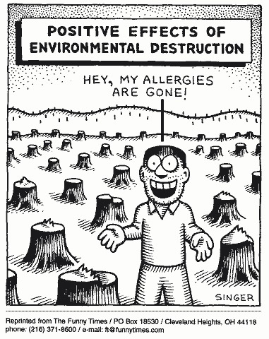
H | Habitat Loss
I | Invasive Species
P | Population Growth
P | Pollution
C | Climate Change
O | Overexploitation

Why are temperate areas more likely to be affected
by habitat loss and degradation?
Because of widespread economic development
in temperate countries
Define: Endemic Species- found in only 1 area of the world

Why are they so vulnerable to extinction? Habitat loss in that area will wipe out the entire population

What creates Habitat Islands? Any habitat that is surrounded by a different one is a habitat island. National Parks are often considered habitat islands because the protected areacan be encircled by industrial activities.

Define: Habitat Fragmentation- caused by roads, logging, agriculture, and urban development and occurs when a large area of land is reduced and divided into smaller patches
-decreases tree populations
-pushes populations into smaller areas that can increase disease, competition, etc
-block migration routes

Case Study: A Disturbing Message from the Birds
Worldwide, 70% of birds are declining.

Major reasons are: habitat loss and fragmentation of breeding habitats,
introduction of invasive species, and illegal trapping for pet trade.

For seabirds, an issue is being caught in baited lines from fishing boats, for migratory birds, flying into power lines, towers and wind turbines.

Birds are important ecologically because they: control populations of rodents and insects, remove dead animal carcasses, and spread seeds of plants.

Birds are also environmental indicators because they live in every climate and biome, respond quickly to environmental changes, and are relatively easy to track and count.

After habitat loss and degradation, introduction of invasive species is the biggest cause of premature animal and plant extinction.

What is the Kudzu vine and what problems is it causing?
-deliberately introduced in the 1930s from Japan to help control soil erosion
-quickly engulfs and suffocates gardens, trees, etc and is difficult to kill

Describe how the fire ant got to the southeast US. What problems are they causing?
The Argentina Fire Ant was accidentally introduced in Alabama because the shipment of lumber was infested with these ants.
These ants have no natural predators and spread rapidly killing off native ant species and have caused thousands in economic damage to crops.

Characteristics of Successful Invader Species: | Characteristics of Ecosystems Vulnerable to Invader Species:
High Reproductive Rate (r-selected) | Climate Similar To Habitat of Invader
Pioneer Species | Absences of Predators
Long Lived | Early successional systems
High dispersal rate | Low diversity of native species
Generalist | Absences of Fire
High genetic variability | Disturbed by Human Activity

List 2 ways of controlling invasive species:
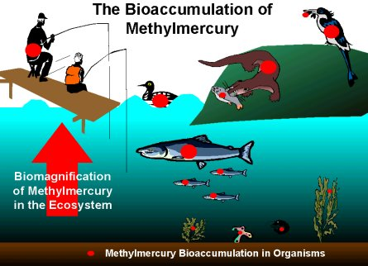
- Don’t capture or buy wild animals

- Don’t dump contents of an aquarium into
waterways, wetlands, or storm drains

Pesticide Pollution Problems:
Define BIOACCUMULATION: accumulation of
chemicals (like DDT and methyl mercury) in
the fat cells of animals
Define BIOMAGNIFICATION: the concentration of
chemicals is at the highest concentration at the
top of the food chain

Two Alarming Disappearances:
Honeybees are responsible for 80% of pollination in insect-pollinated plants, but are dying due to pesticide use, parasites, fungi, invasion, and bee colony collapse syndrome.
Polar bears are suffering because of less floating sea ice, and pollutants like PCBs & DDT.

Poaching is the illegal killing, capturing, and selling of wild species.
-rapidly growing wildlife smuggling is a high profit, low risk business
-smugglers are rarely caught or punished
Illegal pet trade:
-exotic animals carry dangerous infectious diseases

What is bush meat and why is it causing such problems in Africa?
Bush meat= meat from a gorilla
Hunting and killing has rapidly increased in Africa due to an increasing population and reduced food from fishing
The increased hunting has led to local extinction and threatens other species within the food chain.
Who is Jane Goodall?
She works to protect Chimpanzees and their habitats by educating people around the world.

9-4: How Can We Protect Wild Species From Extinction Resulting From Our Activities?

Law or Treaty: | Description:
Convention on International Trade in Endangered Species (CITES) | -internationally bans hunting, capturing, and  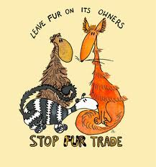  selling threatened or endangered species  -lists over 900 species that can’t be commercially  traded  -however, enforcement varies by country
US Endangered Species Act | -designed to identify and protect endangered  species in the US  -forbids federally funded projects that would  damage the habitat of endangered or  threatened species  -illegal for Americans to buy or sell products made from endangered or threatened species  -close inspection of animals entering the US  -private land owners are given financial incentives to help protect endangered species on their land

Solutions:
- Wildlife Refuges- serve as sanctuaries for animals and birds
        - Ex: Pelican Island- established as a refuge for birds by President Roosevelt
- Seed Banks- preserve genetic information and endangered plant species by storing their seeds around the world- expensive though
- Botanical Gardens
- Zoos, Aquariums, Game Parks
- Captive Breeding and then release into the wild to build up populations

California Condor- nearly extinct from lead poisoning from ammunition
-in order to save the species, the birds were captured to breed in captivity

- Define: THE PRECAUTIONARY PRINCIPLE- precaution should be taken if there is preliminary evidence that indicates a human activity causes harm to health or the environment

